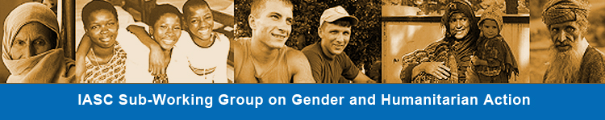
IASC Sub-Working Group on Gender and Humanitarian Action

IASC SUB-WORKING GROUP ON GENDER AND HUMANITARIAN ACTION
MONTHLY MEETING, 09 JANUARY 2013, 09.30 New York/ 15.30 Geneva

Location:
NY: Offices of UN Women: Daily News Building, 220 East 42nd Street, 17th floor, room 17-03. RSVP required to Puk Ovesen (puk.ovesen@unwomen.org, +1 646 781 4734)
Geneva: Offices of UNHCR: Palais Wilson 52 rue des Pâquis CH-1201, room MBT 503. RSVP required to Luisa Cremonese, cremones@unhcr.org, +41 22 739 8509
Washington, DC: Offices of Interaction, 1400 Sixteenth Street, NW, Suite 210 • Washington, DC 20036. RSVP required to Nora Malikin nmalikin@interaction.org + 1 (202) 552-6545
Call-in details: The Bridge Number is +1 212-909-7850. Once you dial in you will be prompted for a four digit id and passcode. ID = 9914, passcode = 9778

Agenda:
- Approval of minutes of meeting of 5 December 2012 and follow up to action points (see attachment) – UN Women (5 mins)
- Endorsement of Annual Work Plan (AWP) 2013 and follow up on Annual Report 2012, and Face-to-face meeting report – UN Women and IMC (5 mins)
- Cross-cutting Issues’ study - draft inputs - Piero Calvi-Parisetti (25 mins)
- Prioritization and updating of SWG websites (see attachment) - UN Women (5 mins)
- E-learning hosting service and payment (see attachment ) - OCHA (5 mins)
- Support to task team for French Translation of e-learning tool - OCHA/InterAction (5 mins)
- Suggestions for regular updates from the field – UN Women (5 mins)
- AOB (5 mins)

Attachments:
- Final AWP 2013
- Draft Annual Report 2012
- Note on E-learning hosting service and payment
- Note on prioritization and updating of SWG websites
- Documents approved on 5 December, now uniformly formatted, can be found here
- Minutes of Gender SWG meeting of 5 December 2012

