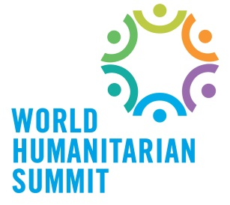
World Humanitarian Summit: Shape the Future of Humanitarian Action
Humanitarian action has changed tremendously in the past two decades. The numbers of those in need are growing. New challenges, including climate change, resource shortages, and urbanization are placing additional demands on already-stretched resources. New humanitarian actors as well as new technologies are changing how we respond to crises. Now more than ever, we need a new humanitarian agenda for a new era in humanitarian action, one that embraces a wide range of actors, forges new partnerships and spurs more innovative and effective ways of working.
How do we get from here to there? Enter the World Humanitarian Summit, to be held in Istanbul in 2016. Leading up to 2016, there will be two years of intensive global consultations, both online and in regional meetings, that will feed into the Summit and include the views of all key stakeholders, including governments and regional organizations, humanitarian organizations, partners from civil society, the private sector, academia, the military, community first-responders and affected populations.
This consultation process will allow the broader humanitarian community to take stock of what has worked, what we have learned, and what we must do to be ‘fit for purpose’ in the 21 st century. In Istanbul, humanitarian stakeholders will come together to discuss these findings and define a forward-looking agenda for humanitarian action.
Themes, Recommendations and Actions
Participants of the regional and online consultations will prioritize the relevant issues in their respective regions. Four themes will serve as broad categories to guide the conversations: (1) the effectiveness of humanitarian aid; (2) reducing vulnerability and managing risk; (3) transformation through innovation; and (4) serving the needs of people in conflict. Consultations on the four themes will focus on how to achieve what’s needed for the future while reaffirming a commitment to the core principles that guide humanitarian action.
Key findings and recommendations will be synthesized in a report by the UN Secretary-General to be shared with all stakeholders in advance of the Summit. In Istanbul, Summit participants will review this report and agree on a set of recommendations and the actions they will undertake, drawing on the full range of humanitarian actors as well as the networks and partnerships that have been formed through the Summit process.
The achievements of the Summit will endure long after the event itself. Practical, cost-effective solutions and new collaborations will help span the preparedness, relief, recovery and development spectrum and better align the humanitarian and development agendas. Summit outcomes will be disseminated widely and the implementation of recommended actions will be monitored and evaluated to distil key lessons that add to the community’s body of knowledge.
To find out more, visit: www.worldhumanitariansummit.org
(by Cynthia Scharf, UN OCHA)

