Cholera and epidemic-prone diarrhoeal diseases:

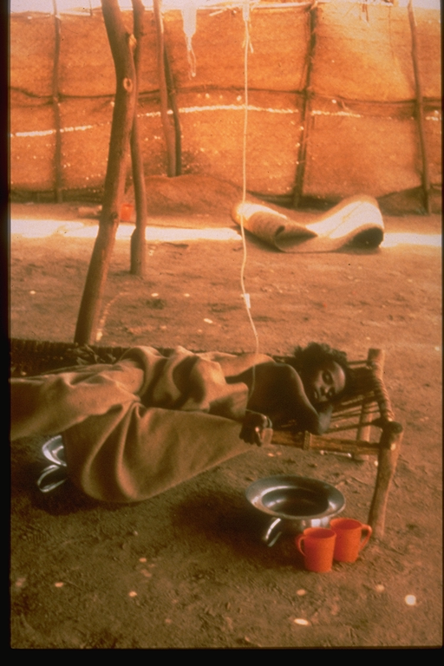Resurgence of a persistent threat
Epidemic-prone enteric diseases, such as cholera, Shigella dysentery or typhoid fever, are a major public health concern in most developing countries where access to safe water is not guaranteed and environmental management is poor. Linked to unprotected water sources, poor sanitation, and overpopulation diarrhoeal diseases still claim too many lives. Refugees, internally displaced populations and populations living in peri-urban settings are the most exposed.
Recent trends clearly demonstrate that cholera is rising. A major outbreak, affecting 16 countries, occurred in West Africa during the second part of 2005 and caused about 70 000 cases.
Recently outbreaks of unprecedented scale have affected countries that has not had reported any cases for decades. Angola, for instance, recorded more than 35 000 cases in the past three months. Response capacities of these countries are often overwhelmed; countries face huge challenges and should adopt a coordinated multisectoral approach to a disease that, in theory, is easy to treat.
Child suffering from cholera,
Kassala, Sudan

The Global Task Force on Cholera Control
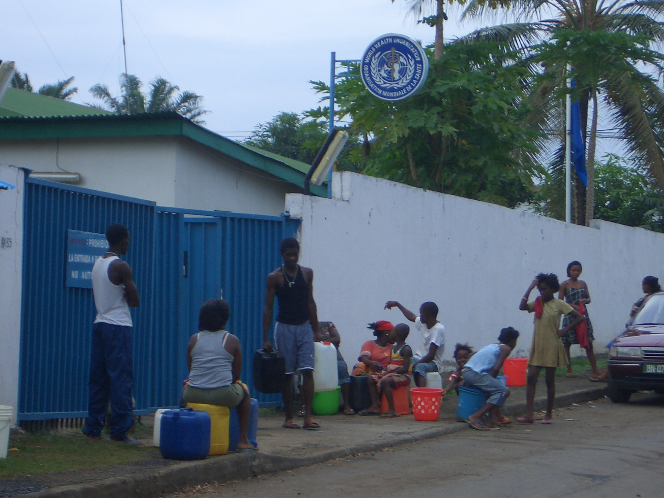
The Global Task Force on Cholera Control, whose objective is to reduce morbidity and mortality as well as social and economic impact, was established through Resolution WHA44.6 in 1991. This partnership brings together UN agencies, governmental and non-governmental organizations, scientific institutions, and different departments and regional offices of WHO. It aims at coordinating activities for prevention, preparedness and response to epidemic enteric diseases at country and sub-regional level, and at providing technical support and training. Developing and disseminating standard guidelines and norms and gaining evidence on the use of new public health tools for improved control of endemic and epidemic diseases are also part of the Task Force responsibilities.

Due to the cyclic occurrence of cholera, and due to competing public health priorities, awareness on better control of epidemic diarrhoeal diseases has dropped over the past decade. Today, The Global Task Force is focusing on following key activities:
Water distribution at WHO office, Malabo, Equatorial Guinea
- Encourage enhanced surveillance and use of data to identify high risk areas and vulnerable populations and guide interventions accordingly
- Provide evidence-based support to countries in prevention, preparedness and response to outbreaks
- Review and revise policies, and develop guidelines and tools for diarrhoeal disease prevention and control
- Gain evidence on the use of oral cholera vaccines (OCV) as an additional public health tool to diminish occurrence of cholera in endemic and epidemic settings
- Link health and environmental management
For more information
www.who.int/topics/cholera
or
cholera@who.int

