Concept of operations – IRIN radio in Afghanistan 2008-2009
Essential radio news reporting to crisis-affected communities

Context

Five years after the demise of the Taliban in 2001, many analysts reported that Afghanistan was on the road to recovery. A government had been elected, the threat of insurgency had diminished, refugees returned home and economic growth was visible – at least in Kabul. By February 2006 the international community had committed USD $10.5 billion towards a four-year reconstruction plan. A year later, this optimism diminished as the country now struggles to make headway against rising conflict and insecurity. For many Afghans, particularly those living in remote or rural areas with poor access to basic services or international aid, daily life remains bleak.

The growing insurgency in the south and east of the country has led to severe insecurity for civilians, government workers and the international aid community. It also hinders humanitarian activities, such as vaccination campaigns, demining and food distribution. In remote and mountainous regions not directly affected by the insurgency, there are isolated and vulnerable populations with basic needs unmet by the government or the international aid community. Corruption, impunity and the absence of rule of law undermines aid and reconstruction activities, while illegal armed groups continue to exercise power.

In 2007 to date, an estimated one thousand civilians have been killed and tens of thousands of civilians have been displaced and lost their homes and livelihoods. While economic growth is apparent in urban areas, insecurity and human rights abuses increase markedly with distance from the city centers. In particular, women and girls continue to be exposed to discrimination and restrictions on all aspects of their lives, notably in education.

Faced with these challenges, the Afghan government and international supporters have made little progress in providing basic needs like security, food, electricity, water and healthcare. An estimated 6.5 million people face perennial hunger while more than half the country’s 30 million inhabitants live below the poverty line.

Rationale

Following a management review of its global radio activities in August 2007, IRIN management agreed that future radio projects would focus on producing radio content for crisis-affected communities with poor access to news and information that could significantly improve their human security and livelihood.

The radio service has two clear aims a) to inform these local communities on relevant issues that directly influence their human security and b) to reflect their views and perspectives to local authorities, humanitarian and development actors and the global aid community. In so doing, IRIN aims to counter misinformation and rumours at a community level, provide insights into humanitarian and reconstruction efforts underway and the challenges they face. Through closer integration with its online news service, radio content can also provide humanitarian and development actors with feedback that contributes to a clearer understanding of community needs, allowing for better planning and responsiveness to local concerns. In this way, radio projects seek to inform three key audiences – the affected community, in-country humanitarian and development actors and the wider global aid community.

To better guide its radio activities, IRIN has honed its criteria for engagement, its approach, desired outputs and handover or exit strategy. While projects will still need to be tailored to specific country situations, the intention is that future IRIN radio projects will provide its target audiences with a standardised, consistent and high quality service.

In Afghanistan, IRIN has operated a radio project since the end of 2003. Serious challenges to human security and reconstruction remain. In particular, fighting between insurgents and national and international forces has led to civilian deaths, destroyed livelihoods, fresh displacement and stalled refugee returns. A recent IRIN review concluded that:

- Afghan communities still have little access to relevant news and information that can positively impact their lives, which is partly due to an underdeveloped media sector (the legacy of over 20 years of conflict) and the challenges of developing media given the current insecurity. Communities remain unaware or misinformed on humanitarian or reconstruction efforts and this can lead to misunderstandings, tensions and the perception that little is being done to address their critical needs.
- The aid community in Afghanistan is confined to Kabul and the larger towns, due to security and logistic concerns. Many have little regular access to remoter Afghan communities, hindering their ability to deliver essential services to these communities.
- Radio remains a powerful tool for reaching out to Afghans, especially in these remoter areas. Recent research conducted by media groups confirmed that radio remains the prime source of information for most Afghan households and the best medium to deliver news and information to rural communities.

Aims & Objectives

IRIN radio projects have the dual aim to a) inform communities in crisis and b) bring their voices to the attention of national and international audiences. In Afghanistan, the aim is to establish IRIN radio content as a primary source of reliable news and information for crisis-affected communities in Afghanistan, and to have their views and perceptions shared with the wider aid community.

Specific objectives are to:

- Provide relevant, timely, accurate and weekly radio content to affected communities in local languages (Pashto and Dari) to inform them of key humanitarian and human security issues and to counter rumour and misinformation.
- Secure regular broadcasting through trusted partner local radio stations to ensure that IRIN radio content is broadcast to target communities on a daily or weekly basis.
- Focus radio content on key humanitarian and human security challenges, such as the needs of communities (including the displaced and returning refugees) affected by the insurgency, food insecurity, natural disasters, public health challenges.
- Ensure that local communities have a voice in humanitarian and reconstruction policies and approaches by ensuring that radio content is systematically integrated into IRIN’s online text reporting, which will help contribute to a clear assessment of humanitarian and reconstruction priorities;
- Maintain and strengthen the radio-journalist network with skills training (mentoring, rotations, workshops) to improve reporting quality.

Approach

Established news service: IRIN draws on four years of radio news experience in Afghanistan and has an established news gathering, production and distribution system which features:
- A network of 23 correspondents throughout Afghanistan (see annex for map of National Network of Stringer Correspondents);
- A professional newsroom in Kabul with a manager and nine editors to guide coverage, support the network and produce radio or text content.
- An integrated radio-text service that allows IRIN to take stories and voices from communities in crisis and incorporate them in reports for national and international audiences and vice-versa;
- Broadcasting agreements on established shortwave, AM and FM services giving audience access Afghanistan and into the border regions of neighbouring countries;
- Regular news reports posted on the IRIN and other websites via RSS feeds and syndication to reach the local authorities, international aid community, media and other interested parties.
- Regular field missions to communities in conflict (where possible) and remote regions by correspondents and editorial team

Editorial Focus: While much of the national and international media concentrates on security and narcotics issues, and the local media is critically under-funded and under-trained, IRIN’s focus on humanitarian issues brings another side of the story to the attention of Afghans and the international community. For local communities, IRIN reports counter rumours and misinformation, provide an anchor from which to rebuild confidence and assist Afghans to take an active role in determining their future. For the international humanitarian community, they contribute to a clearer assessment of humanitarian and development needs, allowing better planning and responsiveness to local concerns. Specific topics to be covered include:

- Communities affected by conflict. With severe restrictions in their movement (see annex for UN security – access map) many humanitarian concerns are going unaddressed in the areas directly affected by fighting. Insecurity has also disrupted a range of activities, notably demining in Kandahar province, food deliveries to western Afghanistan and polio immunisation campaigns.

- Vulnerable remote communities. Populations in remote areas outside of the main conflict areas are poorly served by the government and aid community. Food insecurity, lack of clean water and sanitation, absence of primary health care and other basic services lead to acute vulnerability, with some of the highest maternal mortality rates in the world. In winter, some communities are entirely cut off by snow for up to five months.

- Refugees and Repatriation. While Pakistan and Iran are putting increasing pressure for over 2 million refugees to return home, many do not wish to do so citing factors including insecurity and lack of opportunity. The experience of returnees bear out their concerns, with many returnees keen to return to Pakistan or Iran as unemployment, lack of access to land and other frustrations hinder their attempts to rebuild their lives.

- Natural Disasters. Afghanistan is subject to frequent natural disasters. The limited capacity of the national authorities to cope with disasters combined with the extremely low coping capacity of the Afghan population after 30 years of conflict compounds the suffering caused. While plans exist to improve government capacity, little has been achieved to date.

- Humanitarian and reconstruction aid. Decisions made by the international humanitarian community on these and other issues directly impact on the aid provided to communities in crisis. Other topics that could be covered include civil-military guidelines, perceptions of humanitarian neutrality and military reconstruction programmes, the potential for alternative conflict resolution and dialogue between insurgents and government/international community for humanitarian access.

Partners

In the last four years, IRIN has established partnerships with broadcasters, media development organizations, humanitarian and development agencies, national authorities and international actors.

- Broadcasting: IRIN radio content is broadcast to target audiences through existing international, national and community radio services, notably:
  - Azadi Radio covering the country on shortwave, AM and FM;
  - Good Morning Afghanistan (on the government Radio Television Afghanistan) service on AM and FM reaching much of urban and rural Afghanistan;
  - Salam Watandar (Internews current affairs service for community radio stations in the provinces) on more low-power FM stations around the country.

- Media Development: IRIN has helped Internews (and its local partner Nai) and IMPACS establish community radio stations by training more than 70 journalists. The IRIN network of correspondents is mostly drawn from radio journalists working in these local stations.

- Humanitarian Information Systems: IRIN works closely with UN and government agencies where it can advise or assist in the development of humanitarian information systems that directly benefit local communities. Currently IRIN advises UNESCO on humanitarian journalism training for the national government broadcaster as well as the UNDP project in support of the national disaster management agency.

- Reporting: IRIN journalists have developed good working contacts in government, within communities in crisis and within the international aid community, to facilitate accurate, timely news gathering on relevant issues.

Outputs

The outputs of the current radio project (as at September 2007) are as follows:

- Regular and consistent radio output with a minimum of four stories every week in Dari and/or Pashto targeting communities in crisis, using more diverse programming formats to reach target audiences (see IRIN Afghanistan radio coverage )
- Minimum of two text news stories every week in which local concerns are brought to attention of national and international audiences (see IRIN Afghanistan articles )
- Strengthened humanitarian and human security reporting by IRIN team and correspondent network
- Extended reach within communities in crisis, national and international audiences through the development of new radio programming, new website services and improved marketing
- Robust monitoring and evaluation in place, informed by best practices and tailored to available budget, that is able to demonstrate that IRIN reports reach and influence behaviour of affected communities

Timeframe & Activities

Given the challenging situation in Afghanistan, IRIN has assumed a two year planning horizon for its radio project. In the immediate term, activities for September – December 2007 will include:

- Ongoing news gathering and production of radio content and text reports
- Focus reporting on needs of conflict-affected and most vulnerable communities
- Skills training to reinforce correspondent network
- Undertake field missions to selected communities to report on conditions
- Conduct informal surveys to garner feedback on information needs of the target communities
- Defining 2008 strategy, targets and outcomes.
- Assessing innovative formats for presenting news and information to specific rural communities (some communities may respond better to radio drama formats for relaying essential information on, for example, public health issues)

Monitoring & Evaluation

In the course of this year, IRIN – with the help of in-house OCHA expertise – will develop performance indicators and success criteria against which it will measure its impact by garnering direct feedback from local affected communities and the humanitarian community. The intention is to develop criteria that can be measured relatively easily, at low cost, so that the project can react dynamically to changes in the operating environment in Afghanistan. This will provide a rationale basis for key decisions, such as whether to scale radio activities up or down, or, to phase out and handover to a local entity.

Budget

IRIN is seeking a two-year funding commitment for its radio project in Afghanistan. The budget summary below outlines the cost of implementing the radio project at the current level of activity in 2008. Current radio activities until December 2007 have been financed with resources from the Afghan Emergency Trust Fund and Norway. Four donors – Canada, Norway, Sweden and DFID – have expressed interest in providing support to the radio project next year.

Summary Budget for 2008 (12 months)
Description | Cost USD $
International Manager | 170,441
Editorial Team / Correspondents | 196,144
Regional Offices (radio station partners) | 46,500
Travel and Subsistence | 46,240
Equipment | 3,600
Field Security Transport | 45, 888
Monitoring and Evaluation | 20,000
Kabul Newsroom / Office | 12,000
Sub Total | 540,813
Project Support Cost (13%) | 70,306
TOTAL | 611,119

Annex

I. Deteriorating Security Environment

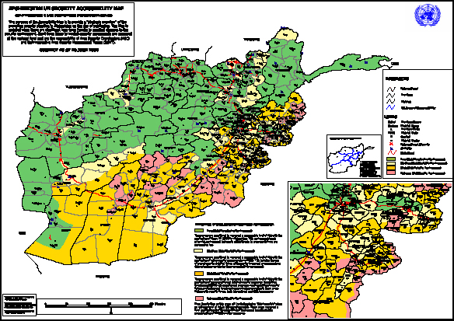 | 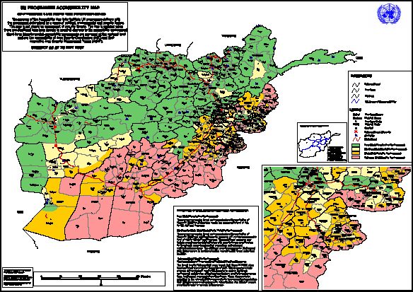
June 2006 | May 2007

These UN maps showing security accessibility in June 2006 and May 2007 show a worsening security environment. By May 2007 most of the southern third of Afghanistan had been downgraded from high risk/volatile environment (orange) to extreme risk/hostile environment (pink). In these areas UN movements are either impossible or approved only with armoured vehicles and armed escorts. Many NGOs have withdrawn from insecure areas and government services are severely limited.

II. National Network of Stringer Correspondents

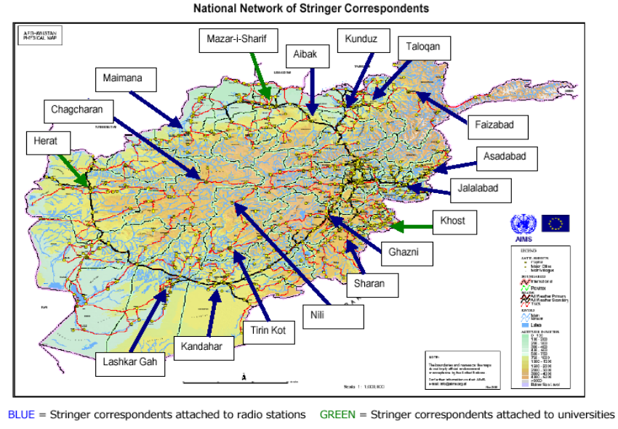
[end]

In August 2007 Representative of the Secretary-General for the Human Rights of Internally Displaced Persons, Walter Kalin appealed for more to be done to prevent displacement and assist those already displaced and noted "the fact that most areas affected by the conflict are not accessible for humanitarian organizations for security reasons hampers the delivery of urgently needed humanitarian assistance".
Source UNDP.
The IRIN text service has been reporting on Afghanistan since October 2000.
One donor official based in Kabul confirmed that access to information was a major problem: “We’re cut off from the ground and it’s hard to understand the needs.”
In 2006, a survey conducted by The Asia Foundation found that 75 percent of respondents nationwide said they listened to radio regularly with over fifty percent listening nearly daily. This was well-ahead of television (22 percent) and word of mouth (15 percent). With illiteracy levels of 85 percent for women and 60 percent for men, print did not feature as a significant source of news for most Afghans.
Including the provinces of Saripul, Samangan, Daikundi, Bamyan and Badakshan.
As Pakistan prepared to close the 100,000 strong Jalozai camp in August 2007 the Norwegian Refugee Council warned that "The response community in Afghanistan is already exhausted by the humanitarian crisis in the country, returns and internal displacement, and appropriate mechanisms do not exist to deal with more returns at this stage.”
A more detailed budget and narrative can be provided on request.
Japan has also expressed interest in providing support through the UN Human Security Trust Fund, however this arrangement appears increasingly unlikely due to an administrative constraint (namely, the requirement to link radio activities to a broader UNAMA human security initiative, which has yet to be developed).

