REVIEW OF
THE OPERATIONAL GUIDANCE ON
RESPONSIBILITIES OF CLUSTER/SECTOR LEADS & OCHA
IN Information management

Dr. Bartel Van de Walle

Report version 3.2
This version: June 2, 2010

EXECUTIVE SUMMARY
The cluster approach, instituted in 2006 as part of the Humanitarian Reform process, was introduced as a means to strengthen predictability, response capacity, coordination and accountability by strengthening partnerships in key sectors of humanitarian response, and by formalising the lead role of particular agencies/organisations in each of these sectors. A cluster is therefore a group of agencies that gather to work together towards common objectives within a particular sector of emergency response. At the global level, clusters have been established in 11 key areas to support the cluster approach.
A cluster lead is an agency/organization that formally commits to take on a leadership role within the international humanitarian community in a particular sector/area of activity, to ensure adequate response and high standards of predictability, accountability & partnership. By designating clear focal points within the international humanitarian community for all key sectors or areas of activity, the cluster approach should help governments and local authorities to know who to approach for support. This should help ensure more timely, predictable and adequate responses. The global cluster leads report to the UN Emergency Relief Coordinator (ERC).
At country level, clusters will normally be established for any major emergency – any situation where humanitarian needs are of sufficient scale and complexity to justify a multi-sectoral response with the engagement of a wide range of international humanitarian actors:
- Clusters are established according to the needs of the situation; they may or may not correspond to the 11 global clusters (some may be combined, others not required);
- Country cluster leads may correspond to those designated at the global level or be adjusted taking account of the capacities and strengths of the humanitarian organizations present; any IASC member can be a cluster lead (it does not have to be a UN agency);
- Where a coordination group already functions with clear leadership, no new cluster or leadership is required for that sector;
- The country cluster structure and corresponding cluster leads are proposed by the UN Humanitarian Coordinator (HC) – or by the UNRC in a country where an HC has not been appointed – after consultation with Government authorities and relevant IASC partners at country level, and agreed with the ERC after consultation within the IASC at global level.
For the cluster-approach induced coordination mechanisms to lead to informed decisions, knowledge of the emergency situation must be generated. This process involves using data collected from within the clusters, across clusters, and the greater humanitarian community to produce ‘information’ and ultimately a higher level of understanding or ‘knowledge’. This knowledge generating function leading to better informed decisions is the overall objective of the information management function of the humanitarian operation.
The Operational Guidance Note (OGN) on Information Management (IM) is an instrumental aid for cluster leads and OCHA to understand and execute their increasingly complex responsibilities related to the effective and efficient management of information during humanitarian operations.
The IASC Task Force on IM commissioned a review of the usability and actual use of the OGN on IM in order to assess whether it satisfies the envisioned goals of IM and to adjust the Guidance Note if and where needed.
This document reports on the review conducted during in-country visits to DRC, Chad, oPt, Egypt and Jordan in the period January-February 2010, during which 46 interviews were conducted with cluster leads, IM Focal Points, IM Officers, and NGOs.
The overall finding of this review is that while the Operational Guidance Note on IM is indeed mostly considered helpful, its effective use is limited due to inadequate human resource management and, not independent from this, insufficient funding. As a consequence, the cluster leads overall (with some exceptions) do not meet the responsibilities as outlined in the OGN. OCHA’s responsibilities on the other hand are mostly understood and satisfactorily executed, to the appreciation of the wider humanitarian community, yet is often hindered by a lack of understanding of IM needs by the cluster leads.
Based on these findings, it is recommended that the cluster leads commit to the intentions outlined in the OGN on IM and commit to more effective HR actions and increased funding of the IM role within the clusters.
In summary, the major findings of this review are:
- The overall level of implementation of the IM responsibilities at the cluster level is weak
- The overall level of implementation of the IM responsibilities at the level of OCHA is adequate
- The decision making process is de facto disconnected from the information management process. There is no ‘closed loop’ from information to decision and back.
- IM Officers have developed best practices that however are not shared and replicated elsewhere which would lead to a more cost and time effective approach

Contents
1. The Operational Guidance Note 5
1.1 The IM Process and three IM Support Functions 5
1.2 IM Responsibilities at the country level 6
1.3 IM Framework within the cluster approach 7
1.4 OCHA’s Humanitarian Information Products, Sources and data collection methods 9
2. Evaluation method 12
2.1 Overall Approach 12
2.2 Goal-based evaluation of IM 12
2.3 Key evaluation questions 13
2.4 Data collection 13
3. Results 14
3.1 Interviews summary 14
3.2 What is the level of implementation of the Guidance Note on IM? 15
3.3 Is the Guidance Note on IM meeting its objective of contributing to informed Decision Making? 16
3.4 What are best practices and impediments in inter-agency/cluster/sector IM? 17
3.5 What strategies can be identified and what are suggested ways forward? 19
4. References 20
4.1 Academic references Error! Bookmark not defined.
4.2 Other reports Error! Bookmark not defined.

The Operational Guidance Note
The operational guidance is intended for use at the country level to help Cluster/Sector leads, OCHA and humanitarian partners ensure that relevant information related to a humanitarian emergency is provided to the right person at the right time in a usable form to facilitate situational understanding and decision making.

The IM Process and three IM Support Functions

The IM Process consists of the collection, processing, interpretation and dissemination of information by and among the Cluster/Sector leads, OCHA, and humanitarian partners. The objective of IM is to ensure that relevant information related to a humanitarian emergency is provided to the right person at the right time in a usable form to facilitate understanding and decision making. As such, Information Management has three main support functions:
- IM supports coordination: strong IM will ensure that actors are working with the same or complementary information and baseline data. Information is as relevant, accurate and timely as possible.

- IM supports needs assessment:
- Information on humanitarian needs is collected through assessments and their subsequent analysis. Undertaking assessments is primarily the responsibility of clusters/sectors and individual operational organizations. However, clusters/sectors are encouraged to seek the support of an IM specialist (from within the Cluster/Sector or OCHA) who may support the process in a number of ways:
  - Provide guidance on survey design and implementation including sampling, instrument development/adaptation, data collection, cleaning, storing, transformation, analysis and reporting (to ensure the quality, type and format of data collected meets the user’s output needs and advise on relevant existing data);
  - Provide technical advice on data ownership, processing, management and outputs for distribution;
- Where they do not already exist, Clusters/Sectors should develop appropriate strategies and tools for data collection, interpretation and verification, with support from the Cluster lead.
- Where possible, common, complementary or distributed assessment arrangements should be put in place by OCHA and the Cluster/Sector leads to avoid over-assessment by multiple agencies.
- Cluster/Sector leads are to coordinate and share data collection efforts with the Information Management Working Group at the country level to ensure harmonization on data standards and avoid duplication of data collection.
- IM supports monitoring of humanitarian response:
- Each Cluster/Sector lead should identify common standards and indicators for monitoring the progress and the effectiveness of humanitarian response within their Cluster/Sector.
- Standards and indicators should take into account existing globally-agreed standards such as SPHERE, ISO, and IASC or other Cluster/Sector-specific norms as well as national standards or guidelines.
- Once indicators have been agreed to by each Cluster/Sector, mechanisms for ongoing data collection and reporting should be harmonized with the Humanitarian Country Team and OCHA. Mechanisms should clearly indicate a.) What data are needed? b.) Who will collect the data? c) Where will data be aggregated and processed? d.) How often will data be updated? e.) To whom is information disseminated?

IM Responsibilities at the country level
The Operational Guidance Note on IM outlines the following responsibilities for Cluster/Sector leads and OCHA.
IM responsibilities of Cluster/Sector leads
- Allocate the necessary human and financial resources for IM. Each cluster shall appoint an IM focal point, who should have sufficient expertise and an ability to work with different partners and clusters.
- Contribute to inter-cluster IM coordination led by OCHA, and support efforts to ensure coherence and coordination between intra and inter cluster information management initiatives.
- Ensuring adherence to global—and taking into account national—IM norms, policies and standards.
- Work with OCHA to establish the systems and processes needed for effective information sharing with cluster partners related to inter-cluster coordination and cross-cluster programming.
- Generate up-to-date cluster specific information (e.g. contact lists, meeting minutes, standard forms, policy or technical guidance, datasets, needs/gap analysis, etc.) and sharing it with OCHA in order to support inter-cluster data sharing.
- Establish a data confidentiality and privacy policy within their cluster, which ensures that sensitive, personally identifiable datasets are suitably anonymized.
- Ensure all information is age and sex disaggregated where appropriate.
IM responsibilities of OCHA
- Providing information products and services to the humanitarian community. Allocate appropriate IM resources, according to the nature and scope of the emergency.
- Suggest standards that allow for datasets and databases to be compatible in order to support inter-operability of data.
- Produce a minimum set of predictable standardized information products in collaboration with clusters/sectors and made available to all
- Provide or make available minimum services to clusters/sectors
- Provide standardized cross-cluster needs/gap analysis based on information provided by the clusters.
- Establish an IM Network at the country level in order to coordinate IM activities and support sectors/clusters in their IM activities, including the promotion of best practices.
- Be cognisant of those organizations with in-country IM operational capacities willing to support inter-cluster humanitarian response throughout the emergency.

IM Framework within the cluster approach

In an earlier study on the Information Management Framework in the Cluster Approach, Bauman (2007) describes the overall objective of the IM function of the humanitarian operation as follows:
“To generate knowledge of the emergency situation to allow coordination mechanisms to make informed strategic decisions. Process involves using data collected from within the clusters, across clusters, and the greater humanitarian community to first generate ‘information’, then, once information is collated across all sectors a higher level of understanding, or ‘knowledge’ can be realized.”
Bauman continues to describe the internal cluster information generation process as consisting of data collection, data storage, data analysis and information dissemination. The key inputs that feed into data collection are activity data sharing, assessment and survey data, and monitoring and impact data. Dissemination outputs are internal cluster information sharing and the external, inter-cluster information sharing. These processes are shown in Figures 1-3.
The functions that promote and facilitate lateral data and information sharing between clusters (and all stakeholders) are conceptualized and developed through multi-agency collaboration but facilitated by OCHA. This is intended to ensure that data, information and services that are common to all (or most) clusters is available and shared, and that some basic tools required to do IM are available to all clusters.
Similarly, all clusters participate in the function of assembling the overall message and information synthesis from all clusters, yet the information sharing and collation is facilitated by OCHA.

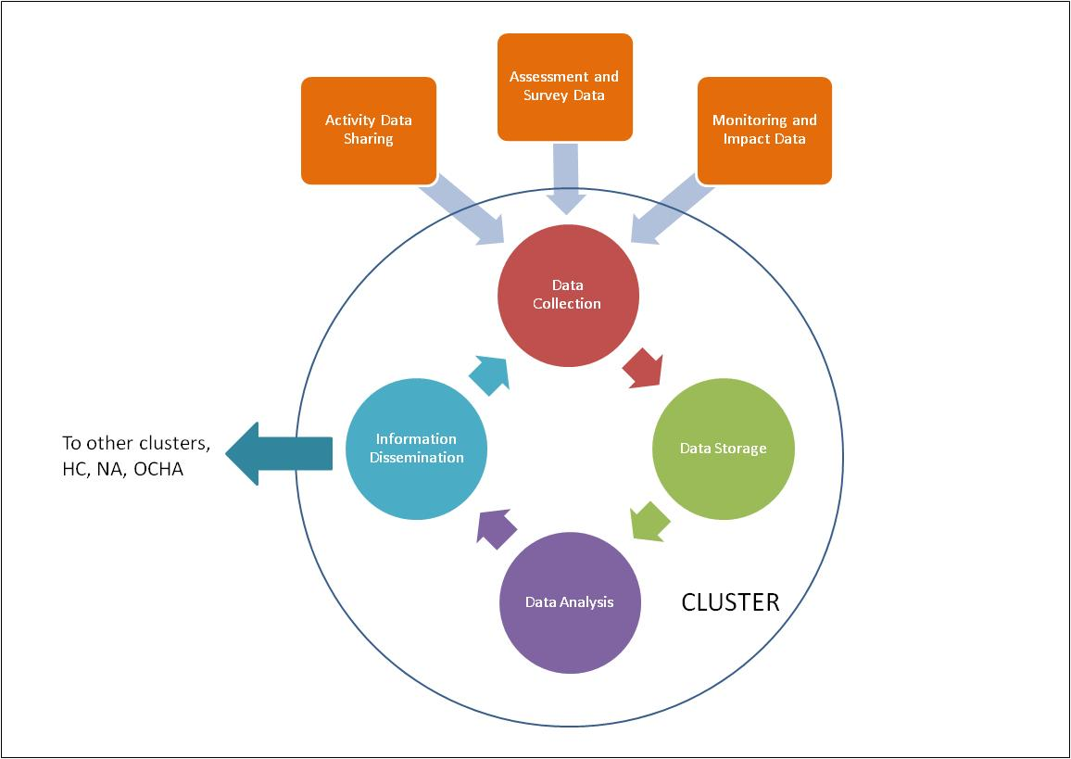

Figure 1 Internal Cluster information generation processes

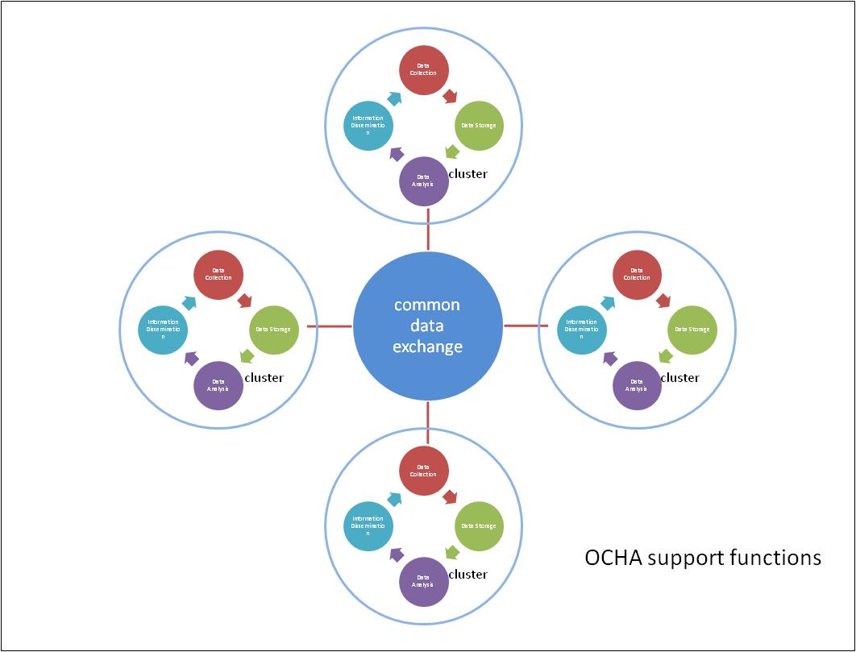

Figure 2 OCHA supported functions that enhance common data exchange

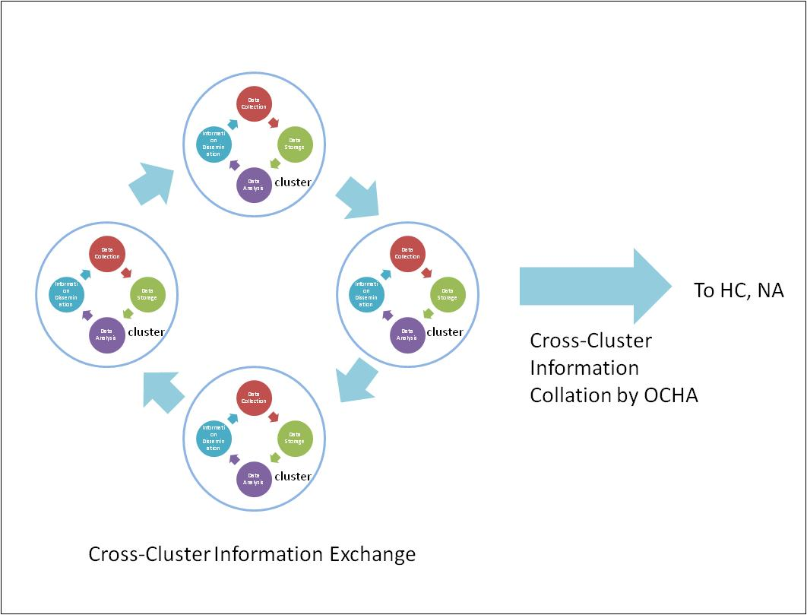

Figure 3 Cross-cluster Information Exchange and Collation

OCHA’s Humanitarian Information Products, Sources and data collection methods
In an initial review of OCHA’s portfolio of Humanitarian Information Products, Rabinowitz (2009) explores the information processes of each product in the portfolio, defines the relationships and linkages between the products, and identifies areas of overlap and conflict between products.
The portfolio of Humanitarian Information Products included in the Rabinowitz evaluation is:
- Harmonized Needs Assessments
- Humanitarian Dashboard
- Situation Reports
- CAP family (CAP, Flash Appeals, FTS)
- ReliefWeb Humanitarian Profiles/Snapshots
- UNDAC Situation Reports
- 3W Database, from which a number of “personalized” products can be derived
- CERF Applications

As OCHA staff is rarely involved in collection of data from direct survey or assessment, OCHA’s products necessarily rely on data supplied by a range of sources:
- Cluster leads: increasingly, information for OCHA’s core products is (or should be) consolidated at the cluster level by the cluster lead agency before being shared with OCHA. OCHA makes its requests to the cluster lead rather than to individual agencies. This is the case for the CAP and Flash Appeals, and increasingly so for Situation Reports.

- Humanitarian Coordinator/Humanitarian Country Team: Some products require information that has been collaboratively agreed upon by the HC and/or the HCT, possibly with OCHA’s support. As an example, the severity ratings of the Humanitarian Dashboard or the sections of CAP and Flash Appeals where humanitarian priorities are defined.

- Humanitarian Agencies: The implementation of the Cluster system has significantly reduced the direct information sharing contacts with humanitarian agencies, as most information is now consolidated at the cluster lead level. Individual agencies are primarily consulted when information is being collected on a per-agency basis, for example contacts for the 3W database or projects for FTS.

- Donors: donors are a formal information source for funding information in FTS, but not generally consulted for other products

- Published sources: OCHA products often rely in part on published sources, including reports from agencies, IFRC, media outlets, or local governments.

Data Collection Methods:
Rabinowitz distinguishes among the following methods or ways in which data for OCHA products is collected:
- Structured information request: an OCHA focal point proactively asks for specific data using a structured collection tool, for instance a Word template or an online form, or potentially just a list of specific questions to be answered.
- Structured self-reporting: pretty much as the above method, but relies more on the initiative of the data providers. Less consistent therefore than the structured information request method.
- Collaborative process: for some data, OCHA might engage in a collaborative process of collection, for instance an email discussion or a face-to-face workshop
- Unstructured requests: when asking for a general category of data, for instance “your latest needs assessment”. Standardization is under way.
- Ad Hoc requests: are made for products with varied information needs, usually in conjunction with research on published sources, and generally involve a specific request to a single agency, e.g. a request to UNHCR to provide the latest IDP stats.
- Research: information collection from published sources, internal reports, or personal interactions.
Challenges identified:
Rabinowitz identifies the appointment of a single focal point for information sharing at the cluster level as one of the key challenges in the data collection process. It appears that in some clusters no focal point is being appointed, at least in the early stages of cluster implementation, while in other cases focal points may be appointed without clear responsibilities. These two factors jeopardize OCHA’s capabilities in collecting the needed data.
In addition, notwithstanding the Operational Guidance notes or other explicit agreements developed at the global level, OCHA still in the end relies on the effective participation of its humanitarian partners in the field to collect data for its products. The willingness of these partners to share data goes hand in hand with the perceived benefits offered in return by OCHA, which may not always be clear or strong enough.

Evaluation method

Overall Approach

This evaluation mainly adopts an inductive approach, using quantitative data where available and relying strongly on qualitative data. Data will be derived from primary and secondary sources, direct observation in the field, key informant interviews and a survey with all stakeholder groups at the global level. The evaluation aims as much as possible to collect empirical evidence.

The evaluation approach chronologically more or less follows on the more extensive evaluation approach developed in the Cluster Approach Evaluation Phase 2 Framework. The purpose of the cluster approach is to achieve greater gap filling and better coverage (both geographic and thematic), as well as ownership and connectedness, through stronger predictable leadership, partnership and cohesiveness, and accountability.

Our evaluation focus is on the level of implementation of the Operational Guidance on IM and its ability to support coordination, needs assessment and monitoring of humanitarian response.

It should be noted here that better coordination is not an end in itself, but serves to improve the humanitarian response. The focus of the evaluation, as with the Cluster Approach Evaluation Phase 2, should therefore be on outcomes and any short term effects that are possible at country level.

Goal-based evaluation of IM

In general, three types of IM evaluation strategies can be distinguished (Cronholm and Goldkuhl 2003):

- Goal-based evaluation
- Goal-free evaluation
- Criteria-based evaluation

The differentiation is made in relation to what drives the evaluation. Goal-based evaluation means that explicit goals from the organisational context drive the evaluation. These goals are used to measure the Information Systems / IM performance. The goal-free evaluation means that no such explicit goals are used. Goal-free evaluation is an inductive and situational driven strategy. Criteria-based evaluation means that some explicit general criteria are used as an evaluation yardstick. The difference to goal-based evaluation is that the criteria are general and not restricted to a specific organisational context.

According to Patton (1990) goal-based evaluation is defined as measuring the extent to which a program or intervention has attained clear and specific objectives. The focus is on intended services and outcomes of a program – the goals. Good et al (1986) claim that evaluations should be measurable and that the evaluation should meet the requirements specification.

The goals that are used for evaluation are derived from an organisational context. The basic strategy of this approach is to measure if predefined goals are fulfilled or not; to what extent and in what ways. The approach is deductive. What is measured depends on the character of the goals and a quantitative approach as well as qualitative approach could be used.

Key evaluation questions

This evaluation focuses on the following main and key evaluation questions, derived from the Terms of Reference, the Cluster Approach Evaluation Phase 2 Framework and comments from the IASC TF on IM:

- What is the level of implementation of the Guidance Note on IM?
More in particular, we are looking for answers to the following questions:
  - How are the guidelines utilized?
  - What are the impediments for implementation?
  - What resources are available?
  - What elements are needed for a successful implementation?
- Is the Guidance Note on IM meeting its objective of contributing to informed Decision Making?
More in particular, we are looking for answers to the following questions:
  - What is relevant information (and who decides on this) and is it available?
  - How that information is provided and to whom is it provided – who is the right person?
  - What is a usable form to facilitate understanding and decision making?
  - How this process is ensured (governance)?

- What are best practices and impediments in inter-agency/cluster/sector IM?
We are looking here to identify gaps in the Guidance Note on IM, such as transition and sustainability. We will also look at human and financial resources needed to implement the guidance at both the Field and Global level.

- What strategies can be identified and what are suggested ways forward?

Data collection

We will work with relevant secondary and primary data from the country and the global level. The data will be collected as follows:

Secondary data: An important source of information for the evaluation will be secondary data, created by others than the evaluator. This data includes documents (meeting notes, situation reports, monitoring data, evaluation results, existing statistics, appeal documents etc.) and relevant literature provided at country and global level. Data will be collected from relevant stakeholders (e.g. through the Web Library) and through research.

Primary data: The evaluator will create primary data through semi structured interviews and a survey. Due to the scope of the evaluation, limited resources and limited time spent in case study countries, it is impossible to create primary technical quantitative data. Most primary data generated will be qualitative.

- Semi-structured interviews: The interviews will be guided by the review questions listed above. They aim to complement the information collected through the analysis of secondary data, to test hypotheses, to triangulate results and to create buy-in of the different stakeholders. Interviews will be held at the global (Europe and New York), regional (Cairo and Amman) and country levels (DRC, Chad, and oPt). As much as possible, interviewees will be selected to cover the appropriate clusters.

- Survey of relevant stakeholders at the global / headquarter level: The survey will include organizations participating in the cluster approach, and working in countries with and without the rollout of the cluster approach. Data will be used to complement data already collected at field level and at global cluster level. The questionnaire will be drafted after the first round of field missions to fill identified gaps in data collection.

Results

Interviews summary

In total 46 interviews have been conducted during the country visits to DRC (January 12-13, Kinshasa and January 15, Goma), Chad (January 18-19, N’Djamena and January 20-21, Abéché), oPt (February 2-5, Jerusalem and Gaza), Egypt (February 7, Cairo), and Jordan (February 11, Amman).
The following organisations have been interviewed during these visits:
- OCHA Regional Office for Middle East, Near East and Central Asia (Cairo)
- OCHA Field Offices in DRC (Kinshasa) and Chad (N’Djamena)
- OCHA sub offices in DRC (Goma) and Chad (Abéché)
- UNICEF (Kinshasa, Goma, Jerusalem, Amman)
- WHO (Kinshasa, Goma, N’Djamena, Gaza)
- WFP / logistics (Jerusalem,
- IMMAP
- UNDP
- OXFAM
- NRC
- FAO
- UNRWA (oPt)
- ISDR
- IOM
The notes taken at these interviews are provided in Appendix 1. Please note that some of the interviews have been anonymized upon request of the interviewee. The full audio recording of the non-anonymous interviews are available upon request.

What is the level of implementation of the operational Guidance Note on IM?

IM responsabilities at the cluster level: the overall level of implementation is weak

- The necessary human and financial resources for IM are in general lacking or of secondary concern. IM focal points are not appointed, or at best assigned as an additional task to a cluster member. The TOR of the IM focal point is not defined. There is no agreed standard on the required level of expertise of the IM focal point. There is no evaluation of the ability of the IM focal point to work with different partners and clusters. The recruitment process to hire an IM person takes too long.
- The clusters do contribute mostly in an ad-hoc way to inter-cluster IM coordination, the lead of which is left to OCHA. Support is weak to efforts to ensure coherence and coordination between intra and inter cluster information management initiatives. There is no self-assessment at the cluster level on the performance of inter-cluster coordination.
- There is a general lack of effort to ensure adherence to global—and taking into account national—IM norms, policies and standards.
- There is only occasional commitment to work with OCHA to establish the systems and processes needed for effective information sharing with cluster partners related to inter-cluster coordination and cross-cluster programming.
- Clusters have in general good intentions to share cluster specific information (e.g. contact lists, meeting minutes, standard forms, policy or technical guidance, datasets, needs/gap analysis, etc.) with OCHA in order to support inter-cluster data sharing. There exists however a general feeling of discomfort among the clusters with the required formats of those information sets, and the lack of feedback that is received on the information that has been supplied.
- Data confidentiality and privacy policies within the clusters are in general lacking. It is unclear whether information is age and sex disaggregated where appropriate.

IM responsabilities at the level of OCHA: the overall level of implementation is adequate

- OCHA does provide a wide variety of information products and services to the humanitarian community. In general, the appropriate IM resources are assigned, with a major exception the presence of IM resources in Gaza.
- OCHA does suggest standards that allow for datasets and databases to be compatible in order to support inter-operability of data. However, the follow-up on compliance with standards (or the lack thereof) is often insufficient and difficult to correct.
- OCHA has produced a minimum set of predictable standardized information products in collaboration with clusters/sectors and made available to all. The standardization however is often experienced as cumbersome and too restrictive by the clusters. However, this appears to be mainly due to the lack of IM expertise at the cluster level.
- OCHA does provide or make available minimum services to clusters/sectors.
- OCHA does not consistently provide standardized cross-cluster needs/gap analysis based on information provided by the clusters.
- OCHA does not consistently establish a formal IM Network at the country level in order to coordinate IM activities and support sectors/clusters in their IM activities, including the promotion of best practices.
- OCHA is in general cognisant of those organizations with in-country IM operational capacities willing to support inter-cluster humanitarian response throughout the emergency. However, formal agreements are lacking.

Is the operational Guidance Note on IM meeting its objective of contributing to informed Decision Making?

- The overall sentiment of the interviewees at both cluster and OCHA level was the Guidance Note on IM contributes to informed decision making. However it was impossible to provide an answer in a more quantitative way, but was often stated through a (logically false) counter-argument: “if this would not be the case, we would have received complaints”.

- The decision making process is overall an informal process, based on the exchange of information during a face-to-face meeting. The impact of information provided by the cluster leads or by OCHA to the decisions made therefore cannot be clearly assessed.

- Feedback to the information provider is often lacking or mostly informal. It is therefore impossible for the provider to identify what information elements were relevant.

- The actual decision making process appeared out of scope of most information providers’ radius of involvement. Information is sent out, and gets possibly shared, but lack of feedback to the sender prevents the information loop to close.

- As a consequence, OCHA typically provides “more of the same” (e.g., more maps) and asks for “more of the same” data. In once case, it was found that OCHA issues multiple and uncoordinated info request from different parts of a single OCHA office. This “blind” IM process increasingly loses its acceptance among cluster leads and consequently the motivation to share information decreases. To avoid this, OCHA should develop an information collection plan at the office level.

- There is no governance of the information sharing processes. OCHA takes the information that it gets, but usually lacks the leverage to insist on more, or better, data and information.

Overall conclusion: the decision making process is disconnected from the information management process. There is no ‘closed loop’ from information to decision and back.

What are best practices and impediments in inter-agency/cluster/sector IM?

- IM at the inter-agency or cluster level is driven by individuals who are highly motivated to achieve high quality work in the IM area. Often these individuals express feelings of insufficient understanding of their role from their local management, as well as being disconnected from the HQ level.

- The support function from global to local is often found to be missing. There is no clear linking between global and local cluster lead with respect to the IM function. IM information or instructions from HQ are often perceived as abstract, not applicable to the country or field situation. HQ visits are often perceived as an additional burden and not providing solutions to the problems that are being experienced.
- Due to short-term assignments, the turnover of IM staff in some locations is very high. This sometimes leads to an immediate and unrecoverable loss of specialized knowledge of the local humanitarian situation. The arrival of new staff is sometimes delayed, therefore no handover can take place between the departing and arriving IM staff, and training of new staff is considered inadequate.
- Inter-cluster meetings typically are “face-to-face” verbal meetings of which meeting notes are created by OCHA staff as a rule. However, it would be helpful if these notes would support the meeting in a more pro-active manner. In particular, a follow-up analysis based on the meeting notes would be considered as helpful in advancing the meeting process. Apart from this operational ‘secretariat’ implementation of IM, the role of OCHA in inter-cluster support is not clearly specified.
- In the French speaking countries visited, a language problem was identified as the necessary documents were available only in English, and not in French. This would be valuable for sharing with local (French speaking) authorities.

- Some participants regretted the lack of “analysis” by OCHA to the information they collected or received. Information is formatted (for example in a map) but does not provide (much) additional analysis. This analysis capacity was mentioned by several respondents to have been present at the HICs, but has since diminished or even disappeared.

- The Information Management products provided by OCHA are well-defined and have become the “de facto” information products used in humanitarian emergencies. While this situation has definite advantages, it may in some cases be a too rigorous and limitative approach, ignoring useful IM innovations that have been developed in the field. It is important that a strategy is developed for dealing with innovative solutions developed in the field.
As examples found during our visits, OCHA had developed an ‘informal’ mailing list or Google group which despite its effectiveness was not supported formally. A similar experience was shared in another case with respect to a similarly informal website that proved an effective means for inter-cluster communication.

- Needs assessments are currently often lacking a fundamental IM approach and appropriate methodological foundation. Some respondents reported missions in the field that were executed without a sound methodological basis.
The role of IM in the Needs Assessment process is currently critically underdeveloped. There is a need for a well-defined and continuous IM involvement and flow from designing the Needs Assessment methodology, to the execution and coordination of the Needs Assessment activities, and up to the Monitoring and Evaluation processes.

Overall conclusion: Various ad-hoc impediments and best practices have been identified. ocha should develop a strategy to capture these consistently at the country level and build up a regional/global knowledge base.

the importance of im in needs assessment is critical yet vision and implementation is lacking.

What strategies can be identified and what are suggested ways forward?

- Cluster leads and OCHA must be accountable to the IM responsibilities as outlined in the OGN.

- Agreed functions of the IM focal point must be developed. It is recommended to develop common Terms of Reference for the various levels of the IM staff in the cluster approach, specifying the required information technology as well as information management skills and knowledge for these positions. These TOR should also include the transition for IM in case IM staff is being replaced.

- Tangible benefits and sanctions may be introduced if information sharing between clusters and OCHA is found to be inadequate. While it is unclear how this can be implemented, there may clearly be a role for the Humanitarian Coordinator / Resident Coordinator in this process.

- OCHA is serving the humanitarian community in its role of secretariat. However, this often implies that OCHA is doing elementary functions such as note-taking, sending invitations to meetings and the like. While these tasks are very important, the term “secretariat” should be interpreted as an enabling environment for proper coordination and decision making. This requires that the processes of coordination and decision making are made more explicit.

- OCHA and cluster representation at the regional level should be tasked to provide essential capacity building and support to the country offices in their respective regions. Several suggestions have been identified throughout the review, among which most notably establishing a help desk at the regional level to which IM staff in the corresponding countries have easy and immediate access 24/7, establish a “best practices” database or IM knowledge base.

References

To be completed.

