Inter-Agency Standing Committee Principals Meeting
Tuesday 9 December 2014, Geneva, Switzerland
Hosted by the International Organization for Migration
Logistics information for Participants

On 9 December 2014, the Inter-Agency Standing Committee (IASC) Principals will meet in Geneva, Switzerland. The meeting will be hosted by the International Organization for Migration (IOM) and will take place at IOM Headquarters, main building – 1st floor conference room. The meeting will begin at 09h00 and end at 16h00.
Location of IOM Headquarters: 17 route des Morillons, 1218 Grand-Saconnex (Geneva), Switzerland.
Access to the IOM building
For this event, no visitor’s badge will be required to enter the IOM building. However, participants are required to present themselves at the IOM reception. They will then be escorted to the conference room.
Accommodation
Participants are requested to make their own arrangements. Geneva offers a large variety of hotels. Please contact Naomi Uliel (nuliel@iom.int / +41 22 717 93 75) if you would like a list of hotels.
Transportation
Please note that access to the IOM courtyard is limited. Principals’ cars with drivers will be allowed to enter the courtyard to drop off participants. A limited number of parking spaces will be made available behind the IOM building.
Bus 28 and F, stop “Vy-des-Champs”, will stop right next to the IOM building. Bus 8, stop “ILO” is more frequent, but a 3 minutes’ walk away from IOM. From there, the IOM building is a little uphill and to the left. Bus F and Bus 8 can be caught from Cornavin (train station) and Bus 28 from Palais des Nations.
For taxis, participants should make a reservation at least 30 minutes in advance at “Cooperative Taxi 202”: +41 22 3 202 202.
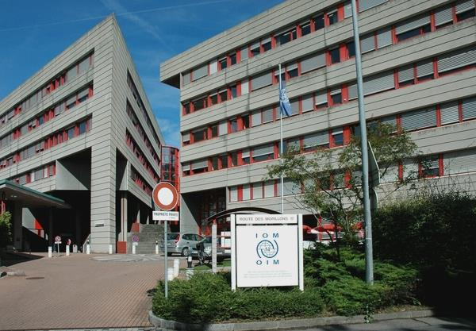
Meals
Croissants and coffee will be available from 8.30 onwards.
A light lunch buffet will be served outside the conference room from 13h00 onwards.
Coffee and tea will be available throughout the meeting.
Internet
A Wi-Fi connection can be accessed free of charge from the conference room.
Photos
A photographer will capture a few moments of the meeting for the IASC’s website and Facebook page and take a group photo at 12h50.
Security in Geneva
Geneva is a relatively safe city. However, there’s been an increase in pickpockets and theft, targeting mostly tourists and expats, these past years. Please don’t leave your bags unattended and be mindful of your surroundings in public transportations and restaurants/bars. Gare Cornavin (the main train station), Pâquis, Eaux Vives, and the lake area have the highest number of pickpockets and theft incidents in the city.
Emergency Contact Numbers
The following are the emergency numbers in Geneva:
- Police: 117
- Ambulance: 144
- Fire Brigade: 118
Further information and assistance
For further information regarding the arrangements for the IASC Principals meeting at the IOM Headquarters in Geneva, please do not hesitate to contact Naomi Uliel (nuliel@iom.int / +41 22 717 93 75).

