IASC Training Guide

Open Atrium Basics

Structure & Permissions

Spaces, Sub-Spaces, and Sections
- Spaces, Sub-Spaces, and Sections are how content is organized on Open Atrium sites and are used to create the logical nesting and division of related content
- Spaces - a collection of content (you could think of it as a filing cabinet)
- Sub-Space - an additional division of content within a particular Space. You can have an infinite nesting of Sub-Spaces (think of this as a drawer within a particular filing cabinet)
- Section - where your content actually lives on your site (think of a file folder within a particular drawer or cabinet)
- We’ve created a series of Spaces, Sub-Spaces, and Sections based on the taxonomy and hierarchy of documents from your legacy site in order to logically nest and house your content. Here’s what the breakdown looks like:

Space | Sub-Space | Sub-Space of a Sub-Space | Section
The IASC Home
IASC Transformative Agenda
>> | >> | >> | Meetings
>> | >> | >> | Documents
>> | >> | >> | News
Events
>> | Geneva
 | >> | >> | Meetings
 | >> | >> | Documents
 | >> | >> | News
>> | New York
 | >> | >> | ^ Same set of three as seen above
Working Group
>> | >> | >> | Meetings
>> | >> | >> | Documents
>> | >> | >> | News
>> | Camp Coordination & Management
 | >> | >> | Meetings
 | >> | >> | Documents
 | >> | >> | News
>> | Champions and Subsidiary Body Co-Chairs
 | >> | >> | ^ Same set of three as seen above
>> | Early Recovery
 | >> | >> | ^ Same set of three as seen above
>> | Emergency Shelter
 | >> | >> | ^ Same set of three as seen above
>> | Emergency Telecommunications
 | >> | >> | ^ Same set of three as seen above
>> | Health
 | >> | >> | ^ Same set of three as seen above
>> | Logistics
 | >> | >> | ^ Same set of three as seen above
>> | Nutrition
 | >> | >> | ^ Same set of three as seen above
>> | Protection
 | >> | >> | ^ Same set of three as seen above
>> | Water and Sanitation
 | >> | >> | ^ Same set of three as seen above
Subsidiary Bodies
>> | Good Humanitarian Donorship
 | >> | >> | Meetings
 | >> | >> | Documents
 | >> | >> | News
>> | Leadership and Humanitarian Coordination
 | >> | >> | ^ Same set of three as seen above
>> | Sub-Working Group
 | >> | Consolidated Appeals Process (CAP)
 |  | >> | Meetings
 |  | >> | Documents
 |  | >> | News
 | >> | Gender and Humanitarian Action
 |  | >> | ^ Same set of three as seen above
 | >> | Humanitarian Consequences of Sanctions
 |  | >> | ^ Same set of three as seen above
 | >> | Humanitarian Financing Task Team
 |  | >> | ^ Same set of three as seen above
 | >> | Preparedness
 |  | >> | ^ Same set of three as seen above
 | >> | Sub-Working Group on the Cluster Approach
 |  | >> | ^ Same set of three as seen above
>> | Task Force
 | >> | Accountability to Affected People
 |  | >> | Meetings
 |  | >> | Documents
 |  | >> | News
 | >> | Assistance to Communities Affected by the South Asia Earthquake (IASC-UNDG)
 |  | >> | ^ Same set of three as seen above
 | >> | Assistance to Tsunami Affected Communities (IASC-UNDG)
 |  | >> | ^ Same set of three as seen above
 | >> | Climate Change
 |  | >> | ^ Same set of three as seen above
 | >> | Collaborative Approaches to Field Security
 |  | >> | ^ Same set of three as seen above
 | >> | HIV/AIDS in Emergency Settings
 |  | >> | ^ Same set of three as seen above
 | >> | HIV in Humanitarian Situations
 |  | >> | ^ Same set of three as seen above
 | >> | Human Rights and Humanitarian Action
 |  | >> | ^ Same set of three as seen above
 | >> | Humanitarian Space and Civil Military Relations
 |  | >> | ^ Same set of three as seen above
 | >> | Humanitarian Space Core Group
 |  | >> | ^ Same set of three as seen above
 | >> | Indonesia Earthquake
 |  | >> | ^ Same set of three as seen above
 | >> | Information Management
 |  | >> | ^ Same set of three as seen above
 | >> | Lebanon Crisis
 |  | >> | ^ Same set of three as seen above
 | >> | Mental Health and Psychosocial Support in Emergency Settings
 |  | >> | ^ Same set of three as seen above
 | >> | Myanmar
 |  | >> | ^ Same set of three as seen above
 | >> | Natural Disasters
 |  | >> | ^ Same set of three as seen above
 | >> | Needs Assessment
 |  | >> | ^ Same set of three as seen above
 | >> | Protection from Sexual Exploitation and Abuse
 |  | >> | ^ Same set of three as seen above
 | >> | Safe Access to Firewood and Alternative Energy in Humanitarian Settings
 |  | >> | ^ Same set of three as seen above
 | >> | Steering Group on Security
 |  | >> | ^ Same set of three as seen above
 | >> | Task Team on Clusters Mainstreaming
 |  | >> | ^ Same set of three as seen above
 | >> | Training
 |  | >> | ^ Same set of three as seen above
>> | Task Team
 | >> | Accountability to Affected Populations, including Protection from Sexual Exploitation and Abuse
 |  | >> | Meetings
 |  | >> | Documents
 |  | >> | News
 | >> | Humanitarian Financing Task Team
 |  | >> | ^ Same set of three as seen above
 | >> | Preparedness and Resilience
 |  | >> | ^ Same set of three as seen above
 | >> | Protection in Humanitarian Crises
 |  | >> | ^ Same set of three as seen above
 | >> | Revitalizing Principled Humanitarian Action
 |  | >> | ^ Same set of three as seen above
Reference Groups
>> | Gender and Humanitarian Action
 | >> | >> | Meetings
 | >> | >> | Documents
 | >> | >> | News
>> | Human Rights and Humanitarian Action
 | >> | >> | ^ Same set of three as seen above
>> | Meeting Humanitarian Challenges in Urban Areas
 | >> | >> | ^ Same set of three as seen above
>> | Mental Health and Psychosocial Support in Emergency Settings
 | >> | >> | ^ Same set of three as seen above
Principals
>> | >> | >> | Meetings
>> | >> | >> | Documents
>> | >> | >> | News
Other
>> | >> | >> | Meetings
>> | >> | >> | Documents
>> | >> | >> | News
>> | Deputy Heads of Agencies
 | >> | >> | Meetings
 | >> | >> | Documents
 | >> | >> | News
>> | ECHA
 | >> | >> | ^ Same set of three as seen above
>> | Focal Points
 | >> | >> | ^ Same set of three as seen above
>> | Global Humanitarian Platform - Steering Committee
 | >> | >> | ^ Same set of three as seen above
>> | Heads of Agencies
 | >> | >> | ^ Same set of three as seen above
>> | Senior Managers
 | >> | >> | ^ Same set of three as seen above

Permissions
- There are four levels of permissions on the new IASC site in order to protect sensitive content:
  - Public - anyone who has access to the URL is capable of viewing the content on the page
  - Donor Group - once logged into Open Atrium, anyone with membership to this group will be able to access the content relevant to the group
  - IASC Only Group - once logged into Open Atrium, content marked with this group will only be available to members of the IASC
  - Administrative - once logged into Open Atrium, users marked as an “administrator” will have the ability to edit and manage the IASC site
- When a piece of content is designated as one of the levels listed above, it will act in the manner described
- Link to OA Structure and Permission Visual

Browsing Content vs. Logging In
- For any content that is open to the public, no user login will be necessary. The user should be able to browse, search, and navigate to pieces of content that are available to the public.
- For those users with accounts to the site that wish to login:
  - Navigate to http://iasc.ch
  - Click on the opening door directly to the left of the search bar
  - You will be directed to a login screen that looks like this:
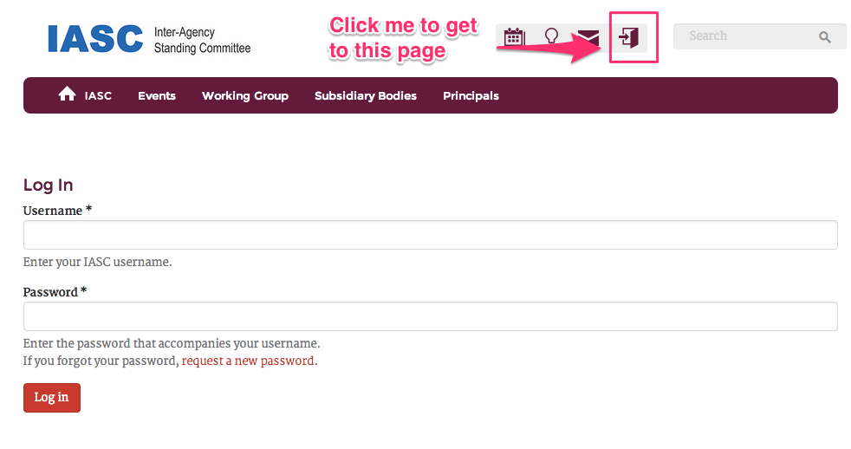
  - Enter your username and password
  - Hit “Login” and you’ll be redirected to the homepage of the site

The New IASC Site

Navigation
There are two versions of navigation on the site - the public facing version and the administrative version. In order to access the latter, a user must be logged in and have administrative level permissions.

Public Facing Version
The public facing version can be found in the bar that spans the top of the site, beneath the search:

This is the navigation that anyone who has not logged into the site can use in order to browse content relevant to the menu items listed. Additionally, certain menu items will have dropdowns that lead to specific areas on the site. The “home” icon will take the user back to the home URL of the site.

This menu is configurable and can be easily changed as your organization grows and shifts.

Updating The Public Facing Navigation
- Ensure that you’re logged into the site. (For instructions on how to login, see the section entitled “Browsing Content vs. Logging In”)
- Navigate to the following URL: http://iasc.com/admin/structure/menu/manage/main-menu/edit
- For new menu items, hit “Add link” and fill out the appropriate fields
- To edit existing menu items, hit the relevant “edit” button under the “Operations” column and edit appropriately
- Hit “Save” and verify that your changes have populated on the main-menu edit page
- Make sure to hit “Save” at the bottom of the main-menu edit page as well to confirm all of the changes you’ve made to the menu structure

Administrative Version
The administrative version of the navigation can only be seen by those users who are logged into the site with administrative level permissions. This version acts as both a navigational breadcrumb as well as a toolbar for the creation of content. When viewing the administrative version, a duplicate of the public facing navigation can be found in the header of the site (the blue part in this screen shot):

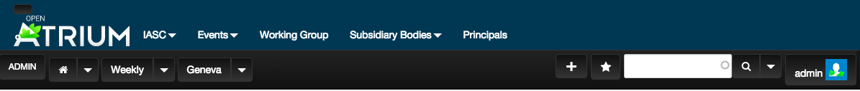

The administrative navigation follows the hierarchy of the site and simultaneously provides breadcrumbs to indicate where the user is within said site hierarchy. A user can navigate more deeply into the structure of the site by selecting the down arrow next to a menu item and clicking on one of the relevant Sub-Spaces or Sections. A user can also utilize these dropdowns to create new Spaces, Sub-Spaces, and Sections by clicking on the relevant “Create new Space/Sub-Space/Section” line item.

Content Types
There are four main content types on the new IASC site: documents, meetings, news, and contacts. The fields from the original site have been mapped to the fields on the new site below as a point of reference for content creators migrating from the legacy site. In addition, there are some brand new fields special to Open Atrium that are listed under the “New Open Atrium Fields” section.

Documents
The “Document” content type has four main variants: documents, products, agendas, or meeting notes. The variant you’re looking for can be selected from the “Document Type” field as seen here:

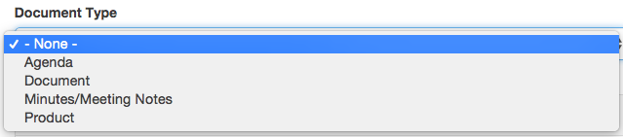
The following table details the fields common to all the “Document Types.” For information about fields specific each variant, scroll down to the “Document Variants” section directly below this table.

Legacy Field Name | Legacy Field | New Field
Title
Date or Published Date |  | 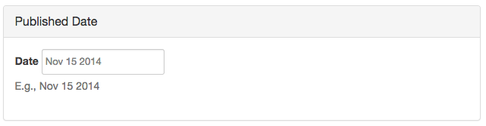
Description  (Products, |  | 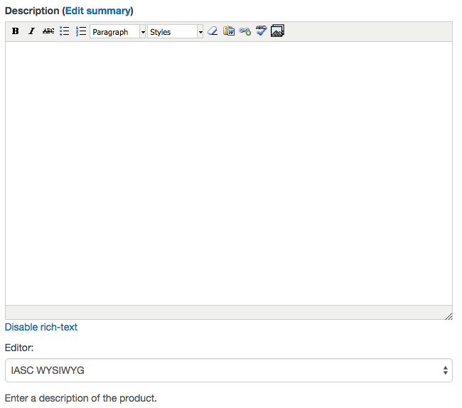
Attachments | 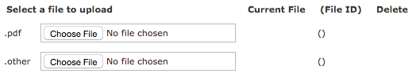 | 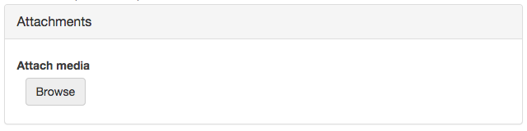
“Publish” |  | Taken care of through Spaces, Sub-Spaces, and Sections on OA.

Document Variants

Document
URL of Edit Node Screenshot

Legacy Field Name | Legacy Field | New Field
Document No.

Product
URL to Edit Node Screenshot

Legacy Field Name | Legacy Field | New Field
Category |  | 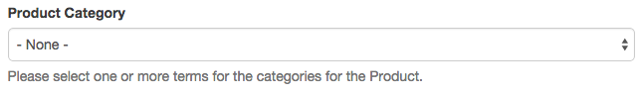
N/A | N/A - field allows the user to specific upload an image to attach to the product | 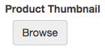

Agenda
URL to Edit Node Screenshot

(No specific fields to note)

Meeting Notes
URL to Edit Node Screenshot

(No specific fields to note)

Meetings
URL to Edit Node Screenshot

Legacy Field Name | Legacy Field | New Field
Title
Event Time |  | 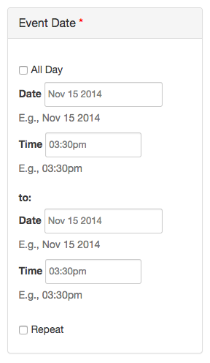
N/A | N/A - doesn’t exist on the legacy site, but allows for the user to easily indicate when a meeting should repeat | 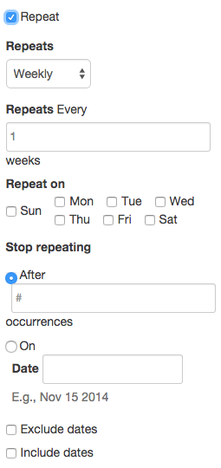
Zone |  | 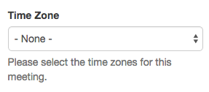
Info Public |  | 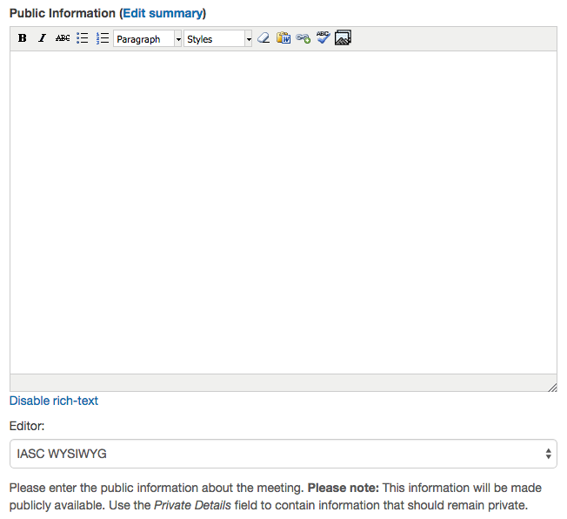
Info Private |  | 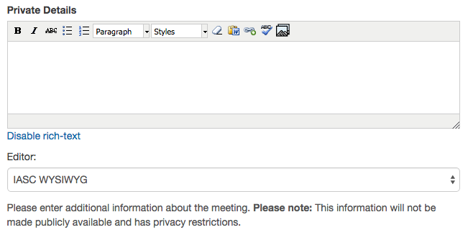
City
Venue
Room
Hosts
Contact |  | 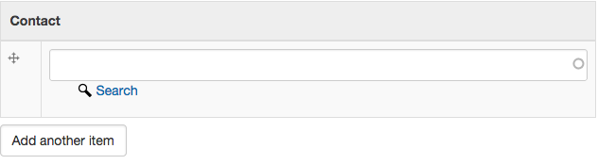
Agendas | 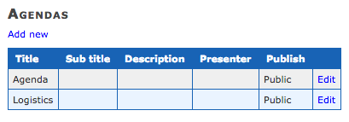 | 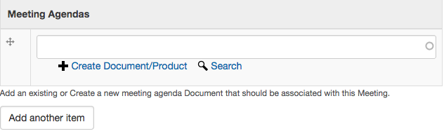
N/A | N/A - a way to easily attach meeting notes to a meeting | 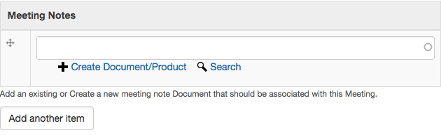
“Publish” |  | Taken care of through Spaces, Sub-Spaces, and Sections on OA.

News
URL to Edit Node Screenshot

Legacy Field Name | Legacy Field | New Field
Header
Date |  | 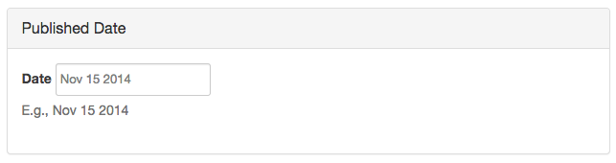
Intro |  | 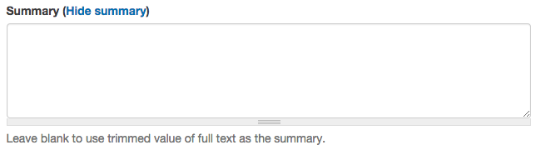
News Text |  | 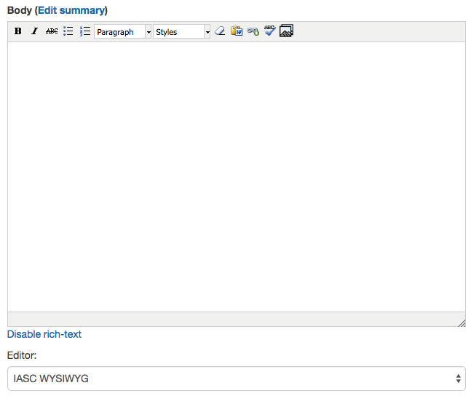
Intro Link |  | 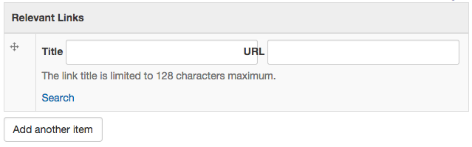
N/A | N/A - allows a user to attach relevant documents to a news item | 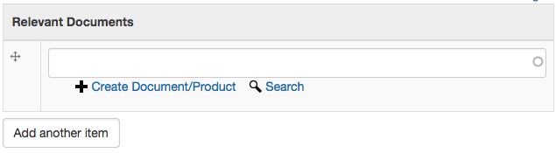
Contact |  | 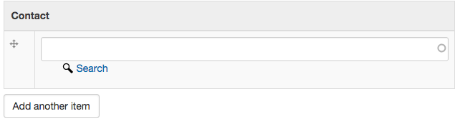
Front Page |  | 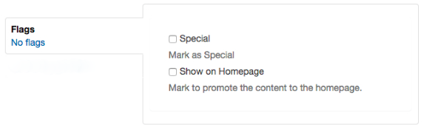
“Publish” |  | Taken care of through Spaces, Sub-Spaces, and Sections on OA.

Contacts
URL to Edit Node Screenshot

Legacy Field Name | Legacy Field | New Field
Title
First Name
Last Name
Image |  | 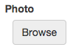
Organization
Organization Address |  | 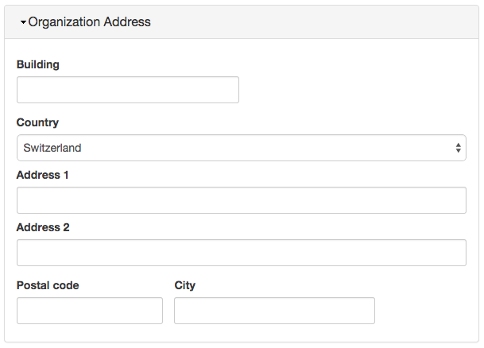
-- | N/A
-- | N/A
Position
Department
Branch
Homepage |  | 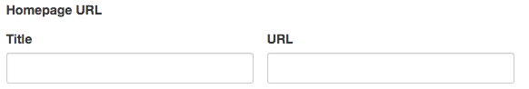
Description |  | 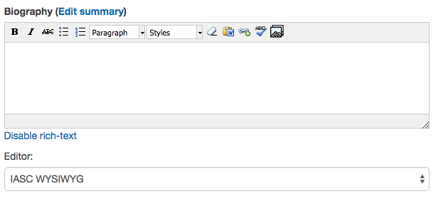
Membership of Bodies | 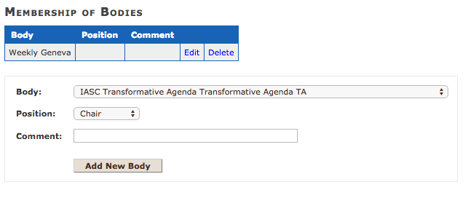 | 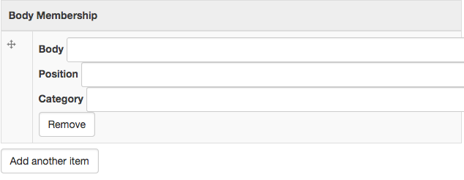
Phone |  | 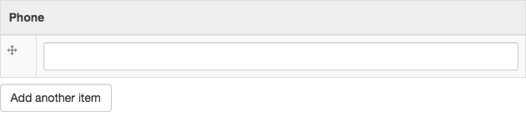
Mobile |  | 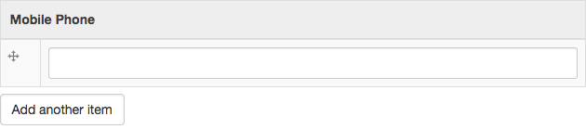
Fax
Email |  | 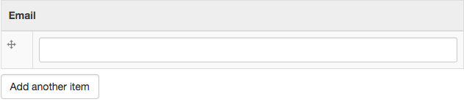
Address related fields | 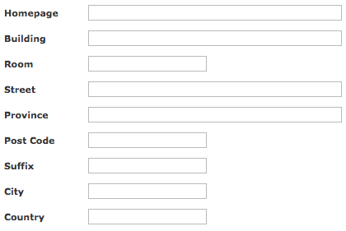 | 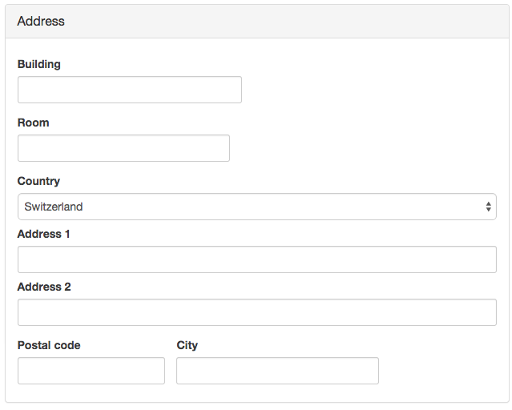

New Open Atrium Fields
The following fields do not map to the original IASC site, but is additional functionality included with the use of Open Atrium.

Field Name | Image | Description
Permalink | 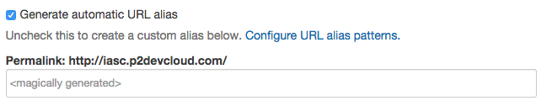 | If you so choose, you can override the automatic URL alias patterns and customize the link to any node of content using the “permalink” field. However, if you keep the checkbox selected, this will be auto generated for you.
Menu |  | If you’d like to create additional, hierarchical menus of content, you can utilize this field to create them by checking the “Provide a menu link” box and selecting the “link title” and “parent.”
Publishing Options | 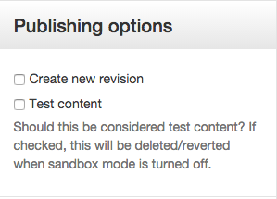 | - “Create new revision” - if you are editing a piece of content and would like to leave a note about what you’ve changed, you can do so here in the description field that pops up when you check the box.  - “Test content” - if you’ve enabled sandbox mode, this allows you to create fake content that can easily be mass deleted.
Authoring Information | 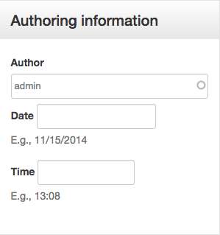 | These fields can be used to designate the author of the content (who created it) as well as the date and time it was created.
Content State Change Buttons |  | These buttons can be used to change the state of the content you’re creating.  - “Publish” will make your content available to all those who have permission to view it  - “Save as draft” allows you to continue editing your content without it becoming available to other users  - “Preview” allows you to view what the “published” version of your content will look like
Notifications | 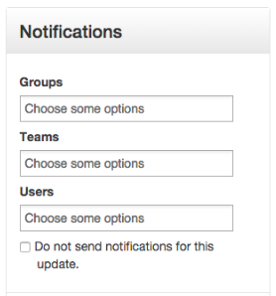 | Once users have individual accounts, these fields can be used to notify individual users or groups of users of changes to a piece of content.

Consuming Content

Search
The search bar can be found in the top right hand corner of the site
To use the search functionality:
- Type in the keyword(s) relevant to the content that you’re searching for
- Hit the “Enter” or “Return” button on your keyboard
- The results of your search will populate on a new page (results page)

On the results page, you will find a generic listing of items that may or may not match the specific item you were searching for. In order to easily filter through the results there are a listing of “facets” that can allow you to break down your results even further based on various categories.

The following facets are currently available to you on the new IASC site:

- Authoring Bodies
- Content Type
- Event Date
- Meeting Host(s)
- Product Category
- Document Type
- Published Date

Additional facets can be added or removed as the needs of your searchers and how they categorize their content change over time.

Creating and Managing Content
Please note that, in order to create, edit, and manage content, you will need to be logged into the site

Creating Content
- Navigate to the administrative toolbar by altering the relative path of the site to read /admin. Alternatively, you can click this URL: http://iasc.ch/admin
- Select the “+” button found on the administrative toolbar
- Select the type of content that you’d like to create (i.e. a document, an event, an announcement, or a contact)
- You will be redirected to the edit node of a new piece of that particular kind of content
- Fill in all relevant fields (Note that anything marked with an asterisk is a required field and will have to be filled out prior to being able to save the content)
- If you’re still editing the document and would like the content to remain private to only you and administrative level users, hit the “Save as Draft” button
- If you would like to see what your content is going to look like once it’s live and available to other users hit the “Preview” button
- Once you are ready to make your content available to other users, hit the “Publish” button

Uploading Attachments
For those content types with the ability to have attachments included, there will be an “Attachments” section on the edit form. In order to add an attachment, follow these steps:

- Navigate to the “Attachments” section on the edit form
- Hit the “Browse” button under “Attach Media”
- To add new attachments to a piece of content, hit “Choose File” and browse for the attachment through your local drive
- Once you’ve selected your desired attachment, hit “Upload,” wait for the upload bar to finish, and then hit “Next”
- You will be directed to a page that allows you customize the name, file title, and perhaps the alt text (used for screen readers) of the attachment
- Click “Save” to finalize that attachment
- Alternatively, if you would like to access an attachment that has been previously uploaded to the site, click the “Library” tab. From there, select the attachment you would like to add, and hit “Submit”
- Once the attachment has been added, you can choose to remove it by hitting “Remove” or edit it by hitting “Edit”

Ensuring Content Privacy and Permissions
Whether or not your content can be seen by the public, the Donors Group, or the IASC only group will be determined by where you choose to house your content on the site. This can be done one of two ways.

Method 1
You can navigate to the relevant Space → Sub-Space → Section and click the “+” while on that page and the content that you create there will populate within that Section and follow that Section’s permissions. For example, if I navigate to the “Principals” Space, I will see the “Meetings,” “Documents,” and “News” sections available to me to create content. These Sections are broken down as follows:

- No parentheses - content created here will be available to the public
- (Donors) - content created here will only be available to the Donor Group and above
- (IASC) - content created here will only be available to the IASC Only Group and above

Method 2
Alternatively, you can also hit the plus button anywhere on the site. If you choose to do that, scroll down to the “Access” label on the edit node and click it to expand your options. From there, you can select which Space the content should live in from “Your Groups.” Once you’ve selected the Space, you can choose the Section from the “Section” drop down. You can also use this method to move a piece of content from one Space to the other after it has been initially created.

Promoting Content
If you would like the content that you just created to also appear on the homepage of the site, appear as a featured product, or appear as a special announcement, you can do so by flagging that content on its edit node. There is a maximum of 10 items per queue at any given time. To promote your content, follow these steps:

- Find the “Flags” section on the edit node
- Select the Node Queue that you would like the content to show up in
- Hit the “Save” button

Node Queue
Once you have flagged a piece of content to be promoted, you can change the order of these items using Node Queues. In order to do this, follow these steps:

- Navigate to the Nodequeues by finding the Drupal Admin menu in the top left hand corner
- Hit the arrow next to “Structure” to expand it
- Select “Nodequeues” (Admin > Structure > Nodequeues)
- Edit the appropriate queue by selecting either “View,” “Edit,” or “Delete” underneath the “Operation” column
- To switch the order, select the “View” option and simply drag-and-drop the items to represent the order you desire
  - To drag-and-drop, click on the compass-looking icon and holding down your mouse while you drag an item to its desired location. Once you’ve reached that location, release your mouse
- Be sure to hit “Save” once you’ve finished making your edits

Creating and Managing Contacts

Creating a New Contact

- Ensure that you are logged into the site as an administrator
- Navigate to the administrative view of the site by altering the relative path of the site to read /admin. Alternatively, you can click this URL: http://iasc.ch/admin
- Find the Drupal “Admin” menu in the top lefthand corner of the site
- Select “Add Content”
- Select “Contact”
- Fill out the relevant fields (Note that anything marked with an asterisk is a required field and will have to be filled out prior to being able to save the content)
- Hit “Publish” to save your new contact

Managing Contacts
In order to quickly browse the contacts that you’ve already created, navigate to this URL: http://iasc.ch/admin/search-contacts. From there, you can do the following:

- Search for a particular contact either by their name, organization, or department
- Edit a contact by hitting the “Edit” button and alter any fields as necessary
- If you would like to delete a contact, hit the “Delete” button on the right hand side of the page

