IASC Login
On the new IASC website you will be prompted to login at several points throughout the site. These login prompts are displayed on the Meeting, Document, and Search results pages.
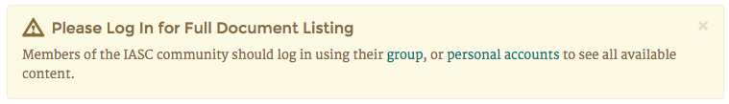
From this login prompt you may choose to login through your group account, or through your personal account once it is created.

If you do not yet have a personal account, click on the link group and then proceed to the instructions Group Login.

Group Login
- After clicking on the link “group” you be redirected to the group account login page.
- On this page, you should enter your Access code. This access code is the same as the password you would have entered on the old IASC website.
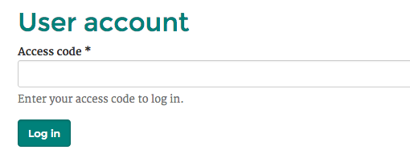

Group Login via the Login Page

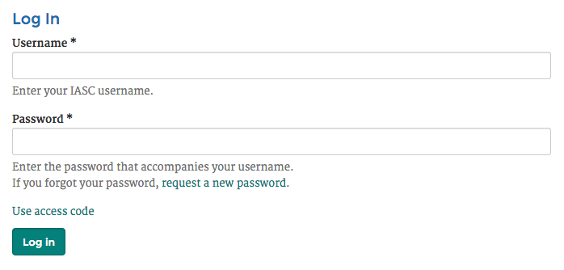

- Click on the link “Use access code” to get to the special group login screen where you will type in your Access code. This access code is the same as the password you would have entered on the old IASC website:

Group Access
- Once you are logged in, you will have access to private documents and meeting information according to your level of access.

Personal Accounts
By creating a personal account, you will be able to take advantage of additional features on the site, including participating in private discussions (if you have been invited to do so).
- Once you’ve logged in, click on the user icon in the top right of the page.
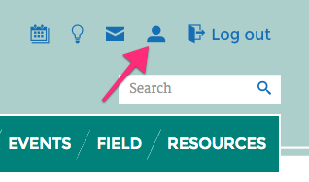
You will be redirected to a summary which is relevant to your current account.
- Locate and click on the button “Create individual account”.
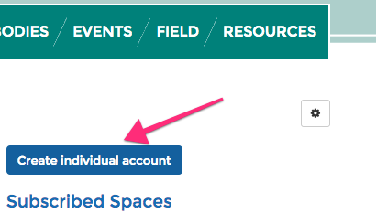
You will be redirected to a form to create a personal account.
- Complete each of the fields for:
  - Username (we recommend using your email username)
  - E-mail address
  - Password (twice)
  - Display Name (your full name which will be displayed to other site users)
- To complete the registration process click the button “Create new account”.
- Once you have completed the registration process, you will be logged into the account with your new, personal account. From now on you may log in using the link “personal accounts” from the login reminder.

Personal Login
- To login using your personal account, locate and click on the button in the top right labeled “Log in”.
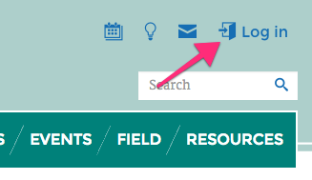
You will be redirected to a login form.
- On this login form, enter your username (not your Display Name), as well as the password you set previously.
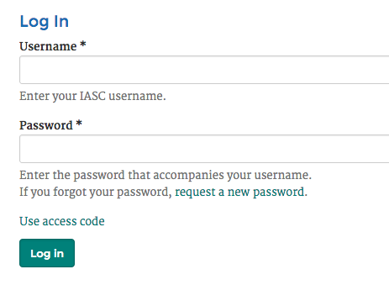
- Once you have entered your username and password, click the button “Log in”. You will be redirected to the page you were on when you started the login process.

