Inter-Agency Standing Committee Principals Meeting
Friday 11 December 2015, Geneva, Switzerland
Hosted by ICVA (International Council of Voluntary Agencies)
Logistics information for Participants

On Friday 11 December 2015, the Inter-Agency Standing Committee (IASC) Principals will meet in Geneva, Switzerland. The meeting will be hosted by ICVA (International Council of Voluntary Agencies) and will take place at Château de Penthes – Le Grenier room (above the restaurant). The meeting will begin at 09h00 and end at 17h00.
Location of Château de Penthes: 18, Chemin de l’Impératrice – 1292 Pregny-Chambésy (+41 (0) 22 734 47 43), up the hill from the Palais and across the street from the US Mission.
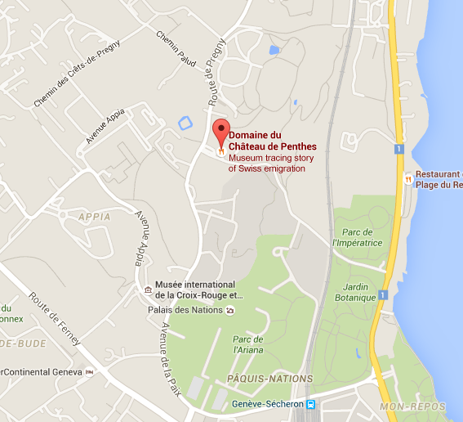
Access to the Château de Penthes:
From Cornavin (Geneva railway station):
-TPG bus V. dir. La Becassière- or Z – dir. Bois-Chatton – stop at Penthes.
- TPG Tram 15 – dir. Nations – stop at Nations. Then TPG bus V – dir. La Becassière- or Z – dir. Bois-Chatton – stop at Penthes.
From Geneva airport:
-TPG bus 28 – dir. Jardin Botanique – stop at Appia. Then TPG bus V – dir. La Becassière- or Z – dir. Bois-Chatton – stop at Penthes.
For taxis: +41 (0) 22 3 202 202 or + 41 (0) 22 331 41 33. Reservation at least 30 minutes in advance is advised.
Free parking adjacent to the venue.
Accommodation
Participants are requested to make their own arrangements as soon as possible. The 55th International Horse Show is taking place at the same time in Geneva. Geneva offers a large variety of hotels. Please find attached the list of hotels in Geneva and do not hesitate to contact Landy Razanajato (landy.razanajato@icvanetwork.org) if you have any question.
Meals
Croissants and coffee will be available from 8.30 onwards.
A light lunch buffet will be served from 13:15onwards.
Coffee and tea will be available throughout the meeting.

Dinner
Please note that the IASC Principals dinner will take place on 10 December starting at 20h00 at Vieux-Bois, Ecole Hôtelière Genève, 12, +41 22 919 24 26 Avenue de la Paix, CH-1202 Genève,
The restaurant is located just in front of the Pregny Gate of the UNOG, on the right hand side.

http://www.restaurant-vieux-bois.ch/site/fr/
Internet
A free Wi-Fi connection will be available in the meeting room.
Security in Geneva
Geneva is a relatively safe city. However, there has been an increase in pickpockets and theft, targeting mostly tourists and expats, in recent past years. Please do not leave your bags unattended and be mindful of your surroundings on public transportation and in restaurants/bars. Gare Cornavin (the main train station), Pâquis, Eaux Vives, and the lake area have the highest number of pickpocket and theft incidents in the city.
Emergency Contact Numbers
The following are the emergency numbers in Geneva:
- Police: 117
- Ambulance: 144
- Fire Brigade: 118
Further information and assistance
For further information regarding the arrangements for the IASC Principals meeting at the Château de Penthes, please do not hesitate to contact:
Landy Razanajato (landy.razanajato@icvanetwork.org / +41 (0) 22 950 96 04).

IASC Secretariat (Geneva)
Mirlinda Pasoma - +41 22 917 1438
Email: iasccorrespondence@un.org

IASC Secretariat (New York)
Melanie Lachica - +1 212 963 5582
Email: iasccorrespondence@un.org

