Inter-Agency Standing Committee Principals Meeting
Tuesday 6 December 2016, Geneva, Switzerland
Co-hosted by UNICEF and UNHCR
Logistics information for Participants
On Tuesday 6 December 2016, the Inter-Agency Standing Committee (IASC) Principals will meet in Geneva, Switzerland. The meeting will be co-hosted by UNICEF and will take place at La Maison de la Paix Meeting Centre, Petal 5, Room C1 (Ground Floor). The meeting will begin at 09h00 and end at 17h00.
Location of La Maison de la Paix: Chemin Eugène-Rigot 2, 1202 Genève (+41 (0) 22 908 57 00).
http://graduateinstitute.ch/home/venues/maison-de-la-paix-meeting-centre.html

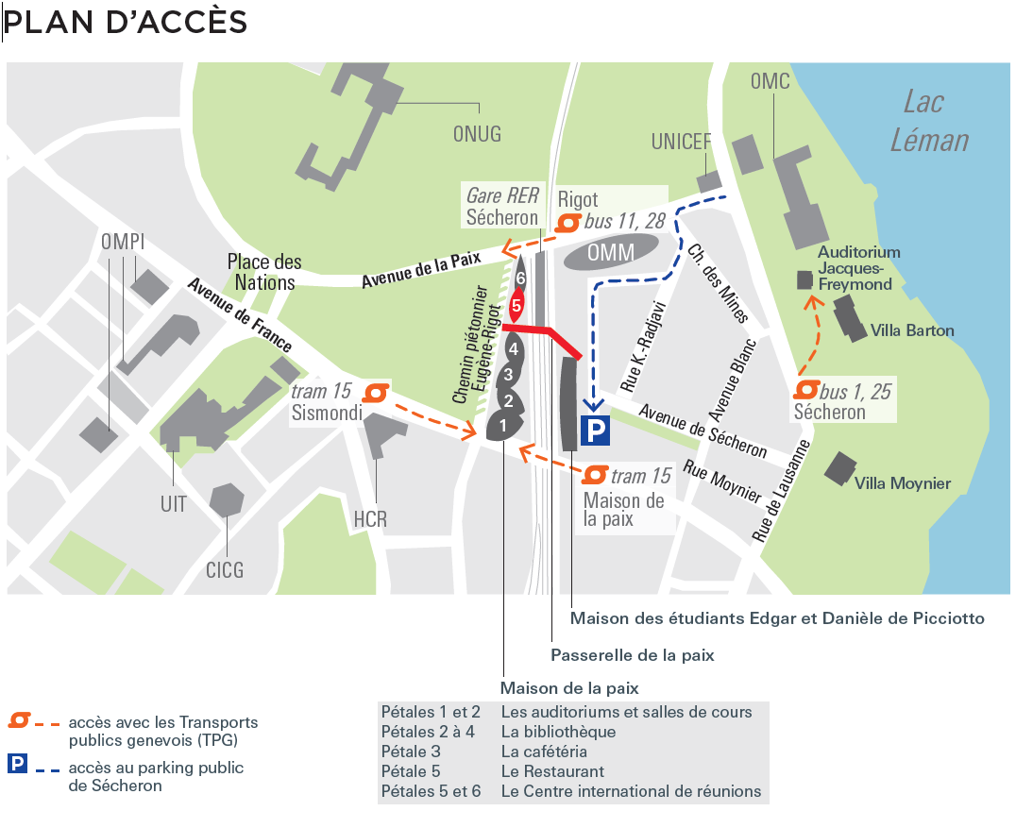
Access to La Maison de la Paix Meeting Centre, Petal 5, from Avenue de la Paix across from the lower entrance gate to Palais des Nations.

From Cornavin (Geneva railway station):
- TPG Tram 15 – dir. Nations – stop at Maison de la Paix
- TPG Buses 1 or 25 – dir. Jardin Botanique – stop at Jardin Botanique.

From Geneva airport:
-TPG Bus 28 – dir. Jardin Botanique – stop at Rigot

For taxis: +41 (0) 22 3 202 202 or + 41 (0) 22 331 41 33. Reservation at least 30 minutes in advance is advised.

The Sécheron car park is 3 minutes away on foot (please refer to map).
Security
For this event, no visitor’s badge will be required to enter the building. However, participants are required to present themselves at the reception.
Accommodation
Participants are requested to make their own arrangements.
Meals
Croissants and coffee/tea will be available from 8.30 onwards as well as during the coffee/tea breaks.
Lunch will be served at 12:00 pm at the restaurant on roof of Maison de la Paix (Petal 5, 8th floor), which offers a 360-degree view of International Geneva, Lake Geneva, the city and the mountains.
Water will be available throughout the meeting.

Please let us know if you have any food restrictions by 28 November 2016 at cmorton@unicef.org

Dinner
Please note that the IASC Principals dinner (Principals only) will take place on 5 December starting at 19h30 at Restaurant Woods, Intercontinental Geneva, 7-9 Chemin du Petit Saconnex, Geneve, CH- 1209, +41 22 919 3333.

The restaurant is located in the Intercontinental Hotel.

Please confirm your attendance as well as any food restrictions that you might have by Monday, 28th November 2016 at divecha@unhcr.org

www.intercontinental.com/geneva
Internet
A free Wi-Fi connection will be available in the meeting room.
Security in Geneva
Geneva is a relatively safe city. However, there has been an increase in pickpockets and theft, targeting mostly tourists and expats, in recent past years. Please do not leave your bags unattended and be mindful of your surroundings on public transportation and in restaurants/bars. Gare Cornavin (the main train station), Pâquis, Eaux Vives, and the lake area have the highest number of pickpocket and theft incidents in the city.
Emergency Contact Numbers
The following are the emergency numbers in Geneva:
- Police: 117
- Ambulance: 144
- Fire Brigade: 118
Further information and assistance
For further information regarding the arrangements for the IASC Principals meeting at the Maison de la Paix, please do not hesitate to contact:
Claire Morton (E-mail cmorton@unicef.org/ +41 (0) 22 909 5653).

IASC secretariat contacts:

IASC Secretariat (Geneva)
Mirlinda Pasoma - +41 22 917 1438
Email: iasccorrespondence@un.org

IASC Secretariat (New York)
Melanie Lachica - +1 212 963 5582
Email: iasccorrespondence@un.org

