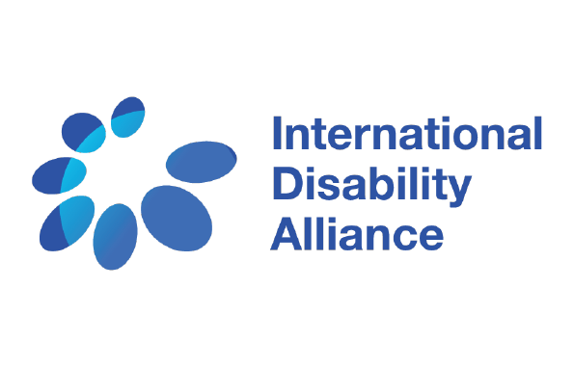
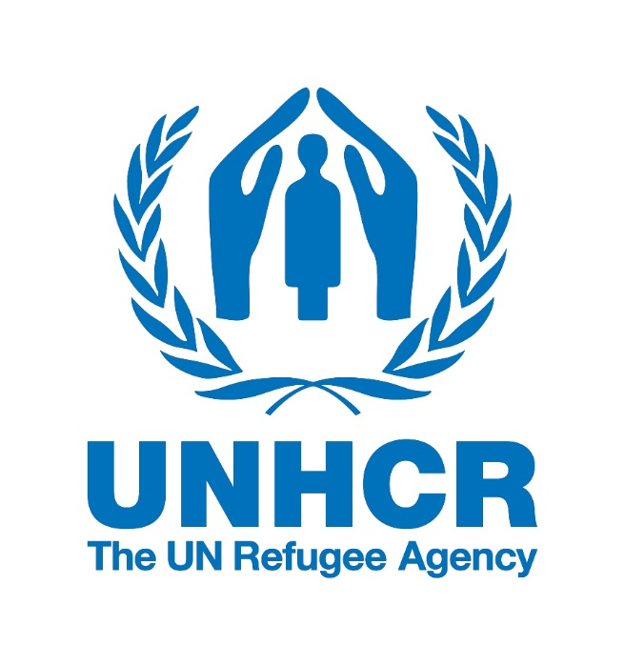
Consultation:
The New York Declaration for Refugees and Migrants and the Rights of Persons with Disabilities
Co-hosted by the International Disability Alliance (IDA) and UNHCR

October 3, 2017
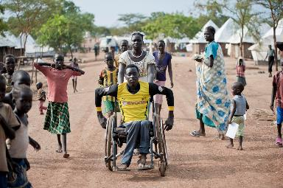
3.30 - 6.00 pm
Palais de Nations, Geneva
Room IX (3rd floor, A Building)
The International Disability Alliance (IDA) and UNHCR would like to invite you to a consultation to receive more information on this process from UNHCR, and to discuss how we can use this opportunity to promote the rights of persons with disabilities in refugee response.
The New York Declaration for Refugees and Migrants was adopted unanimously by the General Assembly in 2016 to strengthen global response to people on the move. The New York Declaration contains a Comprehensive Refugee Response Framework, which is currently being rolled out in a number of countries. The Declaration also sets in motion a process for the development of a global compact on refugees, to be proposed to the General Assembly in 2018.
3.30 pm – 4.30 pm: Online/in-person briefing of the Comprehensive Refugee Response Framework and Global Compact for Refugees by UNHCR team
Mr. Mamadou Dian Balde, Deputy Director of Comprehensive Responses, UNHCR
4.30 pm – 4.45 pm: Break
4.45 pm – 6.00 pm: Discussion on input to the thematic discussions and a written contribution to the global compact on refugees, mapping of key recommendations
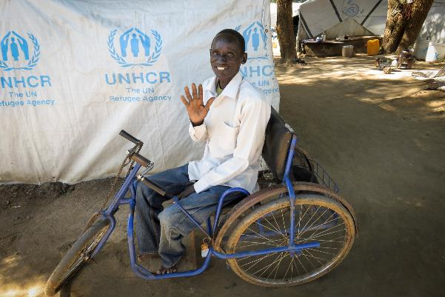

Captioning and International Sign will be available. Remote (online) participation will be possible, connection details on: https://unhcr.webex.com/unhcr/j.php?MTID=m72f858498b46bd2fe885b081fb4f8033

Practical information on accessibility in Geneva and the Palais map is available on the IASC TT webpage at https://interagencystandingcommittee.org/iasc-task-team-inclusion-persons-disabilities-humanitarian-action/news/practical-info-re

