Gender Analysis in WASH
  - Recovery Assistance to Earthquake Affected Communities of Sindhupalchok
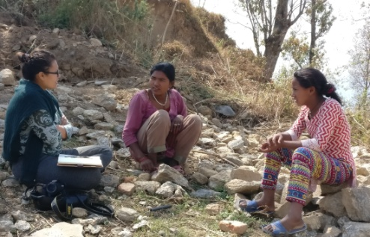
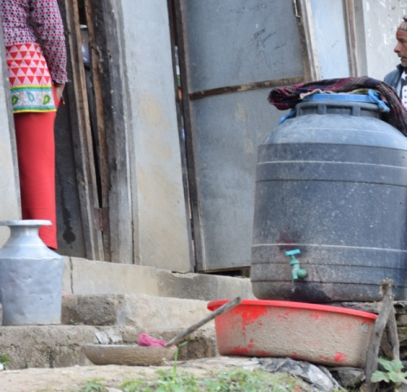

Key Informant Interview in Melamchi Kot
Water storage tank in community
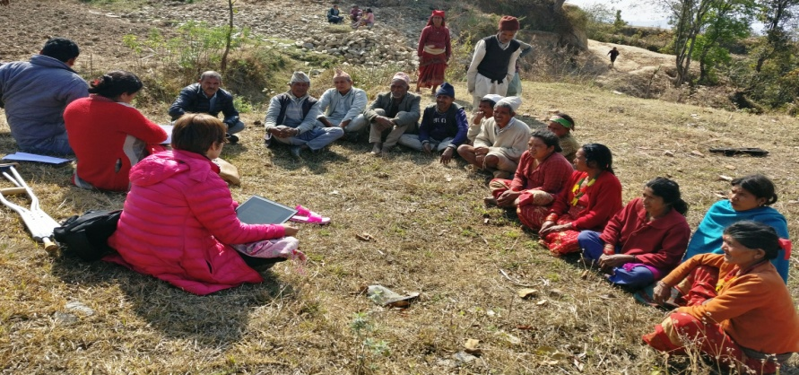

Focus Group Discussion (FGD) Melamchi Kot
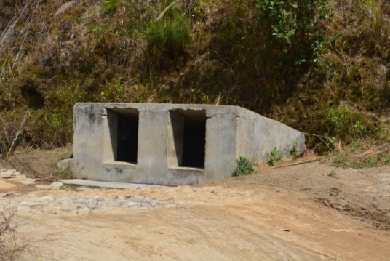
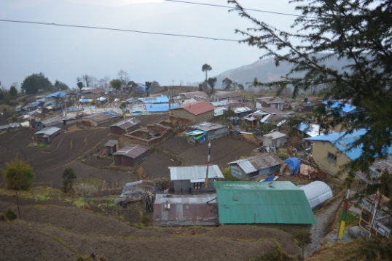

Water source (Well) in Melamchi, Kot
Community settlement in Kuil Sermathang, Sindhupalchowk

Gender and Protection team,

OXFAM Humanitarian Response Programme

Lalitpur, Nepal

TABLE OF CONTENT
Contents | Page number
Background | 4
1.1 Gender Relation in Sindhupalchowk Prior to the Earthquake | 4
The Gendered impact of the earthquake | 5
Humanitarian Assistance | 7
Purpose | 8
Methodology | 9
3.1 Limitation
Findings | 10
4.1 Respondents’ social demographic characteristics | 10
4.2 Gender Differentiated Impact Analysis | 12
4.2.1 Gender relation | 12
Time Povery | 12
Gender Role division: | 12
Girls education | 14
4.2.2 Participation and | 15
4.2.3 Access and control over the resources | 15
4.3 Gendered Differentiated Vulnerability Analysis | 15
4.3.1 Low pay on the basis of gender | 16
4.3.2 Social and power analysis | 16
4.3.3 Social discrimination ( caste based discrimination ) | 17
4.3.4 Protection and GBV | 17
4.4 Gendered Differential Needs and access to service | 18
4.4.1 Gender and reconstruction: Shelter and water | 18
4.4.2 Organizations working in WASH | 18
4.4.3 Access to information and technology | 19
4.4.4 Access to water: distance | 19
4.4.5 Health and sanitation | 19
4.4.6 Latrine and bathing facilities | 20
4.4.7 Menstruation Hygiene | 20
4.5 Gendered Differentiated Coping Capacities and Strategies | 21
Recommendation | 22
5.1 Practical gender need | 22
5.1.1 Water, sanitation and hygiene | 22
5.1.2 Livelihood | 23
5.1.3 Shelter Construction | 23
5.1.4 Protection and GBV | 23
5.2 Strategic gender interest | 24
5.2.1 Women’s meaningful participation in humanitarian intervention | 24
5.2.2 Women’s Leadership | 24
5.2.3 Advocacy and Campaign | 24
5.2.4 Men engagement | 25
Annex
Focus Group Discussion (FGD) | 26
Key Informant Interview (KII) | 28
Table I: Sex and Age disaggregated data prior earthquake | 5
Table II: Respondents’’ Social demographic characteristic | 11
Table III: 24 hours Rapid Tool Analysis | 13

ABBREVATION
EFSVL | Emergency Food Security and Vulnerable Livelihoods
FCHV | Female Community Health Volunteer
FDGs | Focus Group Discussions
GBV | Gender Based Violence
HH | House Hold
IDPs | Internally Displaced Persons
KII | Key Informant Interview
SGBV | Sexual and Gender Based Violence
TLC | Temporary Livelihood Center
UNFPA | United Nations Population Fund
WASH | Water, Sanitation and Hygiene

- BACKGROUND

A magnitude 7.8 earthquake struck Nepal on 25 April 2015. This was followed by several powerful aftershocks, including a major one (7.3 magnitude) on 12 May, 2015. A total of 8,855 people were confirmed dead and a further 22,309 suffered injuries as a result of the earthquakes. Out of Nepal’s 75 districts, 14 districts which were home to 5.4 million Nepalese people were among the most affected. Sindhupalchok district was one of the most severely affected districts in Nepal with total number 3,570 deaths (40 per cent of the total death toll in Nepal; 1,507 males and 2,063 females) and 1,435 cases of injury and 8 are still missing4. The earthquakes have heightened pre-existing vulnerabilities and are expected to significantly stunt the development progress of the district. Following the 25 April earthquake, the immediate response was primarily focused on search and rescue operations.
The damage to infrastructure was quite severe with destruction of 61,170 individual houses6, 75 out of 80 health posts and 547 schools. Essential public infrastructure including drinking water sources were severely affected with 41 out of the 43 district headquarters buildings damaged and 25 out of 29 security posts completely destroyed. In the district, a total of 83421 Households were affected, 89884 relief cards were distributed to the people (in preliminary 7 phase). It was estimated that agriculture loss was about 3 billion Nepali Rupees; and 90% food grains lost.
Sindhupalchowk District is one of the 75 districts of Nepal, with an area of 2,542 Km. The district’s capital and coordination centre is Chautara. It is located in two agro ecological belts of Nepal - hill and mountain - and it is part of the “Central mountain sub-Region”. The assessment team could visit only the hill agro-ecological area where livelihoods system is characterized by agriculture production, livestock rearing and daily labor (mainly unskilled and farm related). According to leaders and communities in the visited VDCs the key determinants of wealth are: access to cultivable land, livestock possession, and formal employment in private and public sectors and business opportunities.
Almost 100% of the households are involved in agricultural activities, with the poorest socio- economic groups being seasonally employed by middle and better off groups. Remittance is an income opportunities for all groups generated by temporary or seasonal migration in Kathmandu, Qatar, Dubai, India.
The illiteracy rates in Sindhupalchowk are higher than the national level. Boys are more likely to be educated than girls across all forms of education from primary to post-graduate. Over 59% of the Sindhupalchowk population is Hindu while 38% is Buddhist. There are five major caste groups in the district: Tamang, Chhetree, Newar, Brahmin and Dalits.
1.1 Gender Relation in Sindhupalchowk Prior to the Earthquake
Gender relations between men, women, girls’ and boys’ in Nepal vary depending on a variety of interrelated factors including: context, caste, religion, education level, socio-economic class and urban/rural divide.
- The population of Sindupalchowk was 287,798 according to the 2011 Census, of whom 48 percent were male and 52 percent female. The population consisted of 66,635 households; with an average household size of 4.32 people (almost 26% of households had more than six members).
- Total 24 percent of households are female-headed, slightly lower than the national average of 25.73% and much lower than Gorkha where it is 37.20%. Male-headed households in which the head of the household is aged 50-70+ was 24% of all households).
- In total 4.4 percent of the female population in Sindupalchowk was comprised of widows, divorced or separated women, compared to the national average of 5%. There is discrimination against single women in Nepal, especially those who have been widowed.
- Child marriage is prevalent. Among marriages recorded in Sindhupalchowk in the 2011 census, the majority involved at least one spouse aged 19 or under (See Table). This is a particular area of concern, because child marriages are likely to increase post-crisis as a form of protection and as a means to ease family economic burdens. Almost 20% of girls are married by the age of 14 years. While 55% of all married females (45000) were married between age of 15 and 19; which is still almost double the 27000 boys married at that age.
- Only 12% of households reported that female members owned fixed assets (house land or both), much lower than the national average of 25.73%. Thus, 88% of the female population does not own any fixed asset, compared to national average of 79.5%.
- The 2011 census identified 2.3% of the Sindupalchowk population as having a disability. However, the census uses self-identified disability. Due to a lack of knowledge of what qualifies as a disability and stigma around certain disabilities, these figures should be assumed to be much higher. On average, 15% of any population has a disability, and females have a higher rate of disability than males. The global average of 15% varies from context to context according to a number of variants.
- Over 40% of the households in sampled VDCs had piped water as their most common source of drinking water before the earthquake. Whereas shared household tap stand and public tap stands were the second and third prevalent sources of drinking water. After the earthquake most of the water source has damaged or dried out as the result women workload had increased sustains.

Table I: Sex and Age Disaggregated Data prior earthquake:
Sex | Male |  |  |  | Female |  |  |  | Total
Age group | 0-4 | 5-19 | 20-59 | 60+ | 0-4 | 5-19 | 20-59 | 60+
No | 11,819 | 50,517 | 60,087 | 15,928 | 11,705 | 52,494 | 69058 | 16190 | 287,798
% by sex | 4.1% | 17.5% | 20.9% | 5.5% | 4.0% | 18.3% | 24.07% | 5.6%
Source: National Population and Housing Census 2011

  - The Gendered impact of the earthquake

Sindhupalchok district was one of the most severely affected districts in Nepal with total number 3,570 deaths (40 per cent of the total death toll in Nepal; 1,507 males and 2,063 females) and 1,435 cases of injury and 8 are still missing. The district has most number of deaths and injuries. Many villagers have had to be rehabilitated in other areas as landslides threaten to bury their whole village. Landslides are also complicating relief operations. 100% of houses destroyed, 3440 human casualties, and all 557 government schools destroyed. Sindhupalchwok is the most damaged district than 13 others earthquake affect districts, where 40% of people died, and about 100 % of buildings in Sindhupalchowk district were damaged due to the devastating earthquake which struck Nepal on April 25. Hence, the physical damaged is directly linkages with economical loss of the nation and the Nepalese economy.
Of the estimated 288,000 people in the district, 99 per cent were affected by the earthquake.
A downgrade in the standard of the latrine used has been observed across the district, with an upward trend in the use of simple pit latrines post earthquake, where those whose pour flush/septic tank/ ceramic pan latrines were damaged resorted to making simple pit latrines. Out of the total 43% of the sampled households reported that they were using the bush in the period immediately after the earthquake. While the numbers of people without latrines in the three other sampled VDCs, it should be noted that efforts to restore the pre earthquake latrine coverage should still be prioritized while awareness about ODF is still relatively high.
Post earthquake households reporting piped water into dwelling has decreased by up to 19%, pointing to damages in the water supply system in those VDCs. It was interesting to note however, that while the number of households reporting piped water into dwelling as source of drinking water after earthquake has decreased, there was no reported increase in the number of people collecting drinking water from unprotected springs in the same areas, pointing to secondary and tertiary sources of drinking water households have been able to resort to, including public and shared tap stands. Average distance from household to water source was reportedly 30 minutes across all the four VDCs, and the entire women respondent reported that they were using buckets, jerry cans and traditional pots for water storage. The common practice across all the VDCs was storing drinking water in traditional
According to the Protection Thematic Report18 (30 July 2015), female representation was lacking in relief coordination and decision-making committees at the community and site level. Widespread damage to WASH infrastructure and displacement of communities has resulted in a lack of adequate segregated sanitation facilities for men, women, and third-gender, increasing the risk of gender-based violence, particularly in spontaneous settlement sites.
According to Displacement Tracking Matrix Round 511 (published on 25 November 2015) out of the nearly 40,706 people in 140 displacement sites, 20,690 were female (51%) , 20,016 male and 5,572 were children under 5 years old. The most common type of security incidents reported was by far alcohol/drug related (74%), followed by theft (10%) and friction/dispute (6%) within the community or household. In 85% of sites assessed, people knew who (or where) to report (or seek assistance) when they or their family face any abuse or exploitation in this area. In 83% of the sites assessed, there were either no or inadequate lighting available in communal areas such as around WASH facilities and public spaces. In 79% of the sites assessed, there were no gender segregated latrines. Majority of latrines/bathrooms have no lighting (85%), and more than half had no lock from inside (43%). 86% of sites did not have designated safe / social places for women.
The UN Women perception survey findings showed that 52% of women respondents felt there was an increase in tensions and risk of violence or harassment since the earthquake. The women reported that the increased tension and violence was mainly perpetrated by community and family members, closely followed by strangers. 53% of women respondents reported that access or engagement with local or government or humanitarian agencies has diminished since the earthquake, mainly due to lack of physical access, stakeholders not listening, or women feeling too traumatized or a lack of energy to engage. Overall women respondents reported an increase in the care work time use burden with 69% of women reporting an increase in time spent on child and elderly care, 51% reported an increase in time spent on fetching water, 63% of women reported an increase in time spent on cooking and cleaning. On the other hand, 68% of women reported a decrease in time spent on paid work and 72% of women reported a decrease in time spent sleeping and resting.
August and September 2015, the Common Feedback Project partnered with UNFPA and UN Women to carry out targeted perception surveys with a total of 32 women in the UNFPA supported Reproductive Health Camp in Dolakha district and 300 women in three UN Women supported Multi-Purpose Women’s Centres in Kavre, Sindhupalchowk and Nuwakot during the distribution of radio sets to elderly women, female heads of households, Dalit women and women with disabilities.
69% of women reported an increase in time spent on child and elderly care.
51% of women reported an increase in time spent on fetching water.
63% of women reported an increase in time spent on cooking and cleaning.
68% of women reported a decrease in time spent on paid work.
72% of women reported a decrease in time spent sleeping and resting.
48% of women responded they have not received any support in staying safe following the earthquake.
23% of women responded that they have not been satisfied with health services.
48% of women responded that either has not been able to access services or information specific to their needs.
1.3 Humanitarian Assistance
Following the 25 April earthquake, the immediate response was primarily focused on search and rescue operations in Sindhupalchowk. A total of 2,563 security forces were deployed and 377 injured people were rescued. With active support of the district authorities, about 200 humanitarian organizations were immediately mobilized to provide lifesaving assistance including shelter, food, health, water, sanitation and hygiene (WASH) and protection to women, girls, boys and men affected by the disaster. The most vulnerable groups (female headed households/single women, pregnant women, lactating mothers, adolescent girls, senior citizens, and persons with disabilities) were provided with dignity kits and other essential support for their health care, nutrition, psycho-social support, and referrals through women safe houses, women centers, and multi-purpose women’s centers.
In the aftermath of the 2015 earthquakes, more than 50 organizations provided services to the vulnerable groups through protection cluster in close coordination with District Disaster Relief Committee under the leadership of Women and Children office. More than 3000 children and 20,000 women in vulnerable situation received various services- dignity kits, radios, solar lamps, psychosocial counseling, livelihood support etc. in that period 9 Female Friendly Spaces, 1 Multipurpose Women Center (MPWC), 79 Child friendly spaces, 3 counter-trafficking posts, 1 information center were set up to provide such services. 1,700 children were supported with the cash value of Rs. 5000.00 from I/NGOs side and 884 children received Rs. 4,000.00 cash support from District child Welfare Board. Similarly, 7,776 vulnerable women (including pregnant, lactating mothers, single women, older women, women with disabilities) were provided with dignity kits by the UN and other international and local organizations in coordination with the WCO.
7247 latrines were built/materials distributed.131 bathing facilities constructed/repaired and maintained in seven working districts under humanitarian response.
OXFAM humanitarian response programme in Nepal organized awareness raising activities against social taboos related to menstruation to stop treating women/girls as untouables during menstruation, to encourage to allow them to go to school, let them sleep in the safe shelter and eat nutritious food like other family members. Out of total beneficiaries10 women received 3 days mason training for individual household latrine and got opportunity to work as well in the construction work where they got equal wages as men masons.
During hygiene promotion campaign as most of the care works are supposed to be done by women, men were also engaged in hygiene promotion campaigns and raised awareness on unpaid care work.
In total 54365 hygiene kits were distributed in Sindhupalchow, Nuwakot, Dhading, Gorkha and Kathmandu valley the hygiene kit consisted of sanitary pad, undergarment, soup and other requirements. Distributions ensured separate queue for male, female, senior citizens and people living with disability. Total 29 female friendly latrines and 28 Safe bathing spaces was constructed in Sindhupalchow, Nuwakot, Dhading, Gorkha and Kathmandu with an area for the disposal of used pads, lockable doors, water for cleaning and hand washing points. Set up a mechanism to keep storage of sanitary pad/napkin so that girls have access to sanitary pad/napkins in urgency.
Teachers (mostly female and health teacher) were selected as a focal person of the school to reach out for sanitary pads/napkins. There are sex segregated latrines and disability friendly latrines as well. 72 FCHVs (female community health volunteers) were trained for menstrual hygiene management. Women with young child or those who were breast feeding were provided especial facilities such as; breast feeding time, an hour early leaves, and provision of keeping child minder. Safe shelter with solar light and lock was provided for adolescent girls and women. Basic level of protection training under humanitarian response was provided to all gender officer and technical leads.
- PURPOSE

The overall purpose of the gender analysis was to identify the impact, need and coping strategies of the earthquake affected population for Wash in Sindhupalchowk. Women, men, girls and boys have distinctively different need and issues during the humanitarian response. In the disaster women and girls are the most vulnerable and understanding this fact and their special capacity to contribute to community resilience and to recovery and development this analysis has been done. This analysis had identified key issues contributing to gender inequalities; gendered power relations social taboos and discrimination, women’s participation in planning and decision making, control and access to resources, subordination and exclusion in society, particularly when overlaid across other areas of marginalization due to class, ethnicity, caste, status, sexuality, etc In line with CIDA’s Policy on Gender Equality. On the basis of the recommendation generated from this analysis WASH sector will explicitly and systematically integrate gender-equality considerations (activities, outputs, results) at all stages of the Project, including budgetary provisions where possible.
Similarly, the purpose of this analysis was also to provide adequacy of the humanitarian response, and recommendations for an improved response.
OXFAM describes gender analysis as:
“The variety of methods used to understand the relationships between men and women, their access to resources, their activities, and the constraints they face relative to each other. Gender analysis provides information that recognizes that gender, and its relationship with race, ethnicity, culture, class, age, and/or other status, is important in understanding the different patterns of involvement, behaviour and activities that women and men have in economic, social and legal structures.” Oxfam’s policy positions Mainstreaming gender equality: basing interventions on gendered analysis of the causes and impacts of crises, the practical needs of women, men, girls and boys, and designing programmes to meet those different needs - Humanitarian actors should carry out a rigorous and context-specific gender analysis of the populations they set out to support. These should be integrated into the humanitarian needs assessments and sector assessments.
The particular purpose and outcome of this gender analysis included:
- Identifying the differing gendered vulnerabilities, needs, roles, capacities and coping mechanisms of community people in dealing with the WASH related issues post earthquake.
- Identifying the situation of women and men pre and post earthquake and change in their gender role.

- METHODOLOGY

To explore gendered dimensions of the impacts and consequences of the earthquake gender analysis was carried out. The study predominantly focused on the gendered differentiated impact of earthquake by addressing key elements of the needs, experiences, roles and capabilities of men, women, boys and girls post earthquake.
The gender analysis used quantitative and qualitative methodology of data collection technique. Both primary and secondary source of information was used to gather comprehensive information to run the gender analysis.
The primary data was collected through Focus Group Discussion (FGD)/ community consultation and Key Informant Interview (KII) in one of the municipalities and 2 VDCs. A rapid care analysis tool was also used to assess the unpaid care work and changes in gender role post earthquake.
Total 5 FGD and 6 KII were conducted with different communities and ethnic groups. FGD was conducted with the mixed group and 5 KII was conducted with 3 women, 1 adolescent girl and 1man from different communities.
Purposive sampling method was used to draw a sample from the Municipality and VDCs where OXFAM have recently completed water system survey to understand the gender need and issue of the community people. The Project will especially target vulnerable groups, including women, ethnic minorities and disabled people, who are typically excluded from local development processes, and unable to secure equitable access to WASH services. Thus, the sample population for the study were such groups from Melamchi municipality, Hagam and Kiul VDCs.

Purposive sampling is a non-probability sampling method and it occurs when “elements selected for the sample are chosen by the judgment of the researcher. Researchers often believe that they can obtain a representative sample by using a sound judgment, which will result in saving time and money”. Alternatively, purposive sampling method may prove to be effective when only limited numbers of people can serve as primary data sources due to the nature of research design and aims and objectives.
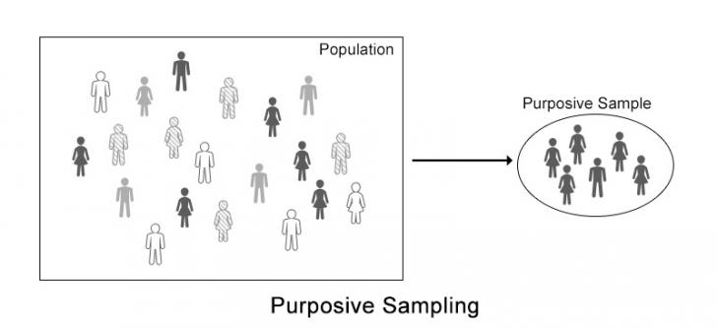
3.1 Limitation of study
Due to time and logistics constraints, Focus Group Discussion (FGD)/Community Consultation and KII were limited in 3 areas. This therefore limits the extent to which the quantitative survey findings can be inferred to the wider population group. Due to insufficient time the KII was not done with the decision makers, however, the member of the water user committees were present in the FGD and consultation.
- FINDINGS
4.1 Respondents’ social demographic characteristics

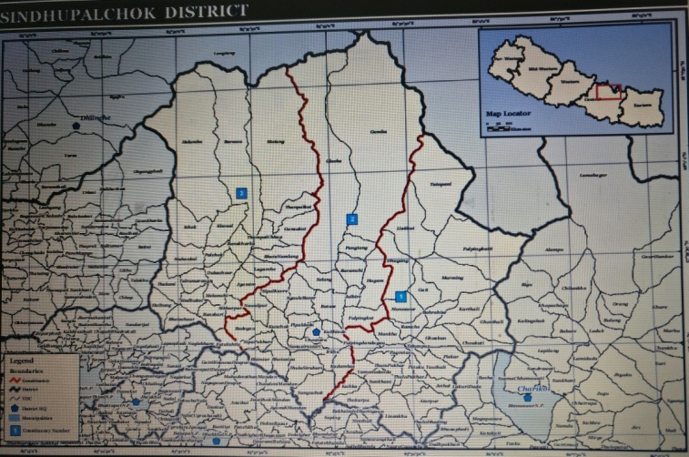
Melamchi is the largest municipality in Sindupalchowk consisting of 13 wards the name of the municipality is after the name of the river Melamchi. Majority of the population is bramin, chhetries, Janajanti and Dalit. It has been announced as municipality recently but there is no blacktopped road, livelihood option and drinking water facility.
Government of Nepal has initiated a drinking water project called Melamchi water supply project to Kathmandu Valley. Ironically, the communities living in periphery of this river are struggling for drinking water and all the work related to reconstruction, agriculture, animal husbandry is stagnant due to scarcity of water. OXFAM has very recently completed the survey of the water source and points for the installation of water outlet in this municipality. FGD and KII were conducted in Fataksila Thati and Kotthock of Melamchi Municipality, ward number 13. There are approximately 112 houses in Fataksila Thati and 84 houses in Kot.
Likewise FGD, rapid care analysis and KII was conducted in Kiul VDC Chitry- 5, Kiul VDC – 7 Serbathang and Hagam ward number 7 too. Kiul VDC Chitry- 5 has 90 houses out of which 68 houses are of Dalit and remaining of Tamang community. Kiul VDC – 7 Serbathang is situated 15000 meter from sea level. There are 110 houses of Tamang cast group residing in this ward. Hagam -7 consists of almost 200 houses of Tamang community with few, chhetrees, Dalits and Newars.
Total five FGD/community consultations and 6 KII was conducted in 3 different locations of Sindhupalchowk. Total number of the male, female and cast/ethnicity of the respondents are as follow:
Table II: Respondents’ social demographic characteristics:
Focus Group Discussion (FGD)/Community consultation
Municipality | VDC | Male | Female | Cast/Ethnicity | Total
Melamchi Fatakshila Thati-13 |  | 8 | 6 | Bramin, chhettries & janajati | 14
Melamchi, kot-13 |  | 10 | 13 | Dalit | 23
 | Hagam-7 | 8 | 6 | Tamang | 14
 | Kiul, Sermathang-7 | 14 | 12 | Tamang | 26
 | Kiul Chitre-5 | 4 | 14 | Dalit | 18
Total Participants |  |  |  |  | 95
Key Informant Interview (KII)
Melamchi Fatakshila Thati-13 |  |  | 1 | Tamang | 1
Melamchi, kot-13 |  |  | 1 | Dalit | 1
 | Hagam-7 | 1 | 1 | Tamang | 2
 | Kiul, Sermathang-7 |  | 1 | Tamang | 1
 | Kiul Chitre-5 |  | 1 | Dalit | 1
Total participants |  |  |  |  | 6
4.2 Gender Differentiated Impact Analysis
In order to identify the impact of earthquake on WASH and as a result on gender equality gender differentiated impact analysis was carried out. It allowed to understand gender relation, time poverty of women due to increased unpaid care work post earthquake.
    - Gender relation
- Time poverty:

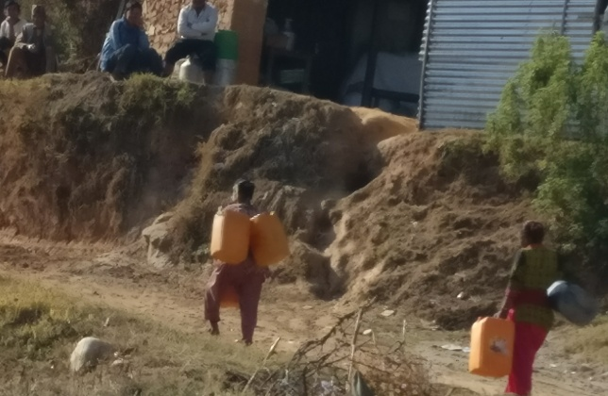
Women from Melamchi Fataksila Thati reported of traveling everyday about 2 hours to fetch water from the distance water source. Without getting water they can’t even cook food or feed their cattle. They have to fetch water about 4/5 t imes a day. They carry two water containers (gagri) in a bask et (doko) at their back from the water source. Likewise, women and adolescent girls from Melamchi Kota also reported of walking an hour distance to fetch water from the well, which is the nearest water resource for them. Female respondents from all the community reported fetching water as primary responsibility of the women and girls in their community.
KII respondent Melamchi Kot: it is tradition for women to fetch water. When we fall sick and if our daughters are not available our men also go to fetch water. We use the water in toilet, washing, cooking, and feeding animals. We have to carry two pots at a time and have to carry almost 5/6 times a day. We have to be in the queue because all the women in our community go to fetch water from the same source. The water is muddy that too dries up sometime and in such case we have to go up hill to another water resource that takes almost 4 hrs to reach their and come back home with water. We can only carry water 3 times because its very time consuming and tiring.
According to respondents from the FGD - Pre earthquake it took only 30 minutes to fetch water (two way) from the water source to the women in Melamchi municipality but after earthquake the water sources have dried up and it takes more than 2 hours (two way). Due to scarcity of water most of the HHs have sold out there livestock. Similarly, vegetable farming was also one of the livelihood opportunity mostly taken care by women, are now remain unused due to lack of irrigation facilities.
- Gender Role division:

In nearly all economies around the world, women perform a larger share of unpaid work than men. Time use surveys provide information about the kind and length of different activities that are carried out by women and men over the course of 24 hours. Such information allows detailed conclusions to be drawn concerning the division of labour, and thus the unpaid work that usually does not appear in many statistical measurements. Men in the community are perceived as bread winners while women are limited to household chores mostly unpaid care work.
According to women in the Kiul Chitre - Every month around 5 times the community people majority women ( male member have to go to job) gather to cle an the water tank at around 11 am to 2 pm. Ensuring water for toilet use, washing, cooking and feeding animals is women’s prime responsibility.
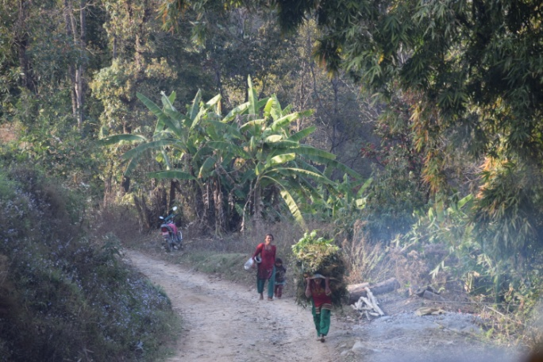
Men in Hagam are working as wage labour, farmer, stone breaking, mason and foreign job and weaving carpet. But most of them also spent playing carom board for almost 7 to 8 hours. In most of the HH, women are responsible for animal care. This is generally similar to most of the VDCs. Pre earthquake it took only 30 minutes to fetch water (two way) but post earthquake it is taking more than 2 hours (two way) and due to water scarcity, most of the HH sold out animals. Similarly, vegetable farming was also one of the livelihood options of women prior earthquake but now the farming lands remain unused due to lack of irrigation facilities especially in Fatakshila, Melamchi. After earthquake the time to rest and sleep has dramatically decreased for women. Baseline data shows that the female members were mostly responsible for water collection including pregnant and lactating women. Out of total respondents 85% of households reported of fetching water from distance source.
No gender role has changed post earthquake in all the community interviewed, in addition the work load of women has increased as men denied sharing the household chores. Given that women often work in the informal sector their economic contributions are also seldom statistically measured in the ‘paid sector’. This leads to a distorted representation of what women and men respectively contribute to economic wealth and production. Specific information about how women and men use their time are of pivotal importance for the planning of economic and socio-political interventions and for assessing the impact, therefore, 24 hours analysis was done to measure time poverty of women and their gender role division as an impact of water scarcity in their community as below:
Table III: 24 hours Rapid Tool analysis:
Time Poverty of Women | Gender Role Division
Melamchi, kot-13: unpaid care work of girl: 8 hours, study time at home: 1-2 hours in the evening, rest and sleep: 8 hours (she did not attend the school as she had to look after household chores and feed domestic animals for the day); | Hagam-7  Women; unpaid care work: 6 hours; paid work: 12 hours; rest 5 hours  Men: play carom board: 8 hours (9 to 5 pm); interaction with neighbors; weaving carpet: around 4 hours
Kiul Chitre-5: unpaid care work: around 10 hours, attending meeting 2 hours, entertainment: 1-2 hours, sleep: 9 hours  If she engage in paid jobs  Unpaid care work: around 8 hours (wakes up early, completes household work then go to cash for work, after returning from paid job get back to household work); sleep: 6 hour; entertainment: 0 hour; meeting; 0 hour | Melamchi, kot-13:  Girl: unpaid care work of girl: 8 hours, study time at home: 1-2 hours in the evening, rest and sleep: 8 hours (she did not attend the school as she had to look after household chores and feed domestic animals for the day);  Boys: unpaid care work 3to 4 hours depends upon their mood, sleep: 9.5 hours; study: 1-2 hours; entertainment: 3-4 hours (he did not attend the school as he had to support her sister to feed domestic animal)
Fatakshila Thati-13: unpaid care work: around 13 hours ; rest and entertainment: 2.5 hours
Unpaid care work: 6 hours event based opportunities only

Hagam-7; unpaid care work: 6 hours; paid work: 12 hours; rest 5 hours

Sermathang-7: unpaid care work: 12 hours; sleep: 10 hours: rest and entertainment: 1-2 hours

- Girl’s education
Women especially mother, daughter in law are primary responsible people in the family for collecting, storing, managing water including preparing meal, taking care of children, elderly people, feeding animals, working in famrs and washing clothes. These work transfers to daughters or young girls if the women of the family gets sick or have other agricultural work. Girls children are primary responsible to look after the houselhold chores when their mother are busy in any other business and for that they even have to drop their school.
Sukumaya, 10 years old studying in grade 5 in Shree Chandershwori Primary School dropped school for the day to take care of her brother and to prepare food, feed animals, fetching water-basically fulfill her mother’s job. Girls do not have time to study in the morning as they have to support their mother in household. They get only 1-2 hours time to study in the night after completion of all errands.
Manita 13 years old doesn’t go to school when her mother has to go to the river basin to work in the field. She cannot control the buffalo she has to take for garaging and she takes help of her elder brother. It’s compulsory for Manita to support her mother and to look after household chores but for her brother it’s a choice. He spends his day playing football, marbles and boxing. Manita wishes she could also have leisure time to play like her brother.
KII Kiul- Chitre-5: My parents married me when I was 15 years old, so I could study only up to grade 6. Now I am taking literacy class in Reflect Circle. I also save NPR 50 per month in Reflect circle and 50 per month in my both son’s account in Mother’s group. My husband also does saving NPR 20 per month in saving and credit group.

    - Participation and decision making

According to women respondents from the FGD they are mostly occupied in household chores and men are mostly involved either in income generational work such as mason, carpenter, farmer, wage laborer, and engaging in foreign employment or in activities like playing cards, carom, participating in the community meetings and going out for drinks with friends.
They further said, they do not know of the community meetings and even if they know are not allowed to go to such meetings. Attending meetings are taken as men territory or if they participate they are abused saying “Janne aaimai or charitrahin aaimai” (over smart woman or characterless woman). According to the respondent in Kiul Chitre - The water tape in their community keeps broking down and the women group have taken the concern for repair and reinstallation of the tape to the water user committee members but no one listen to the problem. Usually women’s need and concerns are least prioritized.
After earthquake lot of organization has started working in women issues. There are mothers group, REFLECT circle, NGO like; Mahila Adhikar Manch (MAM), MANK, saving and credit groups organizing different programme on women participation and empowerment, training for adolescent girls on early marriages. As a result women are at least getting chance to participate in such forums and learn new things.
    - Access and control over resources

In community level so called upper caste (men) has control over resources including water sources. In household level adult male member has control over resources. A woman is prime responsible in animal husbandry but it’s the man of the HH who decides to sell the animal.
Key Informant Interview with Goma B.K, Kiul Chitre: I got an opportunity to participate in Cash for Work to construct irrigation canal. There were more women than men. From my work I earned NPR 10,200 out of which my husband asked for NPR 4,000. Rest of the money I spent in buying cloths for her children and myself. I also spent some in buying household errands. I don’t know where my husband spent the money he took from me he didn’t even say when I asked him.
Usually the members for the Water User Committee is selected through community gathering but most of the time the one who select the members and decides are the political leaders community leaders, Ward coordinator, VDC secretary or municipal executive and all these are dominated by male. Women are only selected by these leaders to fulfill 33% representation. Meaningful participation of women, addressing the concerns of women, and respecting the perspective of women is a huge challenge in such consultation meetings.
  - Gendered Differentiated Vulnerability Analysis
Understanding of Gendered differentiated vulnerability and risk is crucial to our efforts to address the differential impacts of earthquake on men, women, girls and boys. Without addressing gender issues and issues relating to social vulnerabilities, there cannot be effective recovery and reconstruction work in WASH or any other sector to built adequate resilience.
    - Low pay on the basis of gender

From the study it is apparent that men in the community are into skilled labour jobs such as mason, carpenter, electrician, teacher whereas most women are unskilled labour with low pay.
According to the respondent from KII in Kiul- Chitre - Women get NPR 300 for carrying fertilizer while men demands NPR 500 for the same work for same time commitment. But generally, men do not prefer to do such unskilled labor work rather they chose to spend whole day playing cards or carom or just rooming around. “Men get 2000 per day for ploughing farm and women are not allowed to plough. If women were allowed they would have paid only NPR 1000 while men get 2000. Even if women and men are appointed for same labour for same hours men are paid double. Thus, severity of the issue of unequal wages for equal value of work is undervaluing women’s labour resulting exploitation of their labour.
From the FGD it was apparent that few HHs in Melamchi Fataksila Thati had started reconstruction of their houses. They hired labor to carry water from the water source to construction site. Women were chosen as a labor for this work as the fact that the daily labor cost of women is only NPR 300 for carrying 16 pots/containers from water source to the construction site per day. Whereas the labors charge of Men labor is NPR 700 per day for same quantity of labor and time. Mostly men are migrated to golf countries and Kathmandu for work and those we are available in the villages are engaged in playing cards, carom board, meeting with friends and working in the field. Women’s involvement in the migration work is negligible (only women from Dalit community have migrated) and community look down upon those women.
    - Social and power analysis

Patriarchy and social discrimination have created a socio-cultural construct of reality about gender in Sindhupalchow district. From the information gathered from FGD and KII the uneven power relations in household and community level is apparent.
When compared, men have more power than women both at household and community level. At the community level, the social hierarchy cast has domination in planning and decision making.
With reference to the intra-power dynamics amongst women, from the study it is clear that there is visible power hierarchy among women in in Tamang cast ( Buddist ethnicity) in Serbathang. The FGD responded reported of women controlling all the resources and decision making. The water user committee in this community consists of 11 members in which chairperson and the secretary of the committee is women. In rest of all other committee there is domination of male member in the committee and also in planning and decision taking processes. Structure of WUC claims for 33% women representation as a result one position is given to women in other committees, but women are never invited or their issues and concerned heard. Community discouraged women’s voice stating women should not be over smart “aaimai haru janne hunu hunna”.
Comparatively, women in other communities had no say at all the level of social strata. According to the respondents from Melamchi, Kot - Before they had water user committee consisting of 5 members in their community but now due to scarcity of water it is not functioning. The water user committee consisted of all men there was no women representation in it. Women expressed their interest to participate in such committee if it is revitalized or reformed in future. According to community people it will be good to have committee to take issues and problem related to water to VDC and get fund for maintenance and to establish water points in the VDC.
    - Social discrimination (caste based discrimination)
Brahmin people do not take food provided in meetings if Dalits also participate. Pre earthquake there were high amount of caste discrimination but earthquake destroyed house including the worship room. After that Lama People allow Dalit inside their house
Respondent in the FGD in Melamchi Kot: Before we were treated badly we were not allowed inside the houses or shops but now we don’t have such problem. However, we are still not allowed inside the houses. Generally we don’t sit together with higher cast. They haven’t said not to sit together but we make sure we sit separately

According to the Dalit community in Kiul, Chitre - before earthquake there was lot of discrimination around untouchability in the community. Dalit were not allowed to the same shops where higher cast used to go for shopping. According to the respondents from FGD a child from Dalit community was drown in the water source for touching the water source of higher cast group but post earthquake lot of organizations have started working in untouchability. Action Aid started REFLECT session in the community and now MANK is running the reflect circle, which supported by OXFAM. This REFLECT sessions have organized meetings in community against cast based discrimination and taboos, which has created awareness on people on untouchability.
In all the community interviewed - Dalit and menstruating women were restricted to touch the water pots even though they are not restricted to collect water from the same tap.
    - Protection and Gender Based Violence (GBV)

In the communities interviewed mobility of women was seen mainly restricted without permission of their husband or elderly person in the house. Women’s fight over water, men’s drinking, hitting their wives and using abusive language, men’s spending in the gambling was some of the protection and gender based violence cases identified.
According to one of the respondent mostly women fight with each other over the chance to collect water. There was huge fight few months back between two women and the main reason was one woman had filled 3-4 pots/containers of water while another had not got chance to even fill one. Water sources are mostly controlled by either Brahmin or Indigenous groups depending upon the dominancy of the population. However, it was not the same case of Dalit. . Dalit community tried to supply water to their community through pipeline from one of the sources but were chased by the locals ( Tamang ) with Khururi (local sword). Even though they are allowed carrying water from the source but they are not allowed to fit the pipeline to supply water to their community. According to community people they have to walk through the jungle to reach the both sources. Women seek for friends as they are afraid of animal and human attack. They are scared of the thought that someone might rape or sexually abuse them. According to community people, last year 3 years old boy was eaten by tiger at around 7 pm from the jungle.
According one of the Dalit women from Kiul Chitre– pre-earthquake her husband used to drink alcohol everyday and used to verbally abuse her and beat her almost every day. After earthquake the NGO called Mahila Adhikar Manch formed Reflect circle that provided council to her husband and now he has stopped beating her. The respondent reported of having women’s group in the Lama Community as well. This group has set a rule against gambling for men in their community this group is also responsible for handling VAW cases if any.
Another serious protection concern came forward from all the FGDs was issue around early marriages. There is increasing trend of volunteer early marriage among adolescent girls and boys leading early pregnancy and drop out of school. The cases of early marriage are very high as per the community people.
  - Gender Differential Needs and access to services

    - Gender and reconstruction: shelter and water

Most of the communities in Sindhupalchowk haven’t started reconstruction work yet. The major reason are; a)scarcity of water for reconstruction and b) issue of land -the guthi land (unofficial land)) c) road extension and d) designs provided by the Government is not appropriate for some of the community.
Almost 99% of houses were destroyed by earthquake some are living in Gumba in Sermathang where as many are living in temporary shelters in other communities. Many of those who received the first installment for house construction has invested money in clearing up the debris and majority doesn’t have knowledge on calming for remaining installments.
Most of the community reported of having toilet pre earthquake and some of the communities even reported of their VDC being announced as ODF pre earthquake but due to earthquake most of the toilet have broken down and only about 25% have toilet at their houses now.
    - Organizations working in WASH

According to respondents in Melamchi Fataksila Thati - Save the children and UNICEF are working in the schools for construction of toilets and Temporary Learning Centers (TLC) in their community. Very recently OXFAM has completed survey for the water points (the initial consultation for the survey was done in coordination with local political representative, community leader and municipal executive. With their support them the consultation took forward but it is to be notice that it was highly dominated by men).
According to the community members from Melamchi Kot lot of organization has been doing survey and interviews for water in their community and making false promises. Action aid Nepal, Save the children, Japanese organization carried out different level of interview with the community people but there has been no support therefore, the community people have lost hope and trust over the development organizations. According to community people they haven’t been able to construct their broken houses due to scarcity of water and these organizations come and take all their time discussing and distribute pen at the end of the day.
Community people in Kiul, Chitre said no organization has worked in the area of WASH in their community. OXFAM brought water pipe for installation but the size of the pipe were too small and not sufficient to supply water as per the need of community, therefore, community didn’t want it to be installed and it’s lying down in the field for last one and half year. Similarly OXFAM also wanted to install pipeline in Kiul, Sermathang but due to the smaller size of pipe it has’t been installed either. However, OXFAM has supported in construction of 10 toilets to the poor HHs in Serbathang.
    - Access to information and technology

Most of respondents from Melamchi Kot reported of not having television or radio at their houses. Out of total respondents only 2 had television in their houses and 6 had mobile phone. Mostly male respondents were carrying mobile phones whereas only 2 female members had mobile phone. In contrary the community with higher population of so called higher caste groups reported of having Most of the Television, cable channel and radio in their houses. At least one or two family members have mobile phones as well. According to baseline report female respondents tend to prefer radio and community meetings as sources for their information. On a positive note, female respondents were more aware on public health promotion messages in their households than male respondents as most of the public health promotional activities are targeted to women through Female Community Health Volunteers (FCHV). It completely lacks the concept of men engagement and also making them responsible and accountable for public health behavior in individual, family and community level. Thus, gender stereotype of gender division of role is still to challenge through WASH interventions.
    - Access to water: distance

The majorities of respondents predominantly have scarcity of water and have to travel long distance to fetch water. The number of trips taken per day to fetch water is indicative of access to water sources in all the communities’ interviewd. The community in Melamchi Fataksila thati and Kot had to walk one to two hours (one way) to fetch water from the nearest water source. Before the earthquake there were multiple water sources but most of them dried up or broken down post earthquake. Most of the time and labor of women and girls are invested in walking to the water source, standing in queue and managing water. Some HHs who are dependent on animal husbandry take the animal folks to the river basin 4 hrs away from village. In Serbathang 1 water tap is for 10 to 12 HHs. According to Baseline report concerning need of WaSH – all households surveyed had mentioned the need for sufficient and clean drinking water. Specifically female respondents have mentioned more about the need for knowledge on waste management and sanitation and hygiene.
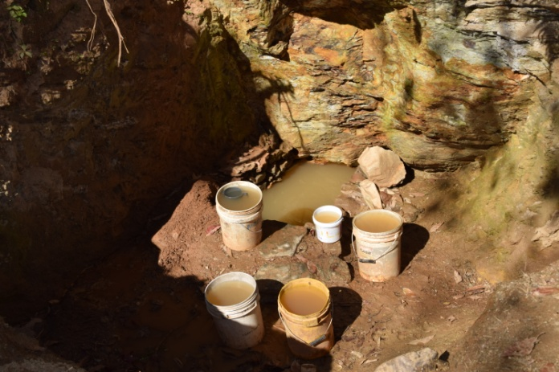
    - Health and sanitation: UP, jaundice, diarrhea, dysentery; no hand washing after using toilet

Sanitation responds to the most basic of human needs. Different factors influence the use of sanitation installations, including their availability, social and cultural norms, and user experience. From limited access to water and sanitation (WASH) facilities, standing in long queue for water, managing water in household is likely to result in stress. Cultural values can make women particularly vulnerable to limitations of WASH-related resources and further amplify stress arising from limited resources.
Majority of the responded reported of their dissatisfaction on quality of drinking water. Majority reported water being dirt and unhygienic but they have no other choices. The entire respondent reported of using no treatment of water and only boiling water for drinking when they have cold or cough. Because of the scarcity of the water there is no practice of washing hand after toilet. Regarding water born diseases, respondents from Melamchi Kot reported of women generally experiencing diarrhea, jaundice and dysentery. Most of the people from all the community reported of not washing their hands with soap after using toilet. Baseline data suggests that there is no significant difference in soap using practices of men and women. Mostly female respondent had lower level of awareness on the use of soaps than male respondents. In the case of awareness on prevention of diarrohea lesser proportion of female had mentioned protecting drinking water containers in home.
Due to the frequent trip taken per day and volume of water women have to carry including the lactating and pregnant – most of the women interviewed reported of uterus prolapse cases. In contrary the lama community in Serbathang reported cleanliness of house, kitchen and toilet as very import cultural norms. They always drink boiled water and never experienced diarrhea and dysentery. Earthquake destroyed toilet as well but almost every household have build temporary toilet for use. It is mostly women who get sick as it’s mostly women who do not wash their hand properly after toilet as they are very concern about the using the amount of water-more water used more they have to collect.
    - Latrine and bathing facilities

Out of total about 25% of the respondent reported of having toilet in their houses. The water that is carried by the women are used for all the purpose including for supply in the toilet. According to the community people it is duty of the daughters to clean the toilet. Most of the respondent said its better to go to field for defecation in such scarcity of water. Out of the total respondent in Melamchi Kot only three HHs reported of having toilet in their home. Most of the toilet has broken down after earthquake and people have been going to field to defecate. According to respondent their community was announced ODF before earthquake but the entire toilet got broken down by the earthquake and they haven’t been able to establish one. No one has a bathing space in their community they have to take bath in the water source so that they don’t have to carry water and very few of them have toilet available now. According to them almost 25 houses have toilet in their community now before they had one but all of them got destructed after earthquake.
    - Menstruation hygiene

Every girl in Dalit community does not attend school for 7 to 11 days during their menarche (first menstruation). They are sent to relative’s house to hide for 7 to 11 days. It is cultural practice and social myth that every girl in her menarche should not see male family members, prohibited to eat spicy and sour food.
KII of Manita Mizar (13 years old Dalit girl) from Melamchi Kot: I didn’t brush my teeth for 7 days during my menarche because I was hiding in my uncle’s house away from my father and brothers and I didn’t have brush and toothpaste. We are not allowed in kitchen, temple and to touch water taps during menstruation. I don’t like to use old cloth because I have to wash it. We don’t have a place to dispose the used napkin, so sometime we throw the used napkin in forest thinking that no one will see it but there have been cases when dogs found these used menstruation napkins and carried it from one place to another-which is very embarrassing. Most of the time we wash the sanitary clothes where no one can see and dry it in sun but make sure that men/boys don’t see it

Generally, social discrimination is not practiced during menstruation among Tamang community. However, as they are living in mix community in Melamchi, Fataksila Thati and practice interdependency for agricultural work and other daily needs, they are compel to practice social discrimination related to menstruation alike other higher cast groups ( Brahmin and Chhettrees). Women face challenges during menstruation as they do not have enough water to take bath and reusable sanitary clothes. Everyone goes to the same water source except for menstruating women/girls. For 5 day during menstruation cycle women are treated as untouchables. They are allowed to fetch water but male members of the family don’t drink the touched water by menstruating women. Water they bring is used for their own purpose and for feeding animals. Unlike in other community in Kiul, Serbathang Menstruation is not taken as social taboo as among Brahmins,Chhetris and Dalits. It is taken as natural process and not prohibited in anything and any place. However, they do not practice worship during menstruation. Most of women and girls use sanitary cloth as sanitary pads are not available in their community. They received orientation on how to wash and dry sanitary clothes by MANK ( OXFAM’s partner organization).
  - Gendered Differentiated Coping Capacities and strategies
Women and girls are particularly disadvantaged as a result of multiple socio-cultural and economic factors that deny them equal rights with men. Likewise, from the study it was apparent that the women in Sindhupalchow are working very hard to cope with water scarcity, denied access or lack the facilities and means to manage the simple biological necessities of defecation and menstruation, and are often forced to adopt a range of coping strategies.
Respondents have used the listed coping mechanisms post earthquake. Female respondents reported of using nine main coping means 1) Rain water harvesting 2) walking long distance and taking frequent trip to fetch water, 3) Carrying as many container as possible in basket at the back, 4) minimizing water use in toilet, for cleaning and washing 5) stopped vegetable gardening 6) Sold off the livestock 7) Traveling to the river basin to feed water to animals and for their garaging 8) Bathing as less as possible 9) defecating in the field 10) less consumption of water. Likewise the coping strategy of men was similar to that of women limiting the work in the own farm and looking for the labor work in Kathmandu or out of country for livelihood.

- RECOMMENDATION
Overall Recommendation
- Ensure both women and men are consulted when determining priority needs and distribution mechanisms.
- Ensure women are represented in all decision-making and consultation structures. All committees being set up, either by organizations or local government, should have at least 50% women. Equal number of women and men should be in leadership positions.
- Consult with and involve women’s civil society groups and women of all ages, including those who are hard to reach or at risk such as women with disabilities.
- When moving towards early recovery stages, make sure that women are provided with livelihoods and income generation opportunities based on direct
- WASH team to plan and allocate budget for capacity development of WASH team of Oxfam and partner in gender
- OXFAM has to consistently provide equitable access to all, especially to people group of men, women, boys and girls to pay specific attentions to the intersectional identities of social entities such as age, religion, ethnicity, disability, elderly, lactating/pregnant and social status in design/planning and implementation stages of the programme cycle.
- OXFAM should do a proper study before making any commitment to the community on providing services. This kind of behavior can have negative impact on the community people.
- All programs and sectors must conduct gender analysis at community level to design, plan and implement gender responsive and inclusive programme intervention.
- Regular monitoring and data management is very essential to ensure vulnerable groups of people are not overlooked and there is no frequent and duplication of data collected as well as too frequent involvement of communities’ time.
- The concept of men engagement to be implemented also holding them responsible and accountable for public health behavior in individual, family and community level. Building awareness on importance of unpaid care work especially focusing on collecting, storing, managing water, cleaning toilet.
- Menstrual hygiene management focusing on Brahmin, Chhettrees and Dalits groups is important also address the cultural myth and taboo related to it.
5.1 Practical gender need
    - Water, sanitation and hygiene
- Establishment or/and maintenance of water points nearby the household
- Construction of toilet, bathing cubicles and laundry place
- Water treatment and storing techniques
- WASH should collect and analyse sex and age disaggregated data from the working community to address different need of men, women, girls and boys
- Hygiene Promotion Teams should comprise of both male and female staff, to be sure to reach both segments of the population.
- Given women’s critical role in water management; women should be trained on how to use household water treatments materials
- Separate WASH Village Committees should be supported and/or set up. Otherwise, women’s views on critical water management decisions will not be incorporated into key community-level decisions.
- Hygiene promotion should target men, women, boys and girls separately. Hygiene promotion messages should be tailored to boys and girl.
- Particular focus should be given to adolescent girls, women and they should get training on menstruation hygiene management.
- Work with gender and protection team to develop gender monitoring tool and to carry gender analysis at different stages of WASH interventions

    - Livelihood
- Selections of women beneficiary have to be justified and made clear for men who might feel power drifts insecurities to reduce threats of domestic violence for women.
- Equal participation of women and girls with men and boys in programme activities and equal wage for equal work.
- In consultation with women, men, girls and boys, actively promote women’s and girl’s dignity and empowerment in program design and implementation
- Develop programme that ensure women’s and girl’s rights are being redressed in and provide men’s and boys’ support as allies
- Oxfam has to provide beneficiaries with alternative livelihoods options using the skills that are known to the people. Hence, Oxfam have to advance on scaling up its protection based livelihoods programme. The suggestions would be to provide training in using women friendly technology that would increase yield and decrease workload.
- Cash for Work programme would be best option where lot of reconstruction work is needed.

    - Shelter construction

- Gender analysis should be done by the shelter sector to analyse the need and protection issues of women who have been living in the temporary shelter post earthquake.
- According to the need and interest of the women they should be enrolled in the reconstruction related work.
- Women and girls should be consulted on safe shelter and their views respected
- Women and girls should get an opportunity to enroll in the mason training ensuring women mason are paid equal for equal work they contribute.
- Building back better training should be given to all the members in the community, so that they are part of recovery and reconstruction in their community.

    - Protection and GBV
- WASH strategy to be guided by protection and GBV concerns (impact, outcome should be achieving water, sanitation and hygiene ensuring non-violent environment)
- In order to ensure sufficient privacy and protection to women and girls community consultation with women and girls is required on water distribution points are in safe and open areas located near settlements.
- Women and girls should be specifically consulted when designing the contents of the different kits to ensure their needs are catered to, and will also be targeted through separate hygiene sessions.
- If appropriate, build a fence and cover unprotected open wells. o Water points should be in a safe & accessible place for women and girls. Consult with women and girls regarding appropriate locations for water points.
- If rehabilitating community latrines, ensure separate latrines for men and women, ensure that they are well lit, hand washing stations available and there to ensure privacy and security.

  - Strategic gender interest

    - Women’s meaningful participation in humanitarian intervention

- Sex segregated consultation meetings, FGDs to be hold
- WASH team need to consider the lower status and confidence level of women while consulting, designing, implementing the interventions such as….
- Women participation in the planning to decision making level should be ensured in the Water User Committees.
- Women groups should be empowered in developing proposals in the ward level planning process to be able to utilize women targeted bulk grant.
- Issues to be addressed on Unpaid Care Work and men’s engagement for women empowerment to improve the active and meaningful participation of women.
- Dalit and marginalized should be encouraged to participate in the planning and decision making process. They should know their rights for participation and laws against discrimination in Nepal.

    - Women’s leadership

- Need to promote women’s transformative leadership possibly through two strategies a) create an environment to share the power among these institutions b) promote women’s leadership in platforms like Ward Citizenship Forum (WCF), school management committee c) design activities to strengthen the leadership capacity of women
- Influence VWASHCC, WCF structure to ensure women in decision making positions and ensure women's voice from initial level.
- Deliver transformative leadership training to women to empower and sensitize women on their important role in recovery and reconstruction.
- Capacity building trainings, income generation activities and support to women on starting up small business is required to empower women in leadership position and to increase their access and control over the resources.
- Replicate the concept of Reflect circle and work closely with people’s organizations like Mahila Adhikar Manch to strengthen capacity of women, girls and Dalit people

    - Advocacy and campaign

- Unpaid care work, social myth and taboo regarding menstruation, Women’s leader, equal wages for equal value of work, women in non-traditional job (if WASH plans to provide mason training to construct toilets), land ownership (joint land ownership), caste discrimination and gender responsive environment are the issues needs to be advocated.
- Gender sensitive messages and slogan should be designed and tailored to aware community on need of equal involvement of men and women to ensure hygiene and sanitation related work.
- Community should be aware on the right of participation of women in the water user committees and other meetings as per the government’s law of ensuring 32% women in all committees and structure.
- Through different campaign and community consultation women participation from the planning/ designing phase of programme intervention to implementation should be ensured.
- Dissemination of messages on laws and policy Against Gender Based Violence, cast discrimination through meetings, consultation and campaign.
- Use different technology to disseminate message on Wash, hygiene and sanitation, gender equality and discrimination and social taboos.
- Increasing donor investment in and support for shelters and other safe spaces for women and girls.
- Increased information about potential political candidates and local election processes at community level for women participation.

    - Men engagement

- Take men as direct beneficiary while promoting public health promotion. Men to hold accountable on collecting, storing, managing water, managing toilet, washing clothes not as support to women but as their responsibility.
- Build awareness on women leadership, safeguarding (especially in construction sites), their role and responsibility to promote women’s leadership, women’s meaningful participation, and women in non-traditional jobs such as masonry jobs to construct toilet.
- However, there is a need of capacity development on gender which will bring clarity on a) role and responsibility on gender mainstreaming b) how and why to mainstream gender
- Empower men to support women and girls in their community as their allies
- Recognize the man as role model who supports his wife/ mother or sister in the household chores and challenges existing gender norms.

ANNEX -I

Focus Group Discussion with mixed group
Reminds:
Write the time of the beginning of the discussion: .........................
Write the time of the end of the discussion: ....................................
Number of women during the discussion: ......................................
Number of men in the discussion:…………………………………….
Cast/ethnicity of the respondents: ..................................................

General questions:
- Do you have water sources available in your village?
- How many water sources available in your village to fetch water from?
- How many water sources were available in your village before earthquake
- How many houses are there in your community?
- Which ethnic/cast group resides in your community?
- What do people do for living in your community?
- Do all the villagers from your community go to the same water source?
- What are the significant differences you have experienced before and after earthquake in your village?

Gender role:
- How do you manage water for drinking and other purposes at your home
- Who is responsible to fetch water in your house
- How far do you have to go to fetch water
- How many trips you take in a day to fetch water
- When the current source of water dry off where do you go next?
- How far is it from your village?
- Is the water available throughout the year from this source?
- How long is the queue/ how long do you stand in the queue for your turn
- For what purpose do you use the water you fetch
- Where do you store water?
- Who goes to fetch water when you are sick
- At what time do you go to fetch water usually?

Participation and decision making
- Who takes care of this drinking water point?
- ( if they don’t have water user committee) – did you ever have a committee in your village?
- What is the reason for not having one?
- Do you think you should have one?
- What do you think are the benefits of having water user committee?
- If you have water user committee in your community who are the members?
- Who selects the member in your committee?
- How do you find your current committee?
- What is their job?
- How do they manage the drinking water point?
- How do you take the issues and your concerns related water to the committee?
- Have your concern been heard and implemented?
- If yes – what has been heard and implemented and if No – why do you think not?
Social discrimination:
- Do all in the community get equal opportunity to use the water source?
- If no why not?
- Are dalit from your community allowed to fetch water from the same source where higher cast group go?
- What are they allowed to do and what not?
- Are menstruating women allowed to fetch water from the same source?
- If not why not?
- Is single women allowed to fetch water from the same source?
- If not why not?
- How do Dalit, menstruating and single women manage water if they are not allowed to go to the water source?
- What do you think should be done so that marginalized cast group can also access water from same source?

Protection and gender based violence:

- Have you or anyone in your community experienced any kind of violence while going to fetch water
- Have you heard of any kind of gender based violence in your community?
- What do they do in such cases – do they report to someone/somewhere
- Do you know where and how to report such incidents?
- Where do you go to take bath?
- How do you manage to bath during your menstruation period?

Sanitation and hygiene

Water quality:

- Is the water you drink good quality. If not why?
- How you describe "clean water" and "dirty water”? Explain what it means.
- Do you use a different pot for storage?
- Do you cover drinking water pot? If not Why?
- Do you boil your water before drinking? Why not?

Sanitation:

- How many of you have toilet in your homes? Those who do not have where do you go to defecate?
- Who manage when the children want to go to defecate? How?
- When do you wash your hands? Why? And How?
- Do you use soap, when and why?
- What do you use during menstruation period?
- Where do you wash your cloth pads?

Health:
- Which common diseases you get in your community?
- Who generally gets sick in your family?
- What are the health related problem of women
- Why and how we can avoid (prevent) these diseases.
- Do you think water can spread diseases? Which ones?

Organizations working in WASH
- Have any organization worked in the area of WASH in your community every?
- Which are the organizations?
- What support in WASH have they provided?
- Are you happy with the services provided?
- What do you think these organizations should do more or do less?

Key Informant Interview (KII)
Reminds:
Write the time of the beginning of the discussion: .........................
Write the time of the end of the discussion: ....................................
Name and Cast/ethnicity of the respondent: ..................................................

General questions:
- Do you have water sources available in your village?
- How many water sources are available in your village to fetch water from?
- How many water sources did you have in your village before earthquake?
- Which ethnic/cast group resides in your community?
- What do people do for living in your community?
- Do all the villagers from your community go to the same water source?
- What is the significant differences you encountered before and after earthquake in your village?

Gender role:
- How do you manage your time – can you help me list out the activities you do 24 hours a day?
- Can you list out activities your wife/husband does 24 hours a day?
- Who is main responsible to fetch water in your house?
- How far do you have to go to fetch water?
- How many trips you take in a day to fetch water?
- When the current source of water dry off where do you go next?
- How far is it from your village?
- Is the water available throughout the year from this source?
- How long is the queue/ how long do you stand in the queue for your turn
- For what purpose do you use the water you fetch
- Where do you store water?
- Who goes to fetch water when you are sick
- At what time do you go to fetch water usually?

Participation and decision making
- Who takes care of this drinking water point?
- ( if they don’t have water user committee) – did you ever have a committee in your village?
- What is the reason for not having one?
- Do you think you should have one?
- What do you think are the benefits of having water user committee?
- If you have water user committee in your community who are the members?
- Who selects the member in your committee?
- How do you find your current committee?
- Do you know their job?
- How do they manage the drinking water point?
- How do you take the issues and your concerns related water to the committee?
- Have your concern been heard and implemented?
- If yes – what has been heard and implemented and if No – why do you think not?
- Who in your house decides on selling livestock?
- Who decides on building latrine and bathing spaces in your house?
- Who keeps the money and who spends it in your family/house?
Social discrimination:
- Do all in the community get equal opportunity to use the water source?
- If no why not?
- Are Dalit from your community allowed to fetch water from the same source where higher cast group go?
- What are they allowed to do and what not?
- Are menstruating women allowed to fetch water from the same source?
- If not why not?
- Is single women allowed to fetch water from the same source?
- If not why not?
- How do Dalit, menstruating and single women manage water if they are not allowed to go to the water source?
- What do you think should be done so that marginalized cast group can also access water from same source?

Protection and gender based violence:

- Have you or anyone in your community experienced any kind of violence while going to fetch water?
- Have you heard of any kind of gender based violence in your community?
- What do they do in such cases – do they report to someone/somewhere
- Do you know where and how to report such incidents?
- Where do you go to take bath?
- How do you manage to bath during your menstruation period?

Sanitation and hygiene

Water quality:

- Is the water you drink good quality. If not why?
- How you describe "clean water" and "dirty water”? Explain what it means.
- Do you use a different pot for storage?
- Do you cover drinking water pot? If not Why?
- Do you boil your water before drinking? Why not?

Sanitation:

- How many of you have toilet in your homes? Those who do not have where do you go to defecate?
- Who manage when the children want to go to defecate? How?
- When do you wash your hands? Why? And How?
- Do you use soap, when and why?
- What do you use during menstruation period?
- Where do you wash your cloth pads?

Health:
- Which common diseases you get in your community?
- Who generally gets sick in your family?
- What are the health related problem of women
- Why and how we can avoid (prevent) these diseases.
- Do you think water can spread diseases? Which ones?

Organizations working in WASH
- Have any organization worked in the area of WASH in your community every?
- Which are the organizations?
- What support in WASH have they provided?
- Are you happy with the services provided?
- What do you think these organizations should do more or do less?

District Disaster Relief Committee- presentation made during Review and Planning workshop for Recovery and Reconstruction in Sindhupalchok on 23-24 May, 2016
Sindupalchowk Detailed need Assessment Report _20 July 2015 OXFAM Humanitarian Response Programme in Nepal
National Population and Housing Census 2011
Sindhupalchow Gender Profile, August 2016, UNwomen
Earthquake: Impact on Nepalese economy and women K. Shakya , 26 September 2016
Reliefweb Sindhupalchok Gender Profile (August, 2016)
Reliefweb Sindhupalchok Gender Profile (August, 2016)
Reliefweb Sindhupalchok Gender Profile (August, 2016)
Reliefweb Sindhupalchok Gender Profile (August, 2016)
GENDER ISSUES IN CONFLICT AND HUMANITARIAN ACTION, OXFAM Humanitarian Policy note, November 2013

