INTERAGENCY STANDING COMMITTEE TASK TEAM ON STRENGHTENING THE
HUMANITARIAN-DEVELOPMENT NEXUS IN PROTRACTED CRISES

Ad Hoc Working Group Meeting Background Document

This document is prepared as background for the discussion during the Ad hoc Working Group Meeting on the Task Team and its work. It represents the collective view of the Task Team for review and endorsement by the IASC WG Members.
Introduction:
- The Working Group (WG) welcomes workshops on the New Way of Working (NWoW) in New York, Dakar, Washington, Copenhagen, Istanbul and elsewhere as well as the recent panel discussion on protracted crises during the humanitarian affairs segment of the ECOSOC. All of which have contributed to increasing the clarity of scope of what is required to implement the NWoW. Together, these initiatives to advance this agenda call for more coherent coordination. These initiatives have shown that that the structural changes required to fully operationalize the NWoW will require a concerted effort of interlocutors both among and beyond IASC members.
Since the World Humanitarian Summit (WHS), the implementation of the NWoW has moved ahead. In some places, country teams have made great strides. At the same time, field experiences are also shaping the understanding of the NWoW. Despite systemic, procedural and administrative challenges, some country operations have moved towards joint analysis and joined-up planning. They have addressed obstacles, including different and staggered programme cycle timelines, tools and procedures; lack of uniformity in support and funding; and inconsistent membership of different planning processes.
As stressed during the workshop in Istanbul, the considerable progress made at field level needs to be accompanied by structures, processes and backing from HQ/ROs to allow operational colleagues the space needed for risk-taking and flexibility. Collective support from HQs will also bring much needed predictability and coherence across operations based on a commonly agreed understanding of the NWoW, while allowing for context specificities. There is now a need for supporting ongoing field efforts, and for documenting and exporting these promising practices to other countries.
- However, the WG also recognizes that as progress continues at field level, the complexities of implementing the NWoW have become more visible. There is a clearly expressed need to clarify, harmonize, and agree on how the NWoW fits with different global processes such as the Grand Bargain and the UNSG’s crisis prevention agenda. The UNSG has outlined that “Delivering the New Way of Working is a critical step” to achieve his vision on prevention and his commitment to reform the way the United Nations works.
In particular, the notion of collective outcomes that has been put at the center of the NWoW needs more clarity and elaboration. In the absence of political solutions, country teams include peacebuilding actors as part of the nexus when responding to protracted crises. This has led to a policy gap around how to preserve humanitarian space while jointly planning and programming with development and sometimes peacebuilding actors.
Some IASC members therefore argue that the NWoW should be limited to humanitarian – development linkages. This position limits the notion of “collective outcomes” to the areas of reducing needs, risks and vulnerability. In this sense, addressing root causes related to peace-building should be left to other actors. While this often entails excluding government perspectives, it is argued that this approach ensures that humanitarian space is preserved and humanitarian principles are upheld.
Others argue that principled action is not limited to the domain of humanitarian action. Against the backdrop of the SDGs and the call to leave no one behind, humanitarian and development actors now have a common reference point to work together. Goal 2—ending hunger and achieving food security, for example, is not only an SDG but also an operational priority for humanitarian organizations in crisis-affected communities. Through Agenda 2030, UN Resident Coordinator functions are now guided by the same principled action as that of the HC function (now often the same person) in helping governments determine where best to deploy development assistance and programming to the benefit of the most vulnerable groups, i.e. those that are furthest behind. As such, programmatic entry points for peace-building are included with aim to interact with and benefit from humanitarian and development efforts to further address root causes.
These arguments are not mutually exclusive. In settings where the government may be party to conflict, pragmatism and the imperative to save lives while keeping with the humanitarian principles will be paramount. However, given that the majority of the humanitarian caseload is in conflict settings, the humanitarian development nexus cannot work without a thorough reflection of how best to include, harmonize with or be informed by peacebuilding efforts. Likewise, it cannot work without an understanding of how strengthening the humanitarian development nexus can contribute to the reduction and prevention of violent conflict and, in sustaining peace before violent conflicts begin. The WG therefore welcomes the twin resolutions on Sustaining Peace and the UNSGs prevention agenda, as high level strategic direction with emphasis on policy coherence and the role agencies, funds, and programmes can play in contributing to this agenda.
Against this backdrop, and building on the progress already made, the WG requests the IASC TT on HDN to further contribute to this agenda in the following ways:
What the Task Team (TT) is:
- The TT is the interagency forum for convening, presenting and validating views of the IASC TT members around the issue of strengthening the humanitarian-development nexus. In collaboration with the UNDG, its aim is to advance a collective narrative on this agenda. Guided by the IASC WG Workplan, the TT purpose is to i) collect good practice from the field, analyse, validate, and map the developing work on the HDN; ii) establish an exchange platform, collating, organising and redistributing/disseminating this material and sharing of information through a web based peer to peer system; iii) identify policy gaps and recommend guidance aimed at operationalizing the NWoW, and clarifying linkages with other policy discussions, such as the Grand Bargain, the Prevention Agenda, and Sustaining Peace.
- This entails that the TT, in collaboration with the UNDG’s relevant Results Groups, shepherd substantive policy and field support discussions at the interagency level on strengthening the linkages between humanitarian and development workstreams. Lastly, The TT will serve as the IASC’s depository from which to draw for substantive input into other interlinked processes such as the Grand Bargain Workstream 10 and the UN WB Partnership on the Humanitarian Development Peace Initiative (HDPI).
What the Task Team does:
- The TT is time-bound and will work through both its agreed workplan of activities as elaborated in the draft workplan, as well as through the Plan of Action between the IASC HDN TT and the UN Working Group on Transitions (pending its reconvening in new outfit). The WGs asks the TT and its members to organize its work to:
  - Coordinate information flows: Shape a common understanding of what is required to strengthen the humanitarian -development and peacebuilding nexus; In particular by
    - Establishing and maintaining an open-source coordination platform to map and communicate existing global processes, initiatives, and mechanisms, operational tools, and field-level activities. It will serve as a living resource for field and policy practitioners.
    - Key messages and common narrative on the nexus. Confirmed by the results of the RC/ HC survey, there is a growing sense of confusion at the multiple sources of information and messaging on the NWoW. The NWoW can only advance through concerted collective messaging. This is an activity with UNDG, through the joint Plan of Action.
    - Gathering evidence from field implementation with UN, NGOs and civil society to establish a compendium of these practices. This will be done through a light methodology and questionnaire to systematize the collection of data around the NWoW. This is an activity with UNDG, through the joint Plan of Action.
  - Review and assess current humanitarian policy, guidance and operational tools on common understanding to identify gaps and best practice; in particular by
    - Expanding on the typologies of response scenarios. An important element is on how the imperative to protect humanitarian space and principles fit in, particularly in situations of conflict. Different types of settings will require a different blend of planning tools and analysis, as well as to what extent humanitarian actors can and should engage with other actors.
    - Understanding linkages with sustaining peace and prevention. The Sustaining Peace resolutions stress the importance of coherence and complementarity between the United Nations’ peace and security efforts and its development, human rights and humanitarian work. The TT will also focus on how the humanitarian-development nexus intersects with the need to Do No Harm and conflict sensitivity requirements and explore programmatic linkages between the humanitarian-development nexus and the prevention agenda with the aim to find common ground and provide guidance on how the NWoW can contribute to peacebuilding and sustaining peace.
    - Articulating Collective Outcomes with three areas the TT can help clarify 1) the issues around coordination around collective outcomes and the role of the government in this; 2) the linkages between collective outcomes and area-based approaches; 3) the question of accountability and a clear framework to track and monitor results.
    - Review of the IASC humanitarian response protocols and related guidance for their application in protracted situations, and supplement this as required. By the end of its lifespan, the TT will present the WG with system wide recommendations on what and how operational guidance may need to change.
  - Support to Country Teams: Ensure coherence in field support towards successful implementation of the NWoW. This is an activity with UNDG, through the joint Plan of Action.
    - Develop generic terms of reference (ToRs) to systematize country and field support.
    - Be the port of call for country support requests. This will ensure that RC/HCs have a clearly identified entry point for formulating support requests on behalf of the country team. The TT will relay to and rely on individual TT members to contribute their expertise for support missions and other relevant means to advance this work in a coherent fashion, whether undertaken bilaterally or collectively. Field support, will be done in conjunction with country teams by coordinating a mechanism which communicates all requests to IASC and UNDG Members and Observers.
- To deliver on the above, it is suggested the lifespan of the TT is extended to December 2018.
Where the Task Team fits:
- In recognizing the larger universe of entities, initiatives, and actors working on the NWoW and that some of these fall outside the remit of the IASC, they nonetheless require coherent contribution by the IASC as a collective, in addition to individual agency/sectoral injects. Among these are the current reforms of the UNDG, the Grand Bargain and its Workstream 10, the Good Humanitarian Donorship Group (sub-working group on humanitarian development nexus), the UN - World Bank Group’s partnership on the Humanitarian Development Peace Initiative, the Senior Transformative Agenda Implementation Team, the Humanitarian Development Action Group (HDAG) supported by the NYC Centre on International Cooperation (CIC), the IASC Clusters, Professionals in Humanitarian Assistance and Protection (PHAP), as well as other IASC subsidiary bodies, etc..
- Against these different initiatives, where collective input on the issue of humanitarian development nexus is required, we acknowledge the value added of the IASC WG in contributing and shaping this agenda. To this end, the value added drawn from the HDN TT is:
  - To be a substantive, interagency policy oriented forum with linkages to the IASC Principals, through the Working Group.
  - To be the technical working-level counterpart to the UNDG: Through the already established joint IASC HDN TT and the UN WG on the Transitions Plan of Action, building on the successful joint workshop in New York in October of 2016.
  - To have a broad representation and is inclusive of non-UN organization through the NGO consortia present in the IASC, some of them also with peacebuilding expertise. Expanding this participation, its scope and linkages in the timespan of the work of the TT is essential to the NWoW.

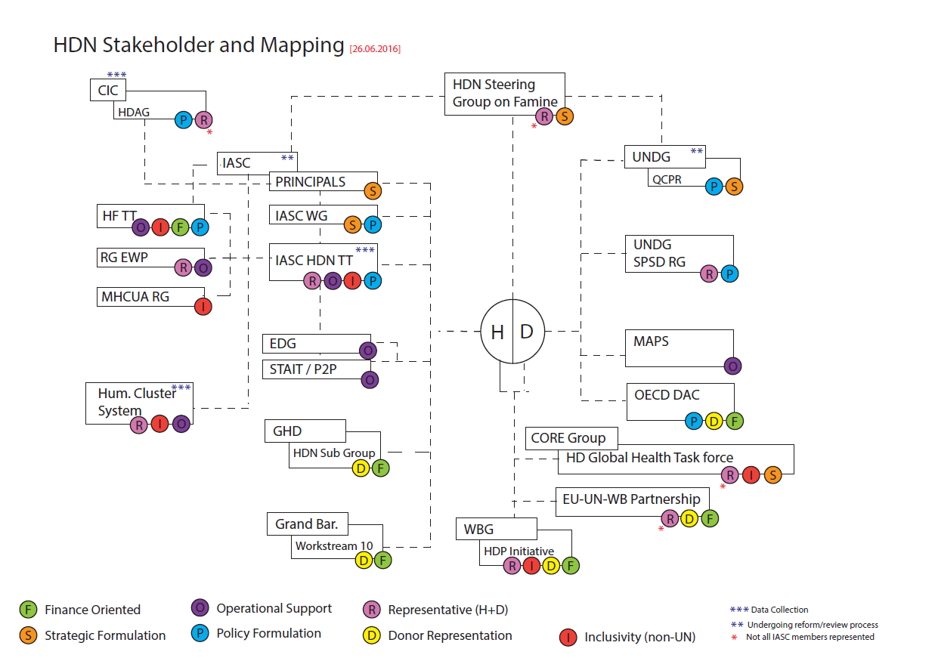

See HC/RC Survey Results
For full articulation of these lines of thought, refer to Analysis Peace on the Intersection between NWoW and Sustaining Peace.
This is drawn from TT meeting summaries, a series of bilateral conversations with TT members, as well as strategic discussions with co-chairs of other IASC References Groups and Task Teams and subsidiary bodies in the UNDG. (undertaken by TT Co-chairs in the period Dec 16-March 17).
Subsidiary bodies of the IASC are not limited to the official membership of the IASC.
See workplan of activities for full details on concrete activities.
See full value added mapping in annex
and its successor group

