INTERAGENCY STANDING COMMITTEE TASK TEAM ON STRENGHTENING THE
HUMANITARIAN-DEVELOPMENT NEXUS IN PROTRACTED CRISES

Ad Hoc Working Group Meeting Background Document

This document is prepared as background for the discussion during the Ad hoc Working Group Meeting on the Task Team and its work. It represents the collective view of the Task Team and has been drafted as a statement of intent, for review and endorsement by the IASC WG Members.
Introduction:
- The Working Group (WG) welcomes workshops on the New Way of Working (NWoW) in New York, Dakar, Washington, Copenhagen, Istanbul and elsewhere as well as panel discussions on protracted crises during the humanitarian affairs segment of the ECOSOC 2017. All of which have contributed to increasing the clarity of scope of what is required to implement the NWoW to more effectively meet the needs of people affected by crisis, and reduce vulnerabilities and risks over time while preserving humanitarian space. Together, these initiatives to advance this agenda call for more coherent coordination. These initiatives have shown that the structural changes required to fully operationalize the NWoW will require a concerted effort of interlocutors both among and well beyond IASC members.
Since the World Humanitarian Summit (WHS), the implementation of the NWoW has moved ahead. In some places, country teams have made great strides. At the same time, field experiences are also shaping the understanding of the NWoW. Despite systemic, procedural and administrative challenges, some country operations have moved towards joint analysis and joined-up planning. They are working to find solutions to the traditional obstacles that perpetuate the humanitarian and development silos, including different and staggered programme cycle timelines, tools and procedures; lack of uniformity in support and flexibility in funding; and inconsistent membership of different planning processes.
As stressed during the workshop in Istanbul, the progress made at field level needs to be accompanied by structures, processes and backing from HQ/ROs to allow operational staff the space needed for innovation, risk-taking and flexibility. In Istanbul, a clear call was made to that global level guidance to make it clear that NWOW is not an experimental process but really is a system-wide expectation. Consistent and collective support from HQs will also bring a commonly agreed understanding of the NWoW, including guidance, key messages and evidence while allowing for context specificities. There is now a need for supporting ongoing field efforts, and for documenting and sharing promising practices with other countries.
Operationalizing the approach and identifying its challenges
- However, the WG also recognizes that as progress continues at field level, the complexities of implementing the NWoW have become more visible. There is a clearly expressed need to clarify, harmonize, and agree on both the scope of the NWoW and how it fits with different global processes such as the QCPR implementation and the UNSG’s crisis prevention agenda. The UNSG has outlined that “Delivering the New Way of Working is a critical step” to achieve his vision on prevention and his commitment to reform the way the United Nations works.
In his report to the ECOSOC on coordination of emergency humanitarian assistance, the UN SG states that “The New Way of Working will enable the United Nations and its partners to deliver shared results over a multi-year horizon in a manner that contributes to sustainable development and achieving the 2030 Agenda, including sustaining peace, where the context permits. In outlining the proposals to ECOSOC on the UNDS reform the UNSG quotes the QCPR, that “a comprehensive whole-of-system response, including greater cooperation and complementarity among development, disaster risk reduction, humanitarian action and sustaining peace, is fundamental to most efficiently and effectively addressing needs and attaining the Sustainable Development Goals” and, that we must “implement the New Way of Working across development and humanitarian activities, with a focus on collective outcomes at the country level”.
In particular, the notion of collective outcomes that has been put at the center of the NWoW needs more clarity and elaboration. In the absence of political solutions, country teams include peacebuilding actors when responding to protracted crises. This has led to a policy gap and associated operational guidance around how to preserve humanitarian space while jointly planning and programming with development and sometimes peacebuilding actors.
Because of this clear lack of policy directive, some IASC members therefore argue that the NWoW should be limited to the strengthening of coherence and cooperation among humanitarian – development workstreams. This position limits the notion of “collective outcomes” to the areas of addressing needs, while contributing to reducing risks and vulnerability. In this sense, addressing root causes related to conflict and implementing peace-building objectives should be left to other actors. While this often entails a limited interaction between humanitarian actors and government representatives in conflict settings, it is argued that this approach ensures that humanitarian space is preserved and humanitarian principles are upheld.
Others argue that principled action is not limited to the domain of humanitarian action. Against the backdrop of the SDGs and the call to leave no one behind, humanitarian and development actors now have a common reference point to work together. Goal 2—ending hunger and achieving food security, for example, is not only an SDG but also an operational priority for humanitarian organizations in crisis-affected communities. It has been argued that the SDGs and the imperative to leave no one behind and reach the furthest first is principled and is humanitarian in nature Through Agenda 2030, the UN Resident Coordinator functions and the Humanitarian Coordinator function (now often the same person) are now guided by the same framework and end goal in helping governments, even in conflict settings, to determine where best to deploy development assistance and programming to the benefit of the most vulnerable groups, i.e. those that are furthest behind. As such, programmatic entry points for peace-building are included with aim to interact with, and benefit from humanitarian and development efforts to further address root causes.
- These arguments are not mutually exclusive. In settings where the government may be party to conflict, pragmatism and the imperative to save lives while keeping with the humanitarian principles will be paramount. We must also acknowledge that humanitarian outcomes contribute to both development and peace outcomes. Including peace as the third pillar in a “triple nexus” does not require explicit and overt involvement of humanitarian actors and be pragmatic in looking at programmatic strategies in contexts where this is relevant. However, given that the majority of the humanitarian caseload is in conflict settings, the humanitarian development nexus cannot work without a thorough reflection of how best to include, harmonize with or, as a minimum, be driven by conflict sensitivity rooted by sound conflict and risk analysis, as well as peacebuilding efforts. Likewise, it cannot work without an understanding of how strengthening the humanitarian development nexus may contribute to the reduction and prevention of violent conflict and, in sustaining peace before violent conflicts begin [WB, OHCHR] In these settings, even if discrete, the effective and efficient achievement of humanitarian outcomes will constitute a contribution to building and sustaining peace
- The twin resolutions on Sustaining Peace and the UNSGs prevention agenda, provide high level strategic direction with emphasis on policy coherence and the role agencies, funds, and programmes can play in contributing to this agenda. To this end, and as outlined by the UNSG that ”Further system-wide implementation and the review of tools and processes must now take place to support the achievement of collective outcomes in different contexts”, the WG suggests a pragmatic approach, e.g. what this means in practice should be further outlined through the collection of field evidence and sharing of promising practice, to be done jointly with the UNDG Sustainable Development / Sustaining Peace Results Group (UNDG SDSP RG) or subgroup/task team thereof, guided by UNDG and IASC Principals as mandated or as otherwise convened in accordance with other suggested measures to improve the inter-linkages between sustainable development and sustaining peace as suggested by the UNSG proposals. While the WG awaits the formalization of the UN SG proposals on repositioning the UN development system and clarification on the working relationship between the suggested Steering Committee, the IASC Principals, and the UNDG leadership, the WG acknowledges that much needs to be done in the short term and that progress in the operationalization of the HDN should maintain its momentum.
Against this backdrop, and building on the progress already made and in its collaboration with the UNDG on the basis of the Joint Plan of Action, the WG requests the IASC TT on HDN to further contribute to this agenda in the following ways:
What the Task Team (TT) is – role and scope:
- The TT is the interagency forum for convening, presenting and formulating the collective views of the IASC TT members around the issue of strengthening the humanitarian development nexus. In collaboration with the UNDG, its aim is to advance a collective narrative on this agenda in a sequenced and time-bound manner. Guided by the IASC WG Workplan, the TT purpose is to i) coordinate information flows that help shape a common understanding of elements around the NWoW; ii) Review and assess current humanitarian policy, guidance and operational tools against this understanding to identify policy gaps; iii) serve as a port of call to offer support where possible to country teams in their efforts to operationalize the mechanisms, processes, and structures required to strengthen the humanitarian development, and where applicable, peacebuilding nexus.
- During this early phase of review of tools and processes utilized in the field, this entails that the TT, in collaboration with the UNDG SDSP RG, and relevant IASC subsidiary bodies shepherds substantive policy and field support and guidance discussions at the interagency level to strengthen the linkages between humanitarian and development response as well as to clarify linkages with other policy discussions. It will not only be a passive collector of views, but will actively seek to propose ideas that move the agenda forward and shapes high-level strategic thinking. Lastly, the TT will serve as the IASC’s depository from which to draw for substantive input into other interlinked processes, including to the work of other IASC subsidiary bodies and the Grand Bargain Workstream 10 on strengthening the engagement between humanitarian and development actors, Workstream 7 on multiyear planning and financing the UN WB Partnership on the Humanitarian Development Peace Initiative (HDPI).
What the Task Team does - workplan:
- The TT is time-bound and will work through both its agreed workplan of activities as elaborated in the draft workplan, as well as through the Plan of Action developed between the IASC HDN TT and the UN Working Group on Transitions (UN WGT) (as reconvened by the UNDG RG SDSP), as well as through strengthened linkages with IASC Subsidiary bodies. The WGs asks the TT and its members to organize its work to:
  - Shapes a common understanding: collects field practices, shares initiatives, and coordinates shared narrative.
  - Shape a common global understanding of what is required to strengthen the humanitarian development, and where applicable, peacebuilding nexus; in particular by
    - Establishing and maintaining an open-source coordination platform to map and communicate existing global processes, initiatives, and mechanisms, operational tools, and field-level activities. It will serve as a living resource for field and policy practitioners.
    - Key messages and common narrative on the nexus. Confirmed by the results of the RC/ HC survey, there is a growing sense of confusion at the multiple sources of information and messaging on the NWoW and other similar/related initiatives. The NWoW can only advance through concerted collective messaging. This is an activity with UNDG, through the joint Plan of Action.
    - Gathering evidence from field implementation with IASC and UNDG members to establish a compendium of these practices. This will be done through a light methodology and questionnaire to systematize the collection of data around the NWoW. This is an activity with UNDG, through the joint Plan of Action.
  - Review and assess current humanitarian policy, guidance and operational tools to identify gaps and best practice; in particular by
    - Expanding on the typologies of response scenarios. An important element is on how the imperative to protect humanitarian space and principles fit in, particularly in situations of conflict. Different types of settings will require a different blend of planning tools and analysis, as well as to what extent humanitarian actors can and should engage with other actors. An orientation to typologies of context can offer practical guidance to field colleagues when to and when not to choose a ‘double’ versus ‘triple nexus’.
    - Understanding linkages with sustaining peace and prevention. In the context of increasingly protracted crisis, with populations displaced on average 17 years and humanitarian needs at levels not seen since the end of World War II, ending need by reducing risk and vulnerability is everyone’s responsibility. The Sustaining Peace resolutions stress the importance of coherence and complementarity between the United Nations’ peace and security efforts and its development, human rights and humanitarian work. Guided by a sobering quote of the UNSG, saying that “For those whose livelihoods and lives are at risk on the ground, the distinction between humanitarian assistance, development support, and building peace is meaningless. These challenges affect people’s lives in a unified and simultaneous manner – our response will never be adequate if fragmented”, the TT will work with the UNDG SDSP RG and contribute to a more joint approach by a focus on how the humanitarian development nexus intersects with the need to Do No Harm and conflict sensitivity requirements and explore programmatic linkages between the humanitarian development nexus and the prevention agenda with the aim to find common ground and provide guidance on how the NWoW can contribute to the SGs prevention agenda and the sustaining peace Resolutions. This activity will be built on strong collaboration between the HDN TT and the IASC RG on PHA.
    - Articulating Collective Outcomes, with three areas the TT can help clarify 1) possible coordination processes to agree upon collective outcomes and the role of the government/authorities in this; 2) the linkages between collective outcomes and area-based approaches; to be done in collaboration with the RG on MCHUA 3) the question of accountability and a clear framework to track and monitor results as well as measure impact.
    - Review of the IASC humanitarian response protocols and related guidance for their application in protracted situations, and supplement this as required. The TT will present the WG, for their review and further action, a set of system wide recommendations on what and how operational guidance may need to be developed emphasizing a light process.
  - Support to Country Teams: Ensure coherence in field support towards successful implementation of the NWoW. This is an activity with UNDG, through the joint Plan of Action and also feeds back into the first two objectives, by providing the TT with field experiences of the opportunities and challenges in operationalizing NWoW.
    - Develop generic terms of reference (ToRs) to systematize country and field support.
    - Be a port of call for country support. Technical advice and support to the field will be done in conjunction with country teams communicating requests from IASC and UNDG members and observers and facilitate peer-to-peer support among country teams and at all times should be under the coordination of the RC/HC. This will ensure that RC/HCs have an identified entry point for formulating support requests on behalf of the country teams that will be shared with IASC TT and UNDG SDSP RG members for further follow-up. The TT will rely on individual TT and UNDG members to contribute their expertise for support missions and other relevant means to advance this work in a coherent fashion, including the support for the development of a pool of experts, whether undertaken bilaterally or collectively.
- To deliver on the above, it is suggested the lifespan of the TT is extended to December 2018.
Where the Task Team fits in – positioning in relation to other bodies:
- In recognizing the larger universe of entities, initiatives, and actors working on the NWoW and that some of these falls outside the remit of the IASC, they nonetheless require coherent contribution by the IASC as a collective, in addition to individual agency/sectoral injects. Among these are the current reforms of the UNDG, the Grand Bargain and its Workstream 10 and other related work streams, the Good Humanitarian Donorship Group (sub-working group on humanitarian development nexus), the UN - World Bank Group’s partnership on the Humanitarian Development Peace Initiative, the Senior Transformative Agenda Implementation Team (also known as the P2P Support Team), the Humanitarian Development Action Group (HDAG) supported by the NYC Centre on International Cooperation (CIC), the IASC Clusters, Professionals in Humanitarian Assistance and Protection (PHAP), as well as other initiatives such as Joint IDP Profiling Service (JIPS).
- In particular, the WG welcomes the formalization of the UNDG SDSP RG which will partially inherent the workstreams under the now discontinued UN WGT workplan. The WG strongly urges the TT to reactivate its linkages with the SDSP RG and relevant subsidiary Task Teams thereof, noting that coherent progress on NWoW at principal level needs to be mirrored at working level. These two groups are best placed to do so, given their representativeness, the inclusivity, and their proximity to field level operations as well as the technical know-how to provide support when needed.
- Against these different initiatives, where collective input on the issue of humanitarian development nexus is required, we acknowledge the value added of the IASC WG in contributing and shaping this agenda. To this end, the value added drawn from the HDN TT is:
  - To be a substantive, interagency policy oriented forum with linkages to the IASC Principals, through the Working Group.
  - To be the technical working-level counterpart to the UNDG and its newly established UNDG SDSP RG or subgroup/task team thereof: through the already established joint IASC HDN TT and the UN WG on the Transitions Plan of Action, building on the successful joint workshop in New York in October of 2016.
  - To have a broad representation and is inclusive of non-UN organization through the NGO consortia present in the IASC, some of them also with peacebuilding expertise. Expanding this participation, its scope and linkages in the timespan of the work of the TT is essential to the NWoW.
  - To ensure where applicable that substantive and technical inputs are provided by relevant IASC subsidiary bodies, namely the IASC RG on PHA, the RG on MCHUA, the HF TT, the Gender Reference Group and the Reference Group on Early Warning and Preparedness. Further linkages will be sought with key stakeholders such as the Humanitarian Programme Cycle support group.
  - In light of the above, and the recent UNSG Report on Repositioning the UN Development System to deliver on the 2030 Agenda, the TT (in collaboration with the UNDG SDSP) will seek to support the WG in establishing functional linkages to the proposed Steering Committee of Principals to provide substantive and technical level support.

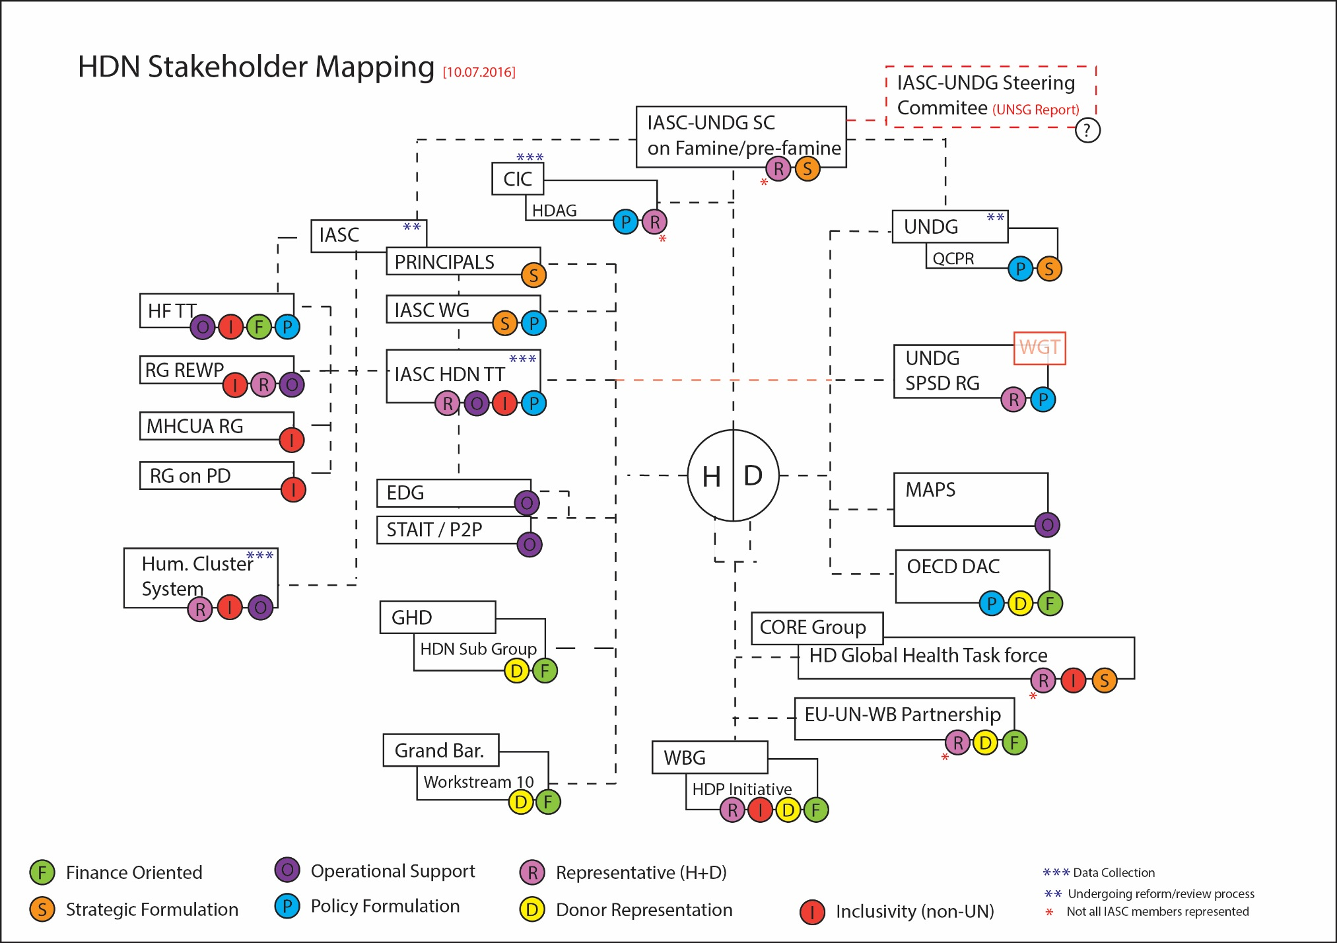
[06.10.2017]
UNDG TT A
RG on Gender

Joint IASC TT and UN WG Transition, 21-22 October 2016.
Secretary-General's statement on the first anniversary of the World Humanitarian Summit
A/72/76–E/2017/58, “Strengthening of the coordination of emergency humanitarian assistance of the United Nations, advance unedited draft”, para 79, May 2017.
SG Report “Repositioning the UN development system to deliver on the 2030 Agenda – Ensuring a Better Future for All”, Advanced Unedited Version, para 77, 30 June 2017.
See HC/RC Survey Results.
For full articulation of these lines of thought, refer to Analysis on the Intersection between NWoW and Sustaining Peace, drafted for IASC WG meeting, April 2017, Rome, available at https://interagencystandingcommittee.org/working-group/content/iasc-wg-analysis-papwer-nwow-sustaining-peace.
Panel Discussion: Protracted crises, ECOSOC - Humanitarian Affairs Segment 2017, chaired by ERC O’Brien, with panelist Mr. Amir Mahmoud Abdulla, Deputy Executive Director, World Food Program [http://webtv.un.org/watch/panel-discussion-protracted-crises-ecosoc-humanitarian-affairs-segment-2017/5481209238001] 1h32m / 2h.32m : “It is about a change in mindset (…) we all need to stop thinking about humanitarian and development action as if they were two separate things. We do have a framework of leaving no one behind and reaching the furthest first. This framework is hugely principled and humanitarian in nature”
Panel Discussion: Protracted crises, ECOSOC - Humanitarian Affairs Segment 2017, with panelist Ms. Ahunna Eziakonwa - Onochie , UN Resident Coordinator and Humanitarian Coordinator in Ethiopia [http://webtv.un.org/watch/panel-discussion-protracted-crises-ecosoc-humanitarian-affairs-segment-2017/5481209238001] 02h.09m
A/72/76–E/2017/58, “Strengthening of the coordination of emergency humanitarian assistance of the United Nations, advance unedited draft”, para 80, May 2017.
SG Report “Repositioning the UN development system to deliver on the 2030 Agenda – Ensuring a Better Future for All”, advanced unedited version, paras 81-82, 30 June 2017.
Borne out of the recognition that for the NWoW to advance strong and effective partnerships would need to be created with the UNDG, the HDN TT undertook a series of activities in collaboration with the UN Working Group on Transitions. This joint work culminated in a joint workshop in October 2016, which laid the foundation of a joint Plan of Action, through which common objectives and activities could be planned between those two IASC and UNDG bodies. Since then the UN WGT has been dissolved and its work put on hold until the new RG on Sustainable Development and Sustaining Peace recently began its work. The HDN TT has already began planning ahead on future joint activities and workshops with this new body, and sees this collaboration as integral to the coherent operationalization of NWoW.
This is drawn from TT meeting summaries, a series of bilateral conversations with TT members, as well as strategic discussions with co-chairs of other IASC References Groups and Task Teams and subsidiary bodies in the UNDG, undertaken by TT Co-chairs in the period Dec 16-March 17, available at https://interagencystandingcommittee.org/iasc-task-team-strengthening-humanitariandevelopment-nexus-focus-protracted-contexts/documents/hdn.
Subsidiary bodies of the IASC are not limited to the official membership of the IASC.
SG Report “Repositioning the UN development system to deliver on the 2030 Agenda – Ensuring a Better Future for All”, advanced unedited version, para 75, 30 June 2017.
General Assembly resolution (A/RES/70/262) and a Security Council resolution (S/RES/2282), OP 10, 27 April 2016,
SG Report “Repositioning the UN development system to deliver on the 2030 Agenda – Ensuring a Better Future for All”, advanced unedited version, para 76, 30 June 2017.
See http://www.alnap.org/resource/20505, http://www.undp.org/content/dam/undp/library/corporate/speakercorner/a-practitioner-guide-to-area-based-development-programming.pdf, https://www.odi.org/sites/odi.org.uk/files/odi-assets/publications-opinion-files/3437.pdf amongst others.
See workplan of activities for full details on concrete activities.
See full value added mapping in annex
and its successor group

