IASC Task Team on Strengthening the Humanitarian Development Nexus in Protracted Settings

PROGRESS REPORT: q2/2016 – q4/2017

BACKGROUND:
This document is prepared in response to a request made during the Ad hoc meeting of IASC Working Group (WG) on the IASC Task Team on Strengthening the Humanitarian Development Nexus in Protracted Settings (HDN TT). During this meeting, the IASC WG agreed to “undertake an initial review of the endorsed HDN Workplan by 31 December 2017, and establish the timetable for subsequent reviews as necessary”. To this end, this document outlines key achievements and products by the HDN TT since its inception as background for this review. Given this specific request, this document is designed to provide additional granularity and information to the standard IASC subsidiary body progress reports.

MEMBERSHIP:
The workplan and its activities, achievements, and products represent individual organizational efforts made on behalf of, consulted with, and validated by the TT membership. Since its inception, the TT membership has grown steadily, now consisting of over 60 individuals from 21 UN agencies, NGOs, the Red Cross and Crescent Movement as well as not-for-profit think tanks. Since Q2 2016, these members have met 15 times as a group and have held a total of 13 bilateral meetings with the co-chairs.

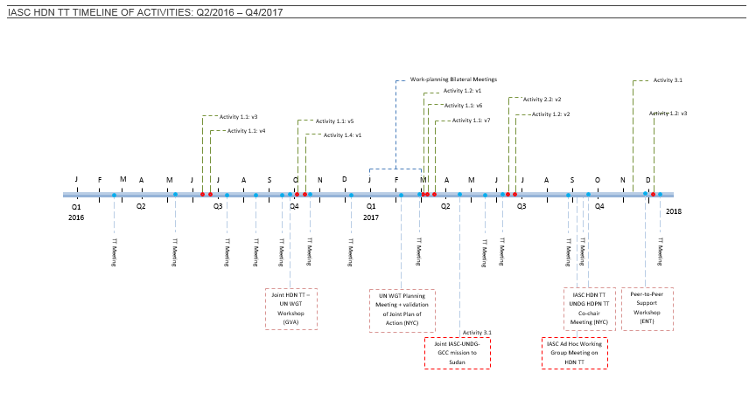
STRUCUTRE OF THE WORKPLAN:
As agreed by the WG through the WG Statement of Intent the HDN TT is the interagency forum for convening, presenting and formulating the collective views of the IASC TT members around the issue of strengthening the humanitarian development nexus. . To achieve this, the HDN TT’s workplan is organized around three main objectives:

- Shape and contribute to common understanding of what is required to strengthen the humanitarian development and peacebuilding nexus;
- Review and assess current policy, guidance and operational tools based on common understanding to identify gaps and best practices; and
- Ensure coherence in field support towards successful implementation of the New Way of Working

In addition, in line with calls from the WG to create and maintain functional linkages with development oriented inter-agency mechanism. The HDN TT also contributes to a joint Plan of Action in collaboration with the UNDG Sustainable Development / Sustaining Peace Results Group (UNDG SDSP RG) Task Team A on the Humanitarian, Development and Peace Nexus.

Objective 1: Shape and contribute to common understanding of what is required to strengthen the humanitarian development and peacebuilding nexus

Activity 1.1: Mapping of existing global processes and mechanisms
ONGOING
One of the first tasks the HDN TT undertook was to establish and maintain an informational mapping of existing global processes, initiatives, and mechanisms, operational tools, and field-level activities. The mapping has served as a living resource for field and policy practitioners as well as donors [HDP Nexus mapping].
Activity 1.2: Develop key messages and a common narrative on Humanitarian Development Nexus
ONGOING
There is a growing sense of confusion at the multiple sources of information and messaging on the NWoW and other similar/related initiatives. The co-chairs of the HND TT, in collaboration with the co-chairs of the UNDG TT A on Humanitarian Development and Peace Nexus are in the process of developing Principals-level Key messages. The first, draft has been reviewed by HDN TT members, and currently sits with the ‘counterpart TT’ in the UNDG [Draft Key Messages].
Activity 1.2: v2

Activity 1.3: Understanding the linkages with Sustaining Peace and Prevention
COMPLETE
This analysis was drafted through HDN TT consultations as part of the HDN TT’s role in producing strategic analysis in support of policy-setting discussion. As such it was used as a background document for the WG deliberations [Q2 2017] and will form the basis of future work by the IASC Reference Group on Principled Humanitarian Action and the UNDG TT A on Humanitarian Development and Peace Nexus [Analysis Paper].

Activity 1.4: Expand on typologies of response scenarios
ONGOING
These typologies was drafted as an important element and visualisation of how the imperative to protect humanitarian space and principles fit in, particularly in situations of conflict. Different types of settings will require a different blend of planning tools and analysis, as well as to what extent humanitarian actors can and should engage with other actors without compromising humanitarian principles. An orientation to typologies of country and sub-national contexts can offer practical guidance to field colleagues on how to avoid a one-size-fits-all approach [draft v1. Typologies Paper].

Activity 1.5: Articulating Collective Outcomes
ONGOING
The notion of collective outcomes, in addition to joint analysis and assessments, is considered a central aspect of what is new in the current global policy thrust to improve humanitarian and development collaboration. Since its inception, the HDN TT’s agreed approach has been to monitor and learn instead of produce guidance on this aspect of the HDN. After 18 months of trialling, there is now a clear call from field practitioners (see activity 2.2 and 2.3) for clear guidance, which in turn can be adapted to context. In particular, in light of the several agency-specific guidance notes and the need for collective buy-in, field colleagues have asked for inter-agency guidance to be developed on collective outcomes that is representative of the breadth of sectors and endorsed by a majority of stakeholders including NGOs. In 2018, a study will be commissioned by the HDN TT to gather evidence specifically on this topic.
Objective 2: Review and assess current policy, guidance and operational tools based on common understanding to identify gaps and best practices

Activity 2.1: Open source platform of operational tools:
ON HOLD
The aim of this activity was meant to gather and make accessible the many tools developed to date that can showcase how humanitarian efforts and development work can be brought closer together to better address risks and vulnerabilities when done successfully. However, implementation of joined up planning and programming is currently considered too nascent for a platform to be established for the time being. In the meantime, to fill the gap in information sharing a community of practice (2.3) has been established with an interim dropbox online repository function.

Activity 2.2: Global survey of field practitioners
COMPLETE
The HDN TT was tasked by the WG (ref 92nd IASC WG meeting, 5-6 April 2017) to reach out to HC/RCs with the objective of clarifying gaps and required guidance on the operationalization on the New Way of Working. The findings were clear: despite the strides at policy and field level, the survey conducted in July 2017 highlighted that i) understanding in country teams varies; ii) the parameters of NWoW remain unclear; iii) implementation is unequal; and further support and guidance is required. The HDN TT also conducted a pre-workshop questionnaire ahead of the Peer-to-Peer support network workshop held in Entebbe, Uganda at the request of field colleagues (2.3) which validated the findings [Survey Analysis].
ONGOING

Activity 2.3: Peer-to-Peer engagement and communities of practice
- In Q4, 2017, a Peer-to-peer support network meeting was convened by the HDN TT. Held in conjunction with a regional multi-stakeholder meeting, it targeted approximately 20-25 peer practitioners including representatives from the UN, NGO community and the Red Cross and Red Crescent Movement, possessing the mind-set, in-depth knowledge and hands-on experience in advancing a strengthened collaboration across sectors in the field. The primary aim of this workshop was to facilitate cross-learning, peer-to-peer knowledge exchange and pragmatic trouble-shooting advancing a strengthened collaboration across sectors in the field and included colleagues from FAO, IOM, UNHCR, WFP, WHO, OCHA, UNDP, UNDG (Great Lakes), RCOs, IFRC, ICRC, ICVA and CRS from the 6 countries of Uganda, Ethiopia, Chad, Mali, Cameroon and Sudan as well as regional representation and HQ colleagues from UNDP, OCHA, UNHCR, FAO, WFP and DOCO [Agenda, Participants list, and Executive Summary].
COMPLETE

- The participants of the workshop in Entebbe, established a community of practice (HDN CoP) supported by the HDN TT. The CoP will include practitioners from UN, NGOs, ICRC, IFRC and, as relevant, can also be expanded to other constituencies (e.g. IFIs). The HDN TT will act as a Secretariat by providing support to a) establish a web-based platform, password protected for practitioners’ use and exchange of information; b) convene periodic teleconferences and webinars; c) organise further and geographically spaced workshops with field practitioners working to strengthen HDN. Lastly the practitioner outlined the objective of the CoP to, constitute a light roster of deployable staff for short term support upon request from HCT/UNCT and share HCT/UNCTs requests for surge capacity to support the NWoW [click here for draft Community of Practice ToRs].
ONGOING

Activity 2.4: Evidence Gathering
COMPLETE

Information on country efforts to strengthen humanitarian, development and peacebuilding collaboration will be collected and analysed with a view to use the findings for several purposes, including but not limited to: advocacy materials, a ‘catalogue’ (or other format) with promising practices, documents to support the establishment of peer networks and peer support structures, and communications on blockages to be addressed at HQ. As part of this process, preliminary HDN Progress Snapshots, were developed by the peer-to-peer workshop participants (2.3), using the findings from the HC/RC survey (2.2) and the Pre-workshop questionnaire as starting points. These snapshots will serve as baseline documents to track progress against five key elements of strengthening the humanitarian development and peace nexus i.e. Analysis, Planning, Programming, collective outcomes, and leadership/coordination [HDN Snapshots for: Chad| Cameroon | Mali | Sudan | Uganda| Ethiopia]

Activity 2.5: Review of IASC Emergency Response Protocols
ON HOLD
As part of wider efforts to gain better normative understanding, and building on the criteria and typologies paper (1.4) this activity will aim to systematically review and assess the existing IASC Response Protocols for the relevance and applicability to protracted situations. A preliminary analysis was conducted in Q3 2016 (and presented in HDN TT meeting of 17.08.2016). The analysis used “5 dimensions” of HDN as outlined in the SG report to WHS to review and propose areas of TA protocols that need to be amended or included in order for them to be applicable in protracted crises. This preliminary work was put on hold with the view of allowing field-driven innovation to occur organically. To this end, it was agreed that the HND TT will aim by Q4 2018 to review evidence (2.4) and recommendations stemming from the peer-to-peer experts (2.3). Based on this combined learning the HDN TT will provide, for the IASC WGs consideration a set of system wide recommendations on the applicability of IASC protocols in protracted settings [preliminary review of TA protocols ppt]
Objective 3: Ensure coherence in field support towards successful implementation of the New Way of Working
ONGOING

Activity 3.1:Field Support:
- In 2017, the HDN TT continued to review and assess current policy, guidance and operational tools to identify gaps and good practices in field operations, collate good practices, and provide technical support and guidance on the implementation of the NWoW. To this end a field support mission was undertaken to Sudan, at the request of the RC/HC and in collaboration with the then UN Working Group on Transition and the Global Cluster Coordinators [Sudan Mission Report]
COMPLETE

- Also at the request of the HC/RC Mali terms of reference are currently being finalized to provide short term support to the UNCT to further current advancements in strengthening collaboration between humanitarian, development, and mission actors. Following the Entebbe peer-to-peer support network meeting the support request will be refined to reflect more recent achievements [draft surge request document].
ONGOING

- A meeting was held between the HDN TT co-chairs and the leadership team of the Senior Transformative Agenda Implementation Team (STAIT), now known as the P2P support team. It was agreed that joint modalities will be developed to streamline how the expertise in the HND TT and beyond can be leveraged after STAIT missions identify specific gaps in operations that relate to strengthening analysis, planning, programming and/or coordination between humanitarian, development, and peacebuilding activities. This process has been put on hold pending the proposed EDG discussion on the scope and role of the P2P support group, to be held in Q4 2017.
ON HOLD

