

**Piloting the IASC Guidelines on Inclusion of Persons with Disabilities in Humanitarian Action:**

Disability Inclusion in Gender-Based Violence Programming in Jordan, Sri Lanka, and Uganda

**Report**

**May 2019**

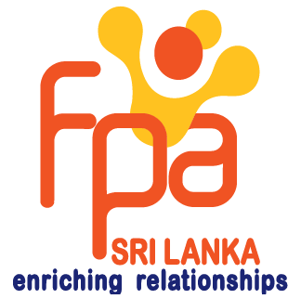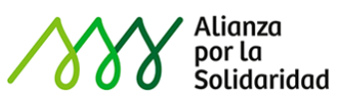

# Introduction

The Women’s Refugee Commission (WRC) improves the lives and protects the rights of women, children and youth, including those with disabilities, displaced by crisis and conflict. We research their needs, identify solutions and advocate for programs and policies that strengthen their resilience and drive change in humanitarian practice.

With funds received from the Australian government, WRC is supporting the work of the Inter-Agency Standing Committee (IASC) Task Team mandated to develop global Guidelines on Inclusion of Persons with Disabilities in Humanitarian Action, assuming a technical lead role to:

1. ensure gender is mainstreamed across the IASC Disability Guidelines in consultation with humanitarian stakeholders;
2. ***draft and pilot sector-specific guidance for GBV prevention and response actors on disability inclusion (completed in February 2019);*** and
3. develop and deliver training packages to support the rollout and implementation of the IASC Disability Guidelines (planned in 2019-2020).

This report summarizes the main outcomes and learning derived from the pilot projects implemented by a consortium of organizations engaged in humanitarian action in Jordan, Sri Lanka, and Uganda (objective 2). In particular, we are grateful to Allianza por la Solidaridad (ApS) in Jordan, Family Planning Association (FPA) in Sri Lanka, and the National Union of Women with Disabilities in Uganda (NUWODU), together with their consortium partners, for leading pilot activities.

# Background

The World Humanitarian Summit (WHS) in May 2016 provided a unique opportunity to promote global political commitment, and establish concrete actions, for more inclusive humanitarian action. Launched at WHS, the *Charter on Inclusion of Persons with Disabilities in Humanitarian Action* calls for signatories to *“develop, endorse and implement policies and guidelines … to improve inclusion of persons with disabilities in emergency preparedness and responses”* and to *“pay specific attention to the situation of women and girls of all ages with disabilities.”*[1]To date, some 200 stakeholders, including States, UN agencies, networks, and civil society organizations, have endorsed the *Charter*[2] and in a critical step to support the implementation of the Charter, the IASC has established a multi-stakeholder Task Team, representing more than 70 different organizations,[3] to develop the ***IASC Guidelines on Inclusion of Persons with Disabilities in Humanitarian Action*** (IASC Disability Guidelines).

The development of the IASC Disability Guidelines marks a significant step in advancing accountability for the inclusion of persons with disabilities within inter-agency coordination mechanisms. However, ensuring non-discrimination requires that such guidelines be gender sensitive and advance the protection, empowerment, and leadership of women and girls. Furthermore, humanitarian actors will need to adapt their own institutional policies, processes, and tools, and those managing and leading humanitarian operations will need to develop and apply appropriate knowledge and skills to ensure the implementation of such guidelines. To this end, the WRC brings particular expertise within the wider humanitarian sector to support this work.

**WRC’s Role on the IASC Task Team:**

WRC, as a member of the IASC Task Team mandated to develop the IASC Disability Guidelines, is supporting the work of the Task Team, with funds provided by the Australian government, assuming a technical role to:

* Ensure gender is mainstreamed across the IASC Disability Guidelines in consultation with humanitarian stakeholders (ongoing);
* Draft and pilot sector-specific guidance for GBV prevention and response actors on disability inclusion (completed);
* Develop and deliver training packages to support the roll out and implementation of the IASC Disability Guidelines (planned for 2020).

**Purpose and Objectives of the Pilot Project:**

* Provide feedback on the Guidelines.
* Identify capacity development resources and needs to support pilot activities.
* Collate broader recommendations from partners on rollout of the Guidelines.

**Process & Timeline:**

|  |  |
| --- | --- |
| April – May 2018 | Gender-specific consultations held with GBV and gender stakeholders in Asia and Africa, GBV section drafted |
| September 2018 | GBV section drafted and a competitive call to pilot the guidelines is widely circulated (August 2018) |
| October 2018 | 19 concept notes were received from organizations interested in piloting the draft GBV section of the IASC guidelines representing all regions |
| November 2018 | 3 pilot projects were launched with a consortium of pilot partners[4] and trainings on the Guidelines were conducted by WRC to support pilot activities |
| December - January/ February 2019 | Pilot activities implemented |
| March 2019 | Case studies/Final reports submitted to WRC |

# Design & Methodology

WRC launched a call for concept notes requesting interested organizations tosubmit proposals not to exceed US$26,000 to pilot select portions of the GBV-specific guidance in their programs within a three-month implementation window.

The **criteria for selection** included:

* Geographic diversity: regions/contexts/settings
* Partnerships with and by organizations of persons with disabilities (OPDs)
* Demonstrated experience implementing GBV activities
* Types of pilot activities proposed in alignment with the recommended actions of the GBV section.

WRC provided technical support to pilot partners to ensure pilot activities were in alignment with the Guidelines, facilitated a training, and supported pilot partners to monitor and document outcomes and recommendations to be shared with the wider IASC Task Team.

**Data collection sources:**

* 3 pilot training reports
* 3 midterm monitoring interviews
* Case studies
* Written feedback and interviews following submission of case studies

# Pilot contexts

|  |  |  |  |  |
| --- | --- | --- | --- | --- |
|  | | ***Jordan*** | ***Sri Lanka*** | ***Uganda*** |
| **Crisis type** | * Rapid onset |  | x |  |
| * Slow onset/cyclical |  |  |  |
| * Health emergency |  |  |  |
| * Mass forced displacement | x |  | x |
| * Armed conflict, including protracted |  |  |  |
| **Location type** | * Rural |  | x | x |
| * Urban | x | x |  |
| * Camp/Settlement |  |  | x |
| **Phase of humanitarian action** | * Disaster Risk Reduction (DRR) |  | x |  |
| * Preparedness |  | x |  |
| * Response | x | x | x |
| * Recovery/Reconstruction |  | x |  |

# Pilot activities

The following actions from the GBV section of the April 2018 draft of the IASC Guidelines were proposed and implemented by pilot partners:

|  |  |  |  |
| --- | --- | --- | --- |
| 1. ***Assessment, Analysis, and Planning*** | ***Jordan*** | ***Sri Lanka*** | ***Uganda*** |
| 1.1 Assess the attitudes and assumptions of GBV program staff and service providers on disability inclusion. Ensure persons with disabilities are included in age- and gender-appropriate community consultations on GBV, employing participatory methods to identify barriers and appropriate strategies to make GBV activities and services accessible to them. | x | x | x |
| 1.2 Map local organizations of people with disabilities (OPDs), identifying who they represent and their capacity development needs on safe identification and referral of GBV survivors. | x | x | x |
| 1.3 Set quotas for including persons with disabilities in age- and gender-appropriate community consultations on GBV, identifying barriers and appropriate strategies to make GBV activities and services accessible to them. |  |  |  |
| 1. ***Resource Mobilization*** |  | | |
| 2.1 Develop proposals that reflect awareness of particular GBV risks for women, men, girls, and boys with disabilities. |  |  |  |
| 2.2 Integrate and mainstream content about persons with disabilities and their caregivers in core GBV training packages, including through case studies and topics on disability into practitioner training and community awareness-raising materials. | x | x | x |
| 1. ***Implementation*** | ***Jordan*** | ***Sri Lanka*** | ***Uganda*** |
| 3.1 Recruit persons with disabilities as staff, volunteers, and community mobilizers, with consideration for gender balance where appropriate in your GBV activities. |  |  |  |
| 3.2 Strengthen national policies and protocols, including standard operating procedures, case management systems, and referral systems, to ensure confidential, compassionate, and quality care for GBV survivors with disabilities in line with a survivor-centred approach. | x |  |  |
| 3.3 Incorporate universal design features into the construction of new women’s centres, health clinics, safe houses, and transportation systems. |  |  |  |
| 3.4 Facilitate the participation of women and girls with disabilities in peace negotiations and peace building, in line with international commitments. |  |  |  |
| 1. ***Coordination*** |  | | |
| 4.1 Engage local OPDs and, in particular, women-led OPDs to support their capacity development needs in the safe identification and referral to appropriate services of GBV survivors. | x | x | x |
| 1. ***Monitoring and Evaluation*** |  | | |
| 5.1 Monitor how many persons with disabilities (disaggregated by sex and age) are attending age- and gender-appropriate GBV activities. | x | x | x |
| 5.2 Establish safe, accessible, and confidential complaint mechanisms aligned with prevention of sexual exploitation and abuse (PSEA) standards. |  |  |  |

# Outcomes

**Linked to the recommended actions in the GBV section of the guidelines, the following outcomes were documented across the various pilot projects:**

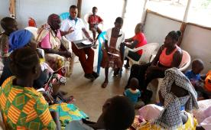Identification of GBV-related risks, barriers, and strategies: All three projects conducted community consultations with different gender and age groups of persons with disabilities to identify GBV-related risks, barriers, and strategies to strengthen their inclusion (actions 1.1 and 1.3).

In Uganda, girls with disabilities highlighted concerns related to confidentiality by service providers.

*“The officers at the complaints desk do not understand disability. If you come without another person, you will not be helped, but sometimes you do not want others to know. Some leaders should be trained on confidentiality because this will help girls to always come to report.”* – Girls with disabilities group discussion.

*Consultation meeting with refugee women with disabilities in Bididi settlement, Uganda*

In Jordan, persons with disabilities and parents of children with disabilities were engaged in the needs assessment and design of the project, making recommendations on their needs related to GBV and sexual and reproductive health (SRH), the facilities, programs implemented, and the target groups that should be prioritized.

Strengthened capacity of GBV service providers on GBV and disability inclusion: All three projects involved a component of assessing GBV staff attitudes, perceptions, or their capacity development needs on disability and GBV-related risks for women and girls with disabilities, followed by trainings (actions 1.1, 1.2, and 2.2)

FPA in Sri Lanka targeted a cross section of government officials representing health, social services, disaster management, women’s and children’s affairs at the district, division, and community levels, which facilitated cross-sectoral dialogue between agencies that did not often interact but were responsible for addressing GBV, persons with disabilities, or disaster management; the pilot project provided an opportunity for government agencies to discuss the close intersection of the three areas.

In Jordan and in Uganda, pilot partners trained coalition members on GBV core concepts and safe identification and referrals as a critical step to prioritizing safety and dignity and in adherence of the “do no harm” principle.

Trainings of GBV and protection service providers operating in Bidibidi settlement camp in Uganda resulted in commitments to strengthen disability inclusion in their work. As an example, International Rescue Committee (IRC) GBV staff agreed to disaggregate disability data in their GBV information management systems database.

Enhanced coordination and referral pathways: Through consultations and trainings with women and girls with disabilities, networking among service providers and government authorities, and coordinating with coalition members, all three pilot projects reported taking steps to strengthen referral pathways for women and girls with disabilities and to strengthen coordination among different service providers and government authorities (actions 1.2 and actions 3.2).

Coalition members in Jordan developed a common standard operating procedure (SOP) and monitored implementation across their various services to ensure that they were accessible to persons with disabilities at risk and survivors of GBV.

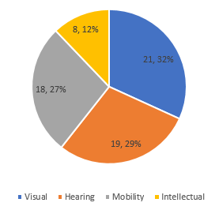Monitored access and participation of persons with disabilities: Pilot projects in Jordan and Sri Lanka were able to monitor and report on how different age and gender groups were attending GBV activities (action 5.1). In Sri Lanka, FPA and Disability Organisations Joint Front (DOJF) selected participants in pilot activities with consideration for age, gender, and different types of disabilities. Based on an analysis of these results, pilot partners adapted their strategies accordingly by inviting caregivers, paying transport allowance, using sign language interpreters, and adapting sensitization messages to ensure they were reachingpersons with intellectual disabilities, girls with disabilities, and persons with hearing impairments.

*Breakdown of participants and percentage by disability, Sri Lanka*

Fostered partnerships with organizations of persons with disabilities: as a key criteria for selection, all projects were implemented through a coalition of partners either with an OPD with expertise on GBV as the lead agency (Uganda) together with a national OPD focused on advocacy and accessibility, with a community-based organization, a GBV and SRH-focused organization partnering with an umbrella network representing organizations of different disabilities (Sri Lanka), or through a GBV actor in partnership with a disability service provider organization, a GBV and SRH service provider, and an OPD focused on advocacy with expertise on accessibility (in Jordan) (actions 1.2 and 4.1). All pilot projects reported on the experience of implementing activities as a coalition, positively.

*“It is useful to foster cooperation amongst organizations with different fields of expertise (especially GBV and disability), so as to profit from each one’s experience and knowledge and ensure the integration of services*.” --APS, Jordan.

# Process Learning

* Immediate feedback obtained from pilot trainings were integrated into subsequent revisions of the GBV draft. These were:
* Strengthened language on safe and ethical collection of data related to sexual violence.
* Added additional content to recommended actions and supplementary guidance notes that were not well understood (e.g., on participation in peacebuilding initiatives and PSEA mechanisms).
* Provided further detail in the guidance notes to supplement recommended actions and provide additional information for readers.
* Clarified the role of GBV actors in conducting community consultations in line with global standards.
* Tools and resources used by pilot partners to support implementation of activities included:
* Their own internal training materials (on GBV, SRH), some of which were adapted to include disability inclusion (topics included the CRPD, accessibility);
* WRC tools: Documenting ‘Stories of Change’ Tool; Staff Reflection Tool;[5]
* IASC Disability Guidelines draft (translated into local languages);
* Global guidelines and resources- such as the IASC GBV Guidelines.[6]

# Picture of a powerpoint slide titled "Common Principles" under which there are three overlapping circles labeled NUWODU, REHORE, NUDIPU and post-it notes posted inside the different circles. Key Learning

***What do partnerships with OPDs in humanitarian contexts look like?*** A central theme threaded throughout the IASC Disability Guidelines is the need to “increase and strengthen the participation of organizations of persons with disabilities in humanitarian action.”[7] The diversity of OPDs, as well as the types of partnerships formed for the purposes of implementing pilot activities, reveals there is no prescriptive approach to working with OPDs.

However, learning from the pilot projects demonstrated the vital need to:

* **Establish common principles and values across humanitarian and OPD stakeholders**. A “principles activity” provided an opportunity for each agency to establish common or overlapping principles that guide their work and facilitate a discussion clarifying language and where values and expertise were different and unique to their mandate.

from Principles Activity, Uganda

* **Clearly define the roles and responsibilities of each stakeholder**. As a precursor to planning activities, participants from the different organizations were asked to identify their own skills and expertise, as well as the skills and expertise of each agency., This provided a solid basis to plan activities. However, in some of the pilot countries, partners chose to lead on activities without fully considering the skills and expertise required to implement a given activity, and which organization would be most appropriate to fulfill this role. There is a risk that OPDs may take on a lead role in activities for which they might lack appropriate expertise, such as assessing GBV risks in communities, and in turn, risk causing harm to survivors.
* **Ensure protection is mainstreamed, including PSEA standards.** GBV partners demonstrated an awareness of potential negative outcomes when implementing activities but did not appear to have a structured way of identifying and responding to this during program implementation. Additionally, some OPD partners reflected limited awareness of the “do no harm” principle and its implications for their work.
  + With respect to action 5.2, *“Establish safe, accessible, and confidential complaints mechanisms,”* some partners reflected limited awareness of how to establish accessible complaints mechanisms aligned with PSEA standards across several of the pilot projects. As such, there is a need for lead partners to conduct training for staff on this topic and to establish appropriate mechanisms within the project and among coalition members.
* **Strengthened accountability of government stakeholders**. In two of the pilot projects, the role of government authorities both in supporting pilot activities and in responding and strengthening capacity to address the needs identified were key indicators of success. In Sri Lanka, which is considered a disaster preparedness context, FPA identified the government of Sri Lanka as the main target for improved SRH and GBV services for persons with disabilities and subsequently was able to engage multiple government agencies at the national, district, and community levels. In Uganda, where government permission is critical for any work with refugee settlements, good relations with the Office of the Prime Minister (OPM)[8] facilitated the engagement of GBV and protection service providers working in the settlement–and in turn, OPM proved to be a disability champion for other stakeholders.

***Participation of women, men, girls, and boys with disabilities in humanitarian action.*** Finally, all pilot partners demonstrated commitment towards the overall objective of the Guidelines, to ensure that “persons with disabilities are *at the centre*, both as actors, and as part of the affected population.”

* The challenge, for some partners, was to **ensure that this is done in an age- and gender- sensitive** way, as well as to **make targeted efforts to reach more marginalized groups**, such as boys and girls with intellectual disabilities and those with communication difficulties or with psychosocial disabilities.

For example, FPA in Sri Lanka noted that the lack of sign language interpreters was frequently “brought up, highlighted, discussed, and debated during the deliberations.”

*“When we go to the hospital or police station, we have great difficulties in communication. The public health midwife came to my home when I was pregnant. She gave me advice; however, I do not understand what she is telling me.”* – A woman with a hearing disability, Sri Lanka

* The other consideration is to ensure that an analysis of needs- and risks also includes an analysis of the **capacities** of affected communitiesand **strategies** to make protection services more accessible, which has longer term implications for change and impact. Women and girls with disabilities who were trained, demonstrated not only improved knowledge and awareness of GBV and where to access services, but also an interest to share information with others and contribute to the wider empowerment of women and girls in the settlement and host community.

*“When I got trained on GBV, I got the power to support my fellow women with disabilities. I need to be trained as a paralegal so that the community can recognize me.”* Woman with disabilities, Bidibidi settlement, Uganda

*“After the training on GBV, I went and shared with my husband and my in-laws. When there is a community meeting on GBV, they now attend and talk about issues of women with disabilities.”* Woman with disabilities from the host community, Bidibidi settlement

# Conclusion

Information generated from the pilot projects implemented by ApS, FPA, and NUWODU, together with their coalition members, modelled key inclusion approaches and strategies that will be important for the dissemination and uptake of the IASC Guidelines. Despite the short implementation period, all pilot partners were able to report that the coalition arrangements **enhanced their engagement with affected communities of women and girls with disabilities**. The main strategies used were consulting directly with women and girls with disabilities to identify their specific needs and capacities engaging them in the design by identifying gaps and barriers, raising awareness, strengthening capacity of GBV service providers, and engaging in coordination and networking on GBV-related issues in the refugee settlement.

However, this approach is not without risks for women and girls with disabilities and their communities. Asking questions about GBV-related risks and needs without ensuring that protection is mainstreamed in accordance with humanitarian protection principles carries potential for risks for communities and individuals consulted. Nonetheless, the rollout, dissemination, and trainings on the IASC Disability Guidelines to follow endorsement should ensure clear guidance on the “roles and responsibilities of different stakeholders,” “PSEA and accountability,” and “protection mainstreaming,” in alignment with global standards and guidelines.

**For more information about this project, please contact:**

Boram Lee, Disability Advisor, Women’s Refugee Commission – [boraml@wrcommission.org](mailto:boraml@wrcommission.org)

# Acronyms and Abbreviations

APS Allianza por la Solidaridad (Jordan)

DOJF Disability Organisations Joint Front (Sri Lanka)

DRR Disaster risk reduction

FPA Family Planning Association (Sri Lanka)

GBV Gender-based violence

IASC Inter-Agency Standing Committee

IFH Institute for Family Health

IRC International Rescue Committee

MPDL Movement for Peace

NUDIPU National Union of Disabled Persons in Uganda

NUWODU National Union of Women with Disabilities in Uganda

OPD Organization of persons with disabilities

PSEA Prevention of sexual exploitation and abuse

REHORE Restoration and Hope for Refugees (Uganda)

SRH Sexual and reproductive health

WHS World Humanitarian Summit

WRC Women's Refugee Commission

# Annex: ‘Stories of Change’ from Bidibidi settlement, Uganda

Following pilot activities, NUWODU collected ‘Stories of Change’[9] from refugee women with disabilities utilizing a participatory approach to engage beneficiaries in evaluating what kind of change matters the most. The following are two example stories collected by NUWODU staff.

Betty Selua

*I am* ***Betty Selua,*** *aged 23 with a physical disability. I live with my grandmother, parents, and siblings. I participated in the 2018 International Day of Persons with Disabilities celebrations in Nakaseke and used my facilitation allowance to buy a matress and construct a house.*

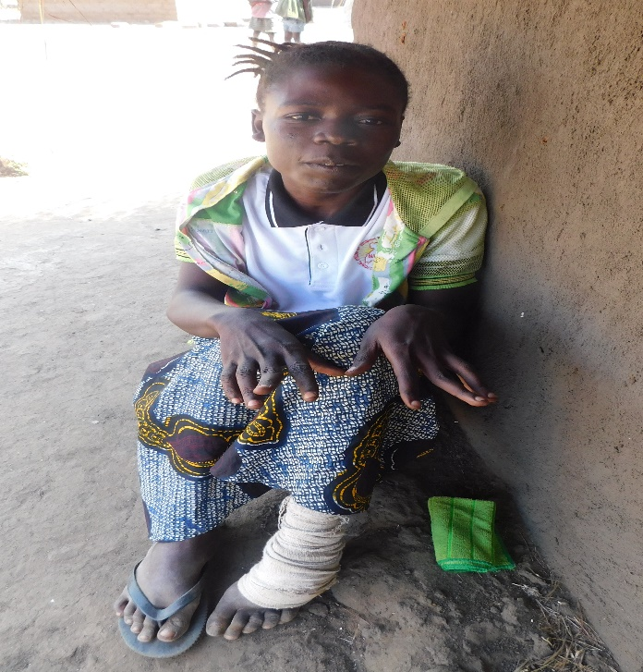

*NUWODU’s training on GBV, rights and GBV referral system was the first of its kind to me and the first training I was attending in my life. I realised that more women suffer from GBV than men and most importantly that persons with disabilities are more at greater risk of gender based violence.*

*The training enabled me to know that pesons with disabilities are important because they have rights just like any other able-bodied persons.*

*The journey to Nakaseke district was thrilling. I was motivated and encouraged when I noticed that there are other women with different disabilities****.***

***From that moment, I realised that I belong;*** *I belong to a family I can identify with; a family of women with different disabilities. I feel part of the community and no amount of words, insults, mockery can shake me! I am confident, I am human.*

**Ms. Selua at the veranda of her new house in Camp Yumbe district.**

*After the celebrations in Nakaseke, I went back a happy person. I did not only receive knowledge but money too! This money did wonders for me and my family. Initially, we slept in shelter made of polythene bags. The facilitation I got from NUWODU helped me construct a grass thatched house. At least we have a house now, even though it’s not permanent. I appreciate the initiative by NUWODU a thousand fold.*

*My parents encouraged me to attend the training and provided my transport to the venue. I want to learn more about people with disabilities generally and women with disabilities specifically. The training venue was made accesible and transport refund was provided. I did not find any challenges in attending the training.*

*I would love to see women with disabilities given livelihood projects like liquid soap making, tailoring and affordable income generating activities so that they are financially and economically empowered to be able to meet their basic necessities in life. I also encourage NUWODU to organise more trainings for girls with disabilities at the village level on specific areas and stakeholders should always plan specific trainings for persons with disabilities.*

Asianju Gloria

*I am* ***Asianju Gloria****, aged 35 years with physical disability. I have been a widow since 2017 and I live with three biological children and six of my husband’s children whose mother also died.*

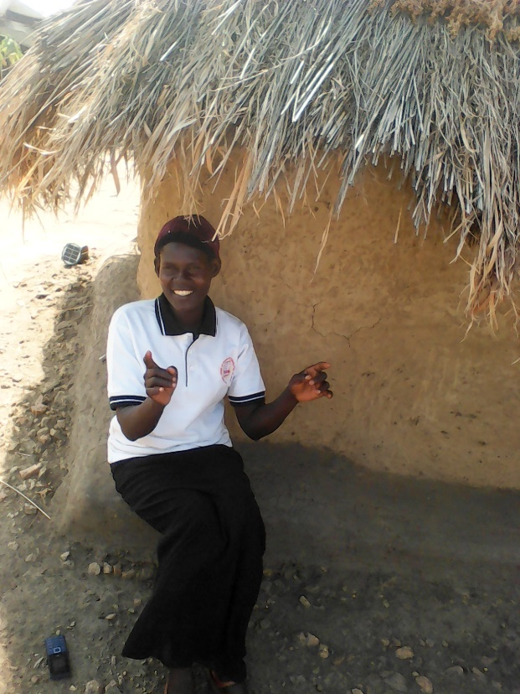

*The International Rescue Committee taught us about hygiene and nutrition and I learned about gender based violence in school.*

*After my husband’s death, my in-laws refused to take care of me as is the culture, saying that they have their wives.This left me defenseless and seen as a target for gender based violence. In the camp, I looked for casual paid employment so that I am not desperate but had no certificate because I lost my secondary education certificate while in transit to Uganda. Last year in 2018, I decided to enroll in secondary school. Since I am older than most students, they named me ‘woman’ which used to bother and stress me a lot.*

*NUWODU’s training and my participation at the International Day of the Disabled in Nakaseke exposed me to new places and many people with disabilities, which totally changed my life. I am confident and focused and no longer ashamed of my disability, age, and nickname ‘woman.’*

***Ms. Asianju at her verandah in Swinga II Settlement Camp sharing about her life.***

*I wish every girl and woman with disability benefited from NUWODU’s training so that people do not take advantage of us. They tackled what affects our lives and the facilitators were practical, teaching us to freely share our experiences. My plan is to concentrate in school and become a teacher because this is where my childrens’ futures lie.*

*NUWODU should train every woman with disability to know about GBV and rights. More so, this provides women with disabilities vocational skills to improve their economic status, be independent and sustain their lives. I am so grateful to organisations like NUWODU that reach to out us even in remote areas.*

1. <http://humanitariandisabilitycharter.org/>
2. Agenda for Humanity. Inclusion of Persons with Disabilities in Humanitarian Action: Update on 2017 Progress Report. Dated 23 May 2017.
3. IASC Task Team on Inclusion of Persons with Disabilities in Humanitarian Action End of Year Report: December 2018. <https://interagencystandingcommittee.org/iasc-task-team-inclusion-persons-disabilities-humanitarian-action/documents/end-year-report-iasc>
4. **From Jordan**, partners were: Allianza por la Solidaridad (ApS), Movement for Peace (MPDL), Institute for Family Health (IFH), and ‘I am Human’; **From Sri Lanka**, partners were: Family Planning Association of Sri Lanka (FPASL) and Disability Organisations Joint Front (DOJF); and **from Uganda**, partners were the National Union of Women with Disabilities in Uganda (NUWODU), the National Union of Disabled Persons in Uganda (NUDIPU), and Restoration and Hope for Refugees (REHORE).
5. WRC (2015). “I See that it is Possible:” A Toolkit for GBV Practitioners. <https://www.womensrefugeecommission.org/?option=com_zdocs&view=document&id=1173>
6. IASC (2015). Guidelines on Integrating GBV Interventions in Humanitarian Action accessed at: <https://gbvguidelines.org/wp/wp-content/uploads/2015/09/2015-IASC-Gender-based-Violence-Guidelines_lo-res.pdf>
7. From the ‘Purpose’ section of the IASC Disability Guidelines (April 2019 version).
8. OPM is the government body responsible for refugee coordination in Uganda.
9. WRC (2015). “I See That it is Possible”: A Toolkit for GBV Practitioners – Tool #12: Documenting Stories of Change, <https://www.womensrefugeecommission.org/component/zdocs/document/download/1158>