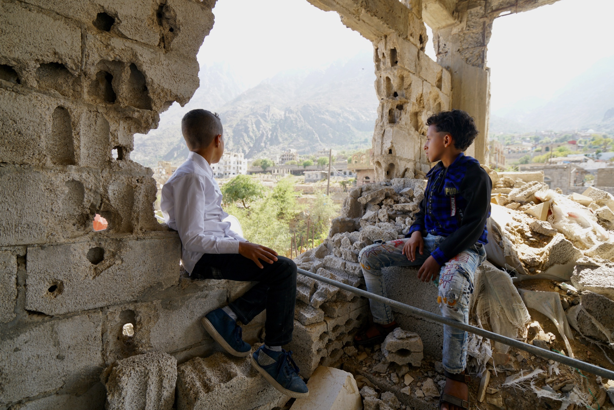

**Announcement Form**

**Submission**

Please return your filled forms by **11 March** to **thompson8@un.org**

**Further information on pledging**

**Ms. Julie Thompson**

[thompson8@un.org](mailto:ismail53@un.org)

**Financial commitments for this conference can be made by filling out and submitting the form below**.

This conference will only record commitments communicated in writing through this form. The financial information provided will be included in the official note of the conference, meanwhile, it will not be made public until the conference is officially closed.

**Participant and follow-up information**

**Registration**

This form is separate from the registration form. The registration form is [available here](https://forms.office.com/Pages/ResponsePage.aspx?id=2zWeD09UYE-9zF6kFubccBQPLHnbDudAs-wPty1uOzFUMjhDQkpKWUZHM0oyTEc5M1pTRjRFSlY4Mi4u).

**Website**

For more information visit: [www.unocha.org/Yemen2022](http://www.unocha.org/Yemen2022)

|  |  |
| --- | --- |
| **Member State / Ministry / Organisation** | |
| **Will make a financial announcement:**  Yes  No | |
| **Announcer / Speaker** | |
| Name: | Title: |
| **Follow-up contact** | |
| Name: | Title: |
| Email: | Telephone: |



**Announcement overview**

**Important notes**

**Please do not include budget support or security aid.** The objective of the conference is to capture announcements for humanitarian activities.

**Please ensure that your pledges are announced at the event in a way that clearly** distinguishes between the years outlined below.

**Please include all humanitarian funding for 2022**, including funding that has been or will be pledged, committed or disbursed.

**Please do not include information about support provided during 2021**. If you wish to report past humanitarian contributions that have not yet been recorded, contact the Financial Tracking Service (FTS) at fts@un.org.

|  |  |
| --- | --- |
| **Currency:**  EUR  USD  Other: | |
| **Channels**:  Yemen Humanitarian Response Plan (HRP)  Bilateral funding  Yemen Humanitarian Fund (YHF)  In-kind support  Other | |
| **Recipients**:  WFP  UNHCR  UNICEF  FAO  WHO  IOM  UNFPA  OCHA  ICRC/IFRC  National NGO  International NGO  YHF  Other | |
| **A. Amount for 2022:** |
| **B. Amount for 2023 and beyond:** |

**A. Announcements for 2022**

|  |  |  |  |  |
| --- | --- | --- | --- | --- |
| **Amount**  Please use same currency as above | **Channel**  Yemen HRP, Bilateral funding, Yemen HF,  In-kind, Other | **Recipient organization / channel** | **Planned disbursement**  Q1 – Q4 | **Details**  Sector, population group multi-year announcement |
|  |  |  |  |  |
|  |  |  |  |  |
|  |  |  |  |  |
|  |  |  |  |  |
|  |  |  |  |  |
|  |  |  |  |  |
|  |  |  |  |  |
|  |  |  |  |  |
|  |  |  |  |  |
|  |  |  |  |  |

**B. Announcements for 2023 and beyond**

**Important notes**

**Please include all humanitarian funding for 2023 and beyond**, specifying amount per year if available.

|  |  |  |  |  |
| --- | --- | --- | --- | --- |
| **Amount**  Please use same currency as above | **Channel**  Yemen HRP, Bilateral funding, Yemen HF,  In-kind, Other | **Recipient organization** | **Planned disbursement** | **Details**  Sector, population group multi-year announcement |
|  |  |  |  |  |
|  |  |  |  |  |
|  |  |  |  |  |
|  |  |  |  |  |
|  |  |  |  |  |
|  |  |  |  |  |
|  |  |  |  |  |
|  |  |  |  |  |
|  |  |  |  |  |
|  |  |  |  |  |

**C. Additional information**

|  |
| --- |
|  |

