Inter-Agency Standing Committee   
Joint IASC Working Group / Emergency Directors Group Meeting

**Biographies of the Presenters and Facilitators**

26 April 2018   
Host: UNDP, New York

**Opening remarks:**

**Mr. Michele Candotti**, Chief of Staff and Director of the Executive Office, UNDP

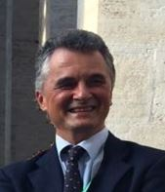Michele is a Chief of Staff and Director of the Executive Office of the United Nations Development Programme from   
1 September 2017.

Michele is an Agricultural and Rural Development professional, with over 30 years of international experience gained in the UN, in international multilateral institutions and international non-governmental organisations, from field - level rural development project operations to public policy processes and organizational management. He was the Director of the Policy and Programme Division of UNEP. He joined UNEP in 2010 as Principal Advisor to the Executive Director and Head of the Office for Policy and Inter-Agency Affairs. In 2011, he was appointed UNEP's Chief of the Executive Office and Principal Policy Adviser to the Executive Director. Previously, he served as Director-General of the World-Wide Fund for Nature (WWF) in Italy for a decade. He began his professional career in 1984 as a Research Officer at a Regional Centre for Agriculture Research in Italy and in 1986 joined the European Commission, first  as a Junior Professional Officer in Zambia, and then through several assignments, from Programme Management (as Coordinator of the European Commission's Microprojects Programme in Zambia), to coordination of the EDF Country Programmes in Zambia and Kenya, where he was responsible for the liaison between the European Commission and the Governments of Zambia and Kenya.

**Session 1: IASC Strategy Discussion: Priorities for Collective Action**

**Session Facilitator: Ms. Clare Dalton**, Head of Humanitarian Diplomacy, ICRC

Clare Dalton has over 15 years experience working for humanitarian organisations. She is currently heading the International Committee of the Red Cross (ICRC)'s Humanitarian Diplomacy Unit in Geneva. She is responsible for designing and delivering effective strategies and joining-up all parts of the ICRC’s diplomacy around its global policy objectives. In this capacity she also oversees the work of ICRC's Delegation to the United Nations in New York. From 2005-2013, she worked for the ICRC in the field in a variety of posts and challenging contexts, including Nepal, Angola, Darfur, Iraq and Kenya. Prior to this she worked with the British Red Cross and briefly with UNDP. Clare has a degree in Anthropology from University College London and an MSc in Conflict and Development Studies from SOAS.

**Presenters:** **Ms. Mbaranga Gasarabwe**, DSRSG/RC/HC/RR for Mali

**Mr. Jamie Mc Goldrick**, Humanitarian Coordinator, Occupied Palestinian Territory (by VTC)

**Ms. Mbaranga Gasarabwe**, DSRSG/RC/HC/RR for Mali



In May 2015, Ms. Mbaranga Gasarabwe was appointed Deputy Special Representative of the Secretary-General for the United Nations Multidimensional Integrated Stabilization Mission in Mali (MINUSMA), United Nations Resident Coordinator, Humanitarian Coordinator and UNDP Resident Representative.

Prior to this, she worked as the Assistant Secretary-General for the Department of Safety and Security in New York. Over the past 25 years working for the United Nations, she served in various capacities both in UNHQ and in the field with UNDP, UNOPS, UNDSS, DPKO including as United Nations Resident Coordinator and UNDP Resident Representative in Benin, Djibouti, Guinea and Mali.

Ms. Gasarabwe, a native of Rwanda, holds a Master’s degree in Economics from the University of Burundi and a Master of Business Administration (MBA) from the Arthur D. Little School of Management, now known as the Hult International Business School (Massachusetts, USA).

**Mr. Jamie Mc Goldrick**, Deputy Special Coordinator for Middle East Peace Process, UN RC and HC for the Occupied Palestinian Territory (by VTC)

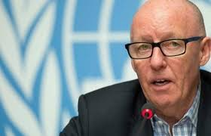Mr. McGoldrick brings extensive experience in humanitarian affairs, international cooperation, economic development and political affairs. Since 2015 he served as United Nations Resident Coordinator, Humanitarian Coordinator and United Nations Development Programme (UNDP) Resident Representative in Yemen. He assumed that position after serving as the Resident Coordinator and the UNDP Resident Representative in Nepal since 2013 and Resident Coordinator and Resident Representative of UNDP in Georgia from 2009 to 2013.

He was previously a senior manager with the United Nations Office for the Coordination of Humanitarian Affairs, notably as the Chief of the Humanitarian Reform Support Unit (2006-2009), and Section Chief ofthe Middle East, North Africa and Great Lakes Unit (2005-2006). He worked with the International Red Cross movement and non-governmental organizations in a number of countries in Africa and as news producer and researcher with several television production companies in the United Kingdom.

Mr. McGoldrick holds a master’s degree in political science and a bachelor’s degree in social sciences, and he has additional qualifications in disaster management, preventive diplomacy and mediation.

Born in Ireland in 1955, he is married and has two children.

Session 2: Review of the L3 emergency response mechanism

**Session Facilitator: Mr. Manuel Fontaine**, Director, Office of Emergency Programmes, UNICEF

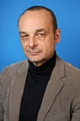Manuel Fontaine took up his position as UNICEF Director of the Office of Emergency Programmes in early January 2017.

Mr. Fontaine has more than 25 years of experience with UNICEF that combines managerial and technical leadership in both development and emergency contexts.

Prior to his current position, Mr. Fontaine served as Regional Director for the West and Central Africa Region (WCAR) where he was responsible for overseeing UNICEF’s programmes in 24 countries. From August 2011 to August 2013, he was WCAR Deputy Regional Director, and before then he was UNICEF Representative in Algeria, Senior Advisor Child Protection in New York Headquarters, Deputy Representative in Afghanistan, Somalia and Albania, and Head of Office in Bosnia and Herzegovina.

Before joining UNICEF, Mr. Fontaine worked for the French Ministry of Foreign Affairs.

Mr. Fontaine is a national of France. He holds a DEA (post-graduate diploma) in International Public Law and International Organizations from the University of Paris I (Pantheon-Sorbonne).

**Session 3: Better Response for Internally Displaced Persons in protracted crises**

**Opening Remarks:** **Ms.** **Cecilia Jimenez-Damary**, SR on HR of IDPs

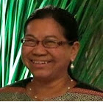Cecilia JIMENEZ-DAMARY (Philippines), LL.M. in Public International Law (King’s Co llege London, UK); MDC in International Organizations-MBA (University of Geneva, Switzerland); LL.B. (Ateneo de Manila, Philippines); B.Sc. in Foreign Service (University of the Philippines). Cecilia Jimenez-Damary is a human rights lawyer specialised in forced displacement and migration. Ms. Jimenez-Damary has over two decades of experience in NGO human rights advocacy for the Asia-Pacific region and also has teaching experience as an adjunct professor of international human rights and humanitarian law. Ms. Jimenez-Damary previously acted as Senior Legal Adviser and Trainer with the Internal Displacement Monitoring Centre (IDMC) of the Norwegian Refugee Council (NRC) in Geneva; as the National Director of the IDP Project of the Commission on Human Rights of the Philippines; and more recently as the government representative to the Philippine Transitional Justice and Reconciliation Commission. Ms. Jimenez-Damary was appointed Special Rapporteur on the human rights of internally displaced persons by the Human Rights Council in September 2016 and assumed the mandate on 1 November 2016.

**Session Facilitator:** **Ms.** **Kate Phillips-Barrasso**, Director, Humanitarian Policy, Interaction

Kate Phillips-Barrasso is the Director of Humanitarian Policy at InterAction, an alliance of over 190 U.S.-based non-governmental organizations engaged in international humanitarian and development work. In this capacity she helps lead the NGO community’s efforts to secure policies for improved humanitarian response and represents the experience and views of InterAction’s members in both U.S. and international humanitarian policy fora. This includes sitting on the Grand Bargain Facilitation Group, the IASC Working Group and UNHCR’s Comprehensive Refugee Response Framework Reference Group.  Prior to joining InterAction, Kate served as the Senior Director of Policy and Advocacy for the International Rescue Committee (IRC). At the IRC, she guided work to draw the attention of policy makers to global humanitarian needs, led advocacy efforts for policy change to better assist people forced to flee war and disaster and oversaw the organization’s relations with the U.S. Congress, U.S. Executive Branch and other NGOs. Kate also worked for several years as a Senior Policy Advisor with CARE, leading the organization’s policy and advocacy efforts on a number of humanitarian and development issues.

**Presenters:**

**Part 1: Mr. Filiep Decorte**, Deputy Director, UN HABITAT,   
New York Liaison Office

**Part 2: Mr. Neal Walker**, Resident Coordinator Ukraine

**Mr. Walter Kaelin**, independent consultant and author,*Breaking the Impasse*

**Mr. Filiep Decorte**, Deputy Director, UN- ABITAT New York Liaison Office

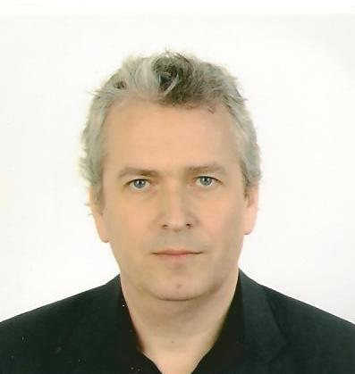He is currently the Deputy Director of UN-Habitat’s New York Liaison Office and the focal point for UN-Habitat’s crisis-related work in New York. He was acting Director from December 2016 to February 2018. He played a key role in developing an urban track towards the World Humanitarian Summit and the emerging Global Alliance for Urban Crises.

During his career, Filiep has predominantly focused on urban initiatives in conflict- and crisis-affected countries, specializing in urban planning, land, and housing issues. He has worked for UN-Habitat for more than fifteen years in different capacities, including long-term assignments in Haiti, the occupied Palestinian territory, Somalia, and Morocco. He also acted as coordinator for UN-Habitat’s Global Disaster Management Program. He was trained as a civil engineer, architect, and urban and regional planner with advanced master’s degrees from the Universities of Ghent and Leuven in Belgium.

**Mr. Neal Walker**, UN Resident Coordinator, Humanitarian Coordinator and UNDP Resident Representative in Ukraine

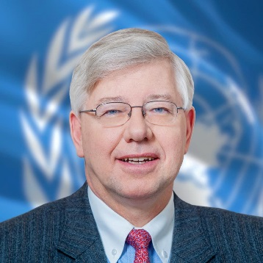Mr. Neal Walker began his duties in October 2014 as UN Resident Coordinator and Humanitarian Coordinator, and UNDP Resident Representative in Ukraine. Mr. Walker has 24 years of senior-level experience working with the United Nations. Prior to joining the United Nations in Ukraine he served as the UN Resident Coordinator and Resident Representative in Bangladesh (2011 – 2014) and Kyrgyz Republic (2006 – 2011); UNDP Chief of Country Offices Oversight & Support for Latin America (2002 – 2006); UNDP Senior Deputy Resident Representative in Guatemala (1999-2002); Deputy Chief covering North East Asia at the UNDP Regional Bureau for Asia and Pacific (1996-1999); UNDP Deputy Resident Representative in Equatorial Guinea (1993-1996); and, Assistant UNDP Resident Representative in Sudan (1990-1993). Mr. Walker has a degree in political science and a master’s degree in public and international affairs from the University of Pittsburgh.

**Mr. Walter Kaelin**, independent consultant and author, *Breaking the Impasse*

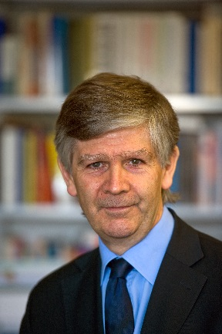Walter Kälin is professor emeritus for international and constitutional law, University of Bern/Switzerland. Presently, he acts as Special Advisor on Internally Displaced Persons to the DSRSG/RC/HC Somalia and Special Advisor to the RC/HC on IDPs in Ukraine. He is also the Envoy of the Chair of the Platform on Disaster Displacement (since July 2017) and the former Envoy of the Nansen Initiative on disaster-induced cross-border displacement (2012 – 1015). Previously, Prof. Kaelin served as Representative of the UN Secretary-General on the Human Rights of internally displaced persons (2004 – 2010), as a member of the UN Human Rights Committee (2003 – 2008 / 2012 – 2014) and as Special Rapporteur of the UN Human Rights Commission on the situation of human rights in Iraqi occupied Kuwait (1991/92).