CHS PSEA INDEX
Revision proposal for comments
Background
The Core Humanitarian Standard on Quality and Accountability (CHS), the result of a global multi-stakeholder consultation, was launched in December 2014 to improve the quality and accountability of humanitarian response by putting people at the centre. It is a set of Nine Commitments to communities and people affected by crisis, stating what they can expect from organisations and individuals delivering humanitarian aid.
The Protection from Sexual Exploitation and Abuse (PSEA) is mainstreamed throughout the CHS and referenced in several Commitments of the Standard. As such, and due to the critical importance of organisations’ ability to assess their performance on PSEA, the relevant indicators were combined into the CHS PSEA Index. This CHS PSEA index has been used by the CHS Alliance and the third-party verification body HQAI since 2015 to indicate the performance of organisations, using any of the four forms of CHS verification, namely self assessment, peer review, independant verification and certification.
Currently, the CHS PSEA Index comprises 18 of the 62 indicators of the CHS. The 18 indicators are all given equal weight in the calculation of the Index. The verification scores feature in the dashboards provided to CHS Alliance members (see Annex 2). These are displayed on the CHS Alliance website and publications, including the 2018 edition of Humanitarian Accountability Report and sector publications such as World Humanitarian Data and Trends 2017.
Given the ongoing issues which have been highlighted and the growing concern about the PSEA in the last months, we would like to explore how we can further develop the CHS PSEA Index to ensure it is giving the best support to organisations and the humanitarian sector. This index could allow them to measure whether their work on PSEA meets existing standards including the the IASC developed a set of Minimum Operating Standards from PSEA (MOS-PSEA), and ensure targeted investments in the quality of their systems.
You are invited to comment this proposal and send a revised version back to the CHS Alliance (bsokpoh@chsalliance.org) by 16 Novemeber 2018.
Proposed elements for revision
The proposal below mainstreams the learnings of both the CHS Alliance and HQAI. It suggests changes at two levels:
- The indicators
The CHS Alliance and HQAI have reviewed the list of indicators to strengthen the focus on the specific aspects that contribute to adequate PSEA management. Indicator 4.6 was added to the list, as experience shows the importance of engaging communities and defining their priorities.
It needs to be noted here that some specific aspects of PSEA are not explicitly covered in the current versions of the CHS and CHS Verification Framework. These aspects include (non-exhaustive list):
- Duty to report allegations or suspicions of SEA;
- Cooperative agreements with partners include commitments to PSEA;
- Dedicated department/focal point is committed to PSEA;
- Written guidance on the provision of victim assistance;
- Specific elements in recruitment and performance management;
- Investigation procedures.
These elements will be included in the guidances notes for the CHS Verification Framework (see the elements indicated in italic in the table below).
- Weighting the indicators
To acknowledge the individual influence and impacts that different indicators have on PSEA management, we suggest weighting the indicators on a simple scale from 1 to 3. The logic behind the proposed weighting sysem is:
- Weighting of 1: Processes that foster an empowering environment/culture of risk awareness, including SEA, but with no direct implication in the actual management of specific cases.
- Weighting of 2: Engagement with affected populations and staff through comprehensive communication from head offices to the ground and awareness-raising on SEA (culture), with a direct impact on the effectiveness of PSEA management at an organisational level.
- Weighting of 3: Organisational processes that directly address PSEA management; mechanisms and tools that allow specific prevention or early identification of SEA cases, or frame the actual organisational response to these.
- Use of the revised CHS PSEA Index
The CHS PSEA index will be used in the following ways:
- The revised index results will continue to be shared by the CHS Alliance in its communication material, including on the CHS Alliance website and in publications. Over time, this will enable us to track progress;
- The CHS PSEA Index will be included in HQAI independent verification and certification reports to reflect the performance of the verified organisation regarding PSEA;
- The CHS PSEA Index may be assessed independently if/when an organisation is willing to assess its performance with regard to PSEA;
- The CHS PSEA Index will be used at response levels (national or regional) together with the AAP and PSEA Task Team of the Inter- Agency Standing Committee’s (IASC).
- For other suggestions regarding possible use of the CHS PSEA Index, please inform the CHS Alliance.

Revision Proposal

Original PSEA index | Suggested changes by CHS Allaince and HQAI |  | Our justification | Reviewer’s suggestion and comments
Indicators | State in the revised index | Ponderation
1.2. Programmes are appropriately designed and implemented based on an impartial assessment of needs and risks and an understanding of the vulnerabilities and capacities of different groups. | To be maintained | 2 | The assessment phase is crucial for the underdanding and awareness of potential risks, including the SEA related riks, although at high level.
2.1. Programmes are designed taking into account constraints so that the proposed action is realistic and safe for communities. | To be maintained | 1 | Related to safe programming.  Linked to awareness of constraints and safety at operational level.
3.6. Programmes identify and act upon potential or actual unintended negative effects in a timely and systematic manner, including in the areas of people's safety, security, dignity and rights, sexual exploitation and abuse by staff, culture, gender, social and political relationships, livelihoods, the local economy, and the environment. | To be maintained | 3 | Related to safe programming.  Includes elements that directly address PSEA systems that should be in place.  Include elements on written guidance on the provision of victim assistance
3.7. Policies, strategies and guidance are designed to prevent programmes having any negative effects such as, for example, exploitation, abuse or discrimination by staff against communities and people affected by crisis, and to strengthen local capacities. | To be maintained | 3 | Includes elements that directly address PSEA systems that should be in place.
3.8. Systems are in place to safeguard any personal information collected from communities and people affected by crisis that could put them at risk. | To be maintained | 1 | Generally related to do no harm in relation to management of sensitive data but not specific to protection against sexual exploitation and abuse by staff.
4.1. Information is provided to communities and people affected by crisis about the organisation, the principles it adheres to, the expected behaviours of staff, and its programmes and deliverables. | To be maintained | 3 | Includes elements that directly address awareness of accepted staff behaviour.
4.5. Policies for information-sharing are in place, and promote a culture of open communication. | To be maintained | 1 | Addresses organisational culture in more general terms, foster adequate environment
4.6. Policies are in place for engaging communities and people affected by crisis and reflect the priorities and risks communities identify in all stages of the work | To be added | 2 | Engagement with communities on risks they identify.
5.1. Communities and people affected by crisis are consulted on the a. design, b. implementation, and c. monitoring of complaints handling processes. | To be maintained | 2 | Direct engagement/consultation of affected populations on Complaints Handling Mechanisms designs.
5.2. Complaints are welcomed and accepted, and it is communicated how the mechanism can be accessed and the scope of issues it can address. | To be maintained | 3 | Effective complaints mechanisms allow the identification of the SEA cases.
5.3. Complaints are managed in a timely, fair and appropriate manner. b. Complaints handling mechanisms prioritise the safety of the complainant and those affected at all stages. | To be maintained | 3 | Directly related to the “how” organisations handle potential complaints safely.
5.4. The complaints-handling process for communities and people affected by crisis is documented and in place. The process covers programming, sexual exploitation and abuse, and other abuses of power. | To be maintained | 3 | Explicit requirement that Complaints Handling Mechanisms cover SEA specifically.  Include elements on investigation procedures
5.5. An organisational culture in which complaints are taken seriously and acted upon according to defined policies and processes has been established. | To be maintained | 1 | Organisational culture aspects, high level.  Include elements on dedicated department/focal point committed to PSEA
5.6. Communities and people affected by crisis are fully aware of the expected behaviour of humanitarian staff, including organisational commitments made on the prevention of sexual exploitation and abuse. | To be maintained | 3 | Direct and significant impact in terms of prevention.
5.7. Complaints that do not fall within the scope of the organisation are referred to a relevant party in a manner consistent with good practice. | To be maintained | 2 | Not explicitly referring to PSEA but has relevance in terms of how cases can be reported externally. It is very linked to whistleblowing, and responsibility of agencies at field level to provide PSEA networks and other agencies with clear informations on how complaints should be referred to them.
8.2. Staff adhere to the policies that are relevant to them and understand the consequences of not adhering to them. | To be maintained | 2 | Awareness of relevant policies amongst staff, but quite broad.  Include specific elements in recruitment and performance management
8.7. A code of conduct is in place that establishes, at a minimum, the obligation of staff not to exploit, abuse or otherwise discriminate against people. | To be maintained | 3 | Directly linked to code of conduct, explicitly mentions PSEA.  Include elements on Duty to report allegations or suspicions of SEA
9.5. The risk of corruption is managed and appropriate action is taken when corruption cases are identified. | To be maintained | 1 | Experienced investigators have pointed out that an environment conducive to fraud is also conducive to SEA.
9.6. Policies and processes governing the use and management of resources are in place, including how the organisation:  a. accepts and allocates funds and gifts-in-kind ethically and legally; b. uses its resources in an environmentally responsible way; c. prevents and addresses corruption, fraud, conflicts of interest and misuse of resources; d. conducts audits, verifies compliance and reports transparently; e. assesses, manages and mitigates risk on an ongoing basis; and f. ensures that the acceptance of resources does not compromise its independence. | To be maintained | 1 | Related to resource management, prevention of corruption and fraud (see justification 9.5).  Include elements on resources are allocated to PSEA and investigating allegation.  Include elements on cooperative agreements with partners include commitments to PSEA  Include elements on cooperative agreements with partners include commitments to PSEA
Reviewer’s general comment:

Annex 1 – Complete list of indicators in the CHS

Commitment 1 | Communities and people affected by crisis receive assistance appropriate and relevant to their needs.
1.1 | The context and stakeholders are systematically, objectively and continuously analysed.
1.2 | Programmes are appropriately designed and implemented based on an impartial assessment of needs and risks and an understanding of the vulnerabilities and capacities of different groups.
1.3 | Programmes are adapted to changing needs, capacities and context.
1.4 | Policies commit to impartial assistance based on the needs and capacities of communities and people affected by crisis.
1.5 | a. Policies set out commitments which take into account the diversity of communities, including disadvantaged or marginalised people. b. Policies set out commitments to collect disaggregated data.
1.6 | Processes are in place to ensure an appropriate ongoing analysis of the context.
Commitment 2 | Communities and people affected by crisis have access to the humanitarian assistance they need at the right time.
2.1 | Programmes are designed taking into account constraints so that the proposed action is realistic and safe for communities.
2.2 | Decisions affecting programming are taken and acted upon without unnecessary delay so that the humanitarian response is delivered in a timely manner.
2.3 | Unmet needs are referred to an organisation with relevant technical expertise and mandate or there is advocacy to address these needs.
2.4 | Programmes are planned and assessed using relevant technical standards and good practice employed across the humanitarian sector.
2.5 | a. Activities, outputs and outcomes are monitored.  b. Programmes are adapted based on monitoring results.  c. Poor performance is identified and addressed.
2.6 | Programme commitments are in line with organisational capacities (see also 8.4).
2.7 | a. Policy commitments ensure a systematic, objective and ongoing monitoring and evaluation of activities and their effects (see 1.3). b. Policy commitments ensure that evidence from monitoring and evaluations is used to adapt and improve programmes. c. Policy commitments ensure timely decision-making with resources allocated accordingly.
Commitment 3 | Communities and people affected by crisis are not negatively affected and are more prepared, resilient and less at risk as a result of humanitarian action.
3.1 | Programmes are built on local capacities and work towards improving the resilience of communities and people affected by crisis.
3.2 | The organisation uses the results of any existing community hazard and risk assessments and preparedness plans to guide activities (see 2.1).
3.3 | Programmes enable the development of local leadership and organisations in their capacity as first responders and promote an appropriate representation of marginalised and disadvantaged groups in local leadership and organisations.
3.4 | A transition or exit strategy is planned in the early stages of the humanitarian programme to ensure longer-term positive effects and reduce the risk of dependency.
3.5 | a. Programmes are designed and implemented in order to promote early recovery. b. Programmes are designed and implemented in order to benefit the local economy (see 3.6).
3.6 | Programmes identify and act upon potential or actual unintended negative effects in a timely and systematic manner, including in the areas of people's safety, security, dignity and rights, sexual exploitation and abuse by staff, culture, gender, social and political relationships, livelihoods, the local economy, and the environment.
3.7 | Policies, strategies and guidance are designed to prevent programmes having any negative effects such as, for example, exploitation, abuse or discrimination by staff against communities and people affected by crisis, and to strengthen local capacities.
3.8 | Systems are in place to safeguard any personal information collected from communities and people affected by crisis that could put them at risk.
Commitment 4 | Communities and people affected by crisis know their rights and entitlements, have access to information and participate in decisions that affect them.
4.1 | Information is provided to communities and people affected by crisis about the organisation, the principles it adheres to, the expected behaviours of staff, and its programmes and deliverables.
4.2 | Communication with communities and people affected by crisis uses languages, formats and media that are easily understood, respectful and culturally appropriate for different parts of the community, especially vulnerable and marginalised groups.
4.3 | Inclusive representation, participation and engagement of people and communities are ensured at all stages of the work.
4.4 | Communities and people affected by crisis are encouraged to provide feedback on their level of satisfaction with the quality and effectiveness of assistance, paying particular attention to the gender, age and diversity of those giving feedback.
4.5 | Policies for information-sharing are in place, and promote a culture of open communication.
4.6 | Policies are in place for engaging communities and people affected by crisis and reflect the priorities and risks communities identify in all stages of the work (see also 1.2).
4.7 | External communications, including those used for fundraising, are accurate, ethical and respectful, presenting communities and people affected by crisis as dignified human beings.

Commitment 5 | Communities and people affected by crisis have access to safe and responsive mechanisms to handle complaints.
5.1 | Communities and people affected by crisis are consulted on the a. design, b. implementation, and c. monitoring of complaints handling processes.
5.2 | Complaints are welcomed and accepted, and it is communicated how the mechanism can be accessed and the scope of issues it can address.
5.3 | a. Complaints are managed in a timely, fair and appropriate manner. b. Complaints handling mechanisms prioritise the safety of the complainant and those affected at all stages.
5.4 | The complaints-handling process for communities and people affected by crisis is documented and in place. The process covers programming, sexual exploitation and abuse, and other abuses of power.
5.5 | An organisational culture in which complaints are taken seriously and acted upon according to defined policies and processes has been established.
5.6 | Communities and people affected by crisis are fully aware of the expected behaviour of humanitarian staff, including organisational commitments made on the prevention of sexual exploitation and abuse.
5.7 | Complaints that do not fall within the scope of the organisation are referred to a relevant party in a manner consistent with good practice.
Commitment 6 | Communities and people affected by crisis receive coordinated, complementary assistance.
6.1 | The roles, responsibilities, capacities and interests of different stakeholders are identified.
6.2 | The response complements the action of national and local authorities and other actors.
6.3 | The organisation participates in relevant coordination bodies and collaborates with others in order to minimise demands on communities and maximise the coverage and service provision of the wider humanitarian effort.
6.4 | Information is shared with partners, coordination groups and other relevant actors through appropriate communication channels.
6.5 | Policies and strategies include a clear commitment to coordination and collaboration with others, including national and local authorities without compromising humanitarian principles.
6.6 | Work with partners is governed by clear and consistent agreements that respect each partner’s mandate, obligations and independence, and recognises their respective constraints and commitments.
Commitment 7 | Communities and people affected by crisis can expect the delivery of improved assistance, as organisations learn from experience and reflection.
7.1 | Programmes are designed based on lessons learnt and prior experience.
7.2 | The organisation learns, innovates and implements changes on the basis of monitoring and evaluation, and feedback and complaints.
7.3 | Learning and innovation are shared internally, with communities and people affected by crisis, and with other stakeholders.
7.4 | Evaluation and learning policies are in place, and means are available to learn from experiences and improve practices.
7.5 | Mechanisms exist to record knowledge and experience, and make it accessible throughout the organisation.
7.6 | The organisation contributes to learning and innovation in humanitarian response amongst peers and within the sector.
Commitment 8 | Communities and people affected by crisis receive the assistance they require from competent and well-managed staff and volunteers.
8.1 | Staff work according to the mandate and values of the organisation and to agreed objectives and performance standards.
8.2 | Staff adhere to the policies that are relevant to them and understand the consequences of not adhering to them.
8.3 | Staff develop and use the necessary personal, technical and management competencies to fulfil their role and understand how the organisation can support them to do this.
8.4 | The organisation has the management and staff capacity and capability to deliver its programmes (see 2.6).
8.5 | Staff policies and procedures are fair, transparent, non-discriminatory and compliant with local employment law.
8.6 | Job descriptions, work objectives and feedback processes are in place so that staff have a clear understanding of what is required of them.
8.7 | A code of conduct is in place that establishes, at a minimum, the obligation of staff not to exploit, abuse or otherwise discriminate against people.
8.8 | Policies are in place to support staff to improve their skills and competencies.
8.9 | Policies are in place for the security and wellbeing of staff.
Commitment 9 | Communities and people affected by crisis can expect the organisations assisting them to manage resources effectively, efficiently and ethically.
9.1 | Programmes are designed and processes implemented to ensure the efficient use of resources, balancing quality, cost and timeliness at each phase of the response.
9.2 | The organisation manages and uses resources to achieve their intended purpose and minimise waste.
9.3 | Expenditure is monitored and reported against budget.
9.4 | Local and natural resources are used taking their actual and potential impact on the environment into account.
9.5 | The risk of corruption is managed and appropriate action is taken when corruption cases are identified.
9.6 | Policies and processes governing the use and management of resources are in place, including how the organisation:  a. accepts and allocates funds and gifts-in-kind ethically and legally; b. uses its resources in an environmentally responsible way; c. prevents and addresses corruption, fraud, conflicts of interest and misuse of resources; d. conducts audits, verifies compliance and reports transparently; e. assesses, manages and mitigates risk on an ongoing basis; and f. ensures that the acceptance of resources does not compromise its independence.

Annex 2 – Example of Dashboards provided by the CHS Alliance.
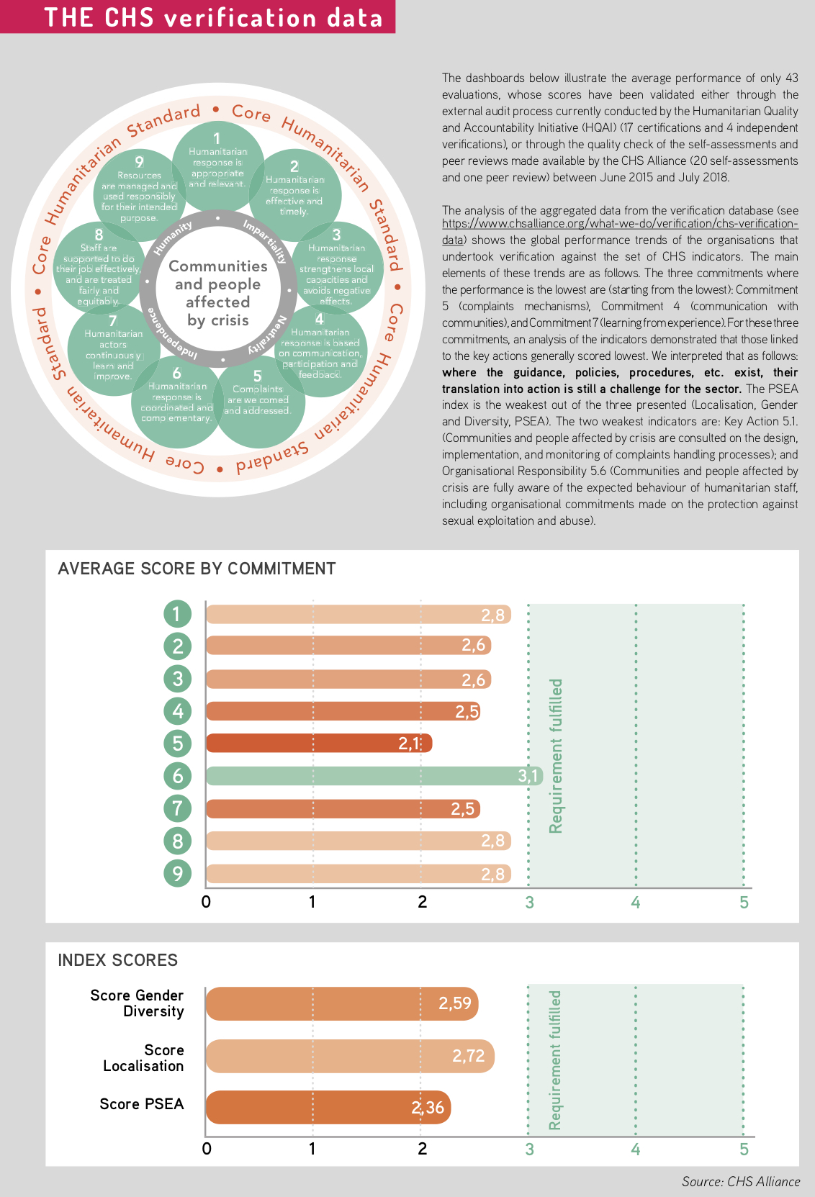

Annex 3: CHS PSEA index score brackdown
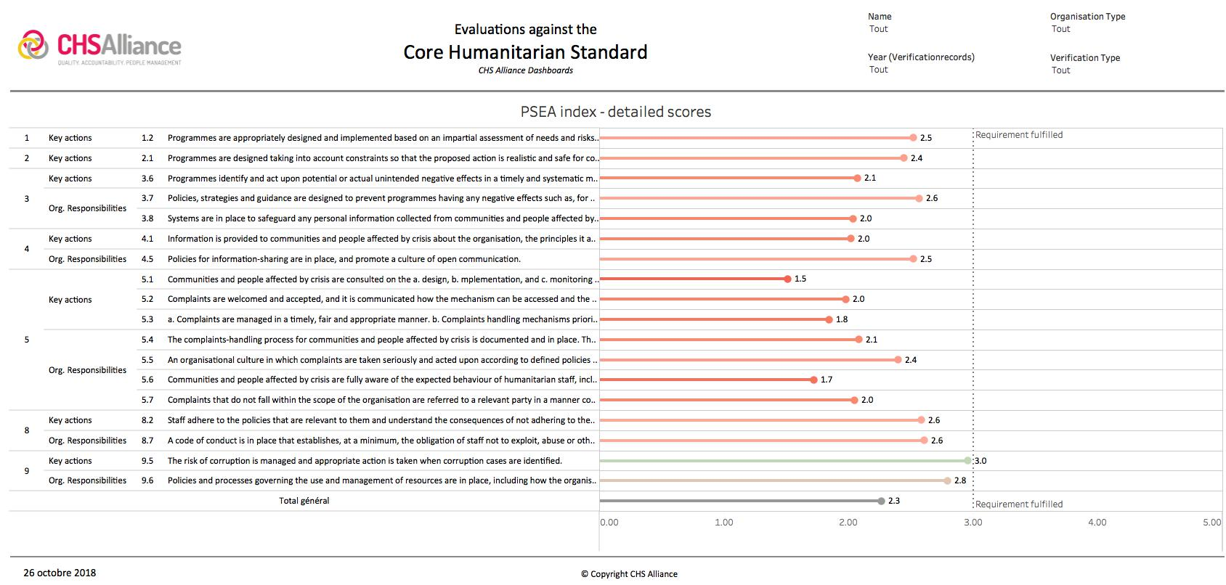

Developed jointly by the CHS Alliance, the Sphere Project, Groupe URD and their respective membership organisations.

