Global Preparedness Partnership
Preparedness paves the way towards ending emergency needs

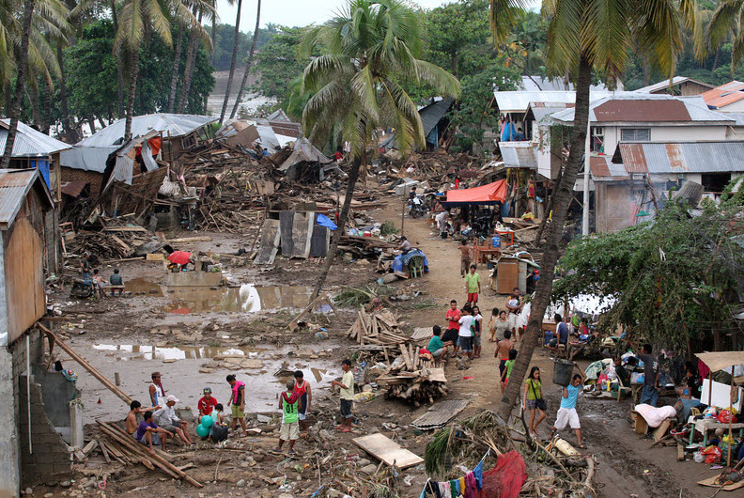
Northern Mindanao, the Philippines, December 2011. Credit: UNICEF / J.Maitem

The Global Preparedness Partnership (GPP) between the Vulnerable Twenty Group (V20), donors and multilateral organizations to strengthen national and local preparedness and develop predictable arrangements for response and recovery in countries most at-risk to the impact of climate change and disasters. The goal of the GPP is to support countries reach an essential level of readiness, so that situations do not spiral out of control and development gains are not lost when hazards strike. This partnership will initially focus on 20 countries, so they reach an agreed level of readiness by 2020.

May 2016

WHY partner and pool resources to boost emergency preparedness?

Over the past 20 years, typhoons, floods, droughts, earthquakes and other natural hazards have claimed 1.35 million lives and affected on average 218 million people per year, mostly in developing countries. Disasters– 90% of which are now climate-related – also have devastating effects on socio-economic development with a global economic impact since 2005 surpassing USD 1.3 trillion.
Preparedness is defined as “the knowledge and capacities developed by governments, professional response and recovery organizations, communities and individuals to effectively anticipate, respond to, and recover from, the impacts of likely, imminent or current hazard events or conditions.”

Evidence suggests that the frequency and magnitude of extreme weather events will continue to rise. Climate change will increase humanitarian stress by exacerbating underlying vulnerabilities related to food insecurity, water scarcity, conflict and migration. The impacts of shocks may also be intensified by unplanned and rapid urbanization and population growth. At the same time, a range of other hazards can exacerbate the impact of climate change, including conflict, displacement and health threats.

The cost of responding to these and other crises is enormous. Roughly $70 billion of international financing for humanitarian response from 1990 to 2013 has gone to the range of humanitarian needs in the 43 countries now making up the V20. During this period, the percentage of ODA dedicated to meeting humanitarian needs at the global level has skyrocketed from 3% to nearly 20%. Unless there is increased investment in risk reduction and preparedness, resources will be increasingly diverted from longer-term development to short-term response.

The Sendai Framework for Disaster Risk Reduction 2015-2030, the 2030 Agenda for Sustainable Development and the Paris Agreement on Climate Change recognize a need for change. All have embraced the indivisibility of risk from development, and the need to shift from reactive crisis management to investing in prevention and early action. Success will be measured by how people's vulnerability and risk are reduced through preparedness, not by how emergency needs are met year after year.

WHAT value will the partnership add?

Decades of investment in preparedness demonstrate that it can reduce life and economic losses as well as the overall cost of response. There is a growing body of evidence showing that shocks do not need to result in major disasters, if they are planned for in advance, have the right decision making mechanisms in place to trigger the early and coordinated delivery of effective response systems, and which are backed by pre-committed financing arrangements.

This has been recognized in priority four of the Sendai Framework for Disaster Risk Reduction, as well as during the consultations for the World Humanitarian Summit (WHS).

However, the international community underinvests in preparedness. Between 1991 and 2010, less than 0.5% of ODA has been spent on disaster risk reduction, and only a fraction of this on preparedness, much of which has been ad hoc. These limited resources also tend to be fragmented and piecemeal, and span humanitarian, development and climate finance. This is despite the fact that preparedness is a no-regret, cost-effective investment. For example, cost-benefit analysis of the African Risk Capacity initiative shows a 4.4 to 1 benefit of early, planned and government-led response compared to the status quo.

This underinvestment leads to inadequate policy and legislation, and prevents the establishment of core national and local capacities, including for community-based early warning, contingency planning, logistics, communications, stockpiling, information management, coordination arrangements and systems, such as social protection and basic services, that are required to deliver rapidly and at scale. As a result, there are heavier casualties and greater economic and development losses, and the costs of financing humanitarian response increases.

To address these needs, the Vulnerable Twenty Group (V20) together with donors and multilateral organizations propose the establishment of the Global Preparedness Partnership (“GPP”), whose ultimate goal is for countries to reach an essential level of readiness so that situations do not spiral out of control when hazards strike.

To achieve this, the GPP partners commit to work collectively to strengthen national preparedness capacities of the most vulnerable countries in a coordinated way. In doing so, the GPP will be aligned and support the delivery of the Sendai Framework for Disaster Risk Reduction, the UN General Assembly Resolution 46/182, the Common Framework for Preparedness, and the UN Secretary-General’s Agenda for Humanity.

The current multilateral partners involved in the GPP include the United Nations Development Programme (UNDP), the Office for the Coordination of Humanitarian Affairs (UNOCHA), the World Bank / Global Facility for Disaster Reduction and Recovery (WB/GFDRR), the Food and Agriculture Organization (FAO), and the World Food Programme (WFP). The GPP will be open to other organizations.

WHAT will the partnership’s principles of engagement be?

In direct line with the Common Framework for Preparedness’ operating principles, the GPP will be guided by the compliance to the following principles:

National Ownership. The investment needed for real transformational change in preparedness capacities must be first and foremost mobilized nationally. Governments have the lead role for preparedness, complemented by civil society and the private sector, and will be supported through the GPP by providing technical support for capacity building, as well as helping leverage and align other investments, including risk finance.
“Response should be as local as possible, and as international as necessary”
World Humanitarian Summit

Joint Planning and Coordination. Under the leadership of national governments and based on their priorities, the GPP Partners will jointly plan and identify specific action and investments required to strengthen national and sub-national preparedness, recognizing the comparative advantage of each organization. The GPP partners recognize that enhancing national preparedness requires a development approach, though informed by best practice and standards from humanitarian response, as well as respecting the humanitarian principles. It also requires effective, quick, and flexible early-action when the warning signs of an impending emergency are raised.

Context Specific. Supporting national and local capacities for preparedness should be context specific and should recognise and build on country and regional initiatives.

Catalytic Approach. The GPP will take a catalytic approach that is an integral part of wider national disaster risk reduction and risk management policies and frameworks.

HOW will the partnership operate?

While GPP’s focus will first be on disasters from natural hazards, the types of activities that the GPP would support are also important for countries to prepare for other threats through strengthening civil protection services and generic disaster risk management systems.

The GPP will focus on up to 50 vulnerable countries, starting with a pilot phase of 20. The list of recipient countries will be established in consultation with the V20 and in line with its Action Plan. Over time, the GPP will also include vulnerable countries beyond those in the V20. The selection of countries will be based on:

Political will, including their commitment to provide national resources to the objectives of the partnership.

Multi-hazard vulnerability analysis including risk of changing climate, and compounding risks and vulnerabilities.

Emerging or imminent hazards for which preparedness needs to be scaled up.

These principles will be translated into a program of action that leads to countries having arrangements in place to achieve a minimum level of readiness. These include: a) an understanding of risks and vulnerabilities; b) the ability to coordinate and manage different stakeholders prior to and during a crisis, based on response and recovery plans that have clear roles and responsibilities and decision making mechanisms, such as triggers, that lead to early action; c) having the operational capabilities and systems in place prior to a shock to allow rapid delivery; and d) undertaking careful financial planning as an essential part of preparedness planning, so that a set of financial instruments are in place to allow access to both quick response and recovery finance.

The GPP can support the following four components:

Assessment of country-level readiness and identifying priority gaps, such as for response and recovery capacities. A diagnostic tool will be developed This will build on existing best practice, such as the country capacity development matrix for preparedness developed by IASC’s thematic group on preparedness. This would include assessing the current programs supporting preparedness, and improving the alignment of these to national plans.

Targeted preparedness building programmes within the following categories:
- Institutional & legislative frameworks
- Hazards, risks and vulnerabilities diagnosis
- Emergency coordination and financial architecture schemes
- Information management and communication
- Emergency services, standby and prepositioning arrangements
- Knowledge and know-how management
- Promoting knowledge sharing between V20 countries, and also other countries. This will include an exchange program to look at each other’s response and recovery systems, and how they are financed. The partnership will also generate evidence on the value for money of preparedness investments.

- Program management and monitoring & evaluation. All individual programmes will have regular and rigorous progress monitoring review. This will also include a system to ensure and measure tangible impact on vulnerable populations. Trend analysis and lessons learnt based on evaluations will inform future operations and allocation decisions.

With the GPP’s principles of engagement and the types of services provided in mind, the overall objective of the GPP is to support countries in understanding and achieving the core capabilities that they need to have in order to achieve a requisite level of response management readiness. These core capabilities are regrouped in four building blocks:

Capability 1  Understand risks and vulnerabilities | Capability 2  Coordinate and manage different partners prior to and during a shock/crisis
Capability 3  Have the operational assets and capacities in place in advance to the shock / crisis | Capability 4  Have the financial means and flexibility in place to rapidly mobilize resources when needed prior, during and after the shock /crisis

“Anticipate, do not wait for crises”
UN Secretary General’s Agenda for Humanity

HOW will the partnership be managed?

The GPP will require a dedicated governance mechanism. Financing will be managed through a two-fund architecture, and complemented by additional funding mechanisms and implementing arrangements.

Governance and management arrangements. The GPP’s governance will be defined through a consultative process involving key stakeholders. Governance arrangements will be designed to generate greater coherence amongst relevant preparedness actors, and promote representativeness, efficiency, demand responsiveness, and transparency. These arrangements could including the following elements:

A Steering Committee responsible for setting the GPP’s priorities and strategic direction and through transparent and accountable decision-making. In addition, it could serve as a forum for policy dialogue between vulnerable countries and the international community on preparedness. The Steering Committee will be composed of the GPP Partners, including representation from at risk countries through the V20, donors and implementing partners. The Steering Committee will be chaired by an at-risk country and co-chaired by a donor and a partner from the multilateral system.

A Technical Secretariat, which could provide direct support to the Steering Committee on general partnership operations, portfolio cycle management, communications, fundraising, and general coordinating of monitoring, evaluating and reporting processes.

Implementing Entities. The GPP will seek different global, national and local implementing entities, the selection of which will be based on demonstrated comparative advantage, knowledge and capacity to undertake the work.

Finance arrangements. Finance, predominantly in the form of grants, for the GPP will be supported by a two-fund architecture and be sufficiently flexible to accommodate contributions from other funding mechanisms. This will consist of:
- A Multi-Partner Trust Fund (MPTF), which will manage funds held in trust, disburse funding based on guidance provided the Steering Committee as well as provide fund management tools to ensure transparency and consolidates programme and financial reports to provide accurate and timely information to all concerned stakeholders.
- A World Bank Trust Fund (WBTTF), which will channel funds managed by WB/GFDRR and used to provide assistance directly to governments, as well as through World Bank and UN teams, to support the GPP objectives, and as guided by the Steering Committee. Activities would be implemented by the governments in close coordination with relevant partners.
- Complementary funding arrangements at the national level, including bilateral project funding and risk financing mechanisms, which support the strategic approach and priorities of the GPP. These additional sources of funding should also seek to ‘crowd in’ investments and capacity from the private sector to strengthen national preparedness systems.

Estimated financing needs: The initial phase of the GPP, covering 20 countries over a two-year period, is estimated to cost $100 - 130 million. A longer-term program of five years, covering 50 vulnerable nations, would involve $250 - $330 million. A detailed budget will be elaborated following the WHS launch. This financing would also leverage far greater resources from development partners, the private sector and participating countries.*

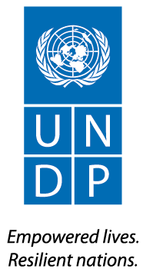

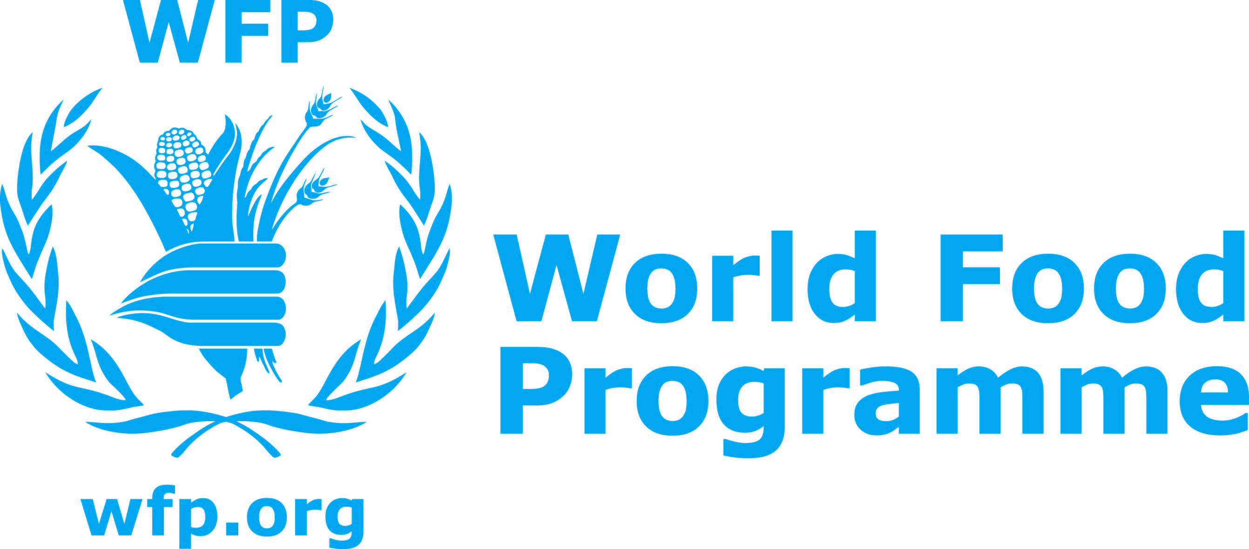

The V20 are the Finance Ministers of the member states of the Climate Vulnerable Forum, a group of 43 highly vulnerable developing countries affected by climate change from Africa, Asia, the Caribbean, Latin America and the Pacific. Further details on the wok of the group and its members can be found at: http://www.v-20.org/
Swiss Re, “The USD 1.3 trillion disaster protection gap: innovative insurance tools exist to support governments to be better prepared”, October 2015.
According to ISDR, preparedness is defined as “the knowledge and capacities developed by governments, professional response and recovery organizations, communities and individuals to effectively anticipate, respond to, and recover from, the impacts of likely, imminent or current hazard events or conditions.”
See Kellett and Caravani (ODI, 2013) Disaster Risk Reduction, A 20 Year Story of International Aid.
The UN General Assembly Resolution 46/182 of 19 December 1991 on the Strengthening of the coordination of humanitarian emphasises the need for the international community to provide coordinated support to national preparedness measures.
Endorsed by the Inter Agency Standing Committee (IASC) Principals, the International Strategy for Disaster Risk Reduction (ISDR), and the United Nations Development Group (UNDG), the CFP is an approach towards coordinating the actions that international humanitarian and development actors take to support the development at country level of national and local capacity to prepare for, respond to, and recover from emergencies

